University of Ottawa
GNG 1103: Engineering Design

Deliverable E- Project Schedule and Cost

February 25^{th,} 2023
Group F-12
Avery Taylor (300366472)
Emily Facette (300109170)
Rashad Nesar (300372555)
Annabelle Osazuwa (300361617)

Abstract
This document presents a comprehensive plan for the prototyping phase of the accelerated erosion testing device. Following a recent client meeting, the updated apparatus configuration sketch is presented, including key features, such as fasteners, adhesives, motors, design details, etc. A project plan has been created which outlines the list of tasks to do with estimated durations and assigned responsibilities while identifying project risks. A spreadsheet is used to account for costs of all materials and devices including both permanent and temporary materials for initial prototyping. The required materials are broken down in the List of Equipment Section, where both the low fidelity (Prototype I) and high fidelity (Prototype II) setups are explained. A prototyping test plan, aligned with established objectives and defined stopping criteria, will help achieve testing goals effectively. This approach ensures a methodical progression towards developing and refining prototypes that align with project objectives and client expectations.

Table of Contents
Abstract 3
1.0 Introduction 5
2.0 Drawing 5
3.0 Plan and Schedule 6
3.1 Tasks 6
3.2 Risks and Contingencies 7
3.2.1 Design Flaws 7
3.2.2 Material Selection 7
3.2.3 Cost 7
3.2.3.4 Material Availability 7
3.2.3.5 Time 8
4.0 Cost Analysis (EXCEL) 8
5.0 List of Equipment 8
6.0 Prototyping test plan 9
7.0 Conclusions and Future Works 11
8.0 References 11

Introduction
The team is in the prototyping phase of the accelerated rock erosion device design thinking process. Following our second client meeting, we were able to receive constructive feedback and alter our design which was chosen in Deliverable D. This report will go into further detail regarding our project plan and schedule before we begin to build our prototypes. As we are approaching design day, a detailed schedule of all remaining tasks is crucial to ensure that the team stays on track and completes all our milestones.

2.0 Drawing
In project deliverable D, our design 1 was selected. The primary features on this design include:
- Multiple speed motor on top
- Baffles for aeration
- Plastic Barrel
- Clamps to attach rock sample
The following figure shows a detailed drawing.
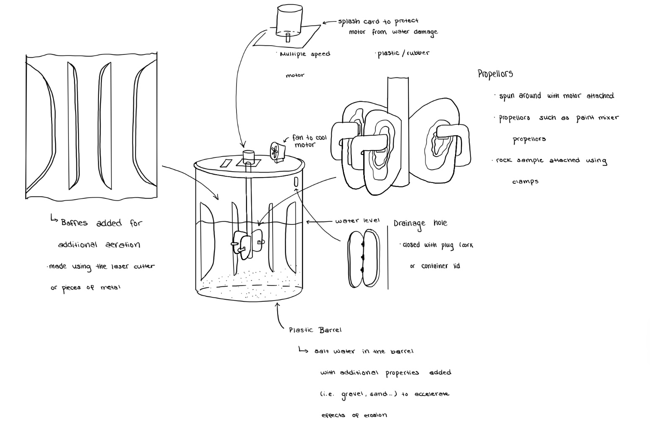
Figure 1: Apparatus Design Diagram

3.0 Plan and Schedule
So far in this design process, we have empathized with the client as well as designed and ideated possible solutions. The background research and benchmarking regarding different subset options were conducted, and the best options were selected. The selected apparatus design can be seen above in Section 2.0: Drawing. Now that the apparatus design has been selected, a project plan and schedule can be created. The main phases in the design process will be broken down and explained in this section, along with the risks and contingencies.

3.1 Tasks
The required tasks for the construction of the three prototypes can be broken down as follows, with corresponding responsibilities and due dates.
Prototype 1:
- Gather materials needed for first prototype; All Feb 13-28
- Assemble initial prototype
  - Overall configuration; All, Feb 13-28
- Record feedback; Anabelle, Feb 26-Mar 1
- Create small analysis on system; Avery & Rashad, Feb 26-Mar 1
- Set meeting date; Emily, Feb 28
Prototype 2:
- Assemble second prototype Feb 26-Mar 3
  - Motor configuration; Rashad
  - Arduino + technical elements; Emily
  - Jug + baffles; Avery
  - Overall configuration; Anabelle
- Gather feedback from client/users; Emily, Mar 3-15
- Set meeting date; Emily, Mar 6
- Update prototyping test plan; Avery, Mar 3-10
- Test effects of short-term erosion and update target specifications; Rashad, Mar3-10

Prototype 3:
- Update any target specifications based off testing feedback; Avery Mar 11-24
- Gather feedback from users other than client; Rashad Mar 17-24
- Test system to ensure it is fully functional; All Mar 10-Apr 4
- Write analysis on final system Mar 10-24
  - Explanation of results; Anabelle
  - Justifications and reasonings for any changes made; Emily
Design Day; All, April 4th

3.2 Risks and Contingencies
When creating any prototype, there are always risks associated with each phase. The most likely risks and their associated contingency plans will be described in this section.

3.2.1 Design Flaws
It is likely that our preliminary design will encounter some obstacles due to poor functionality or failure. This type of risk can be mitigated by performing numerous tests to ensure the functionality of each subsection and component.

3.2.2 Material Selection
We have chosen a plastic barrel and a metal clamp to fasten the rock sample to the propellor. It is possible that the plastic barrel may not perform as we expected and cause a failure in results. Additionally, it is possible that the rock sample may escape the clamp and be launched into the water vortex loosely. To mitigate these errors, we will conduct thorough research into the type of plastic barrel selected, as well as the size and stability of different clamps.

3.2.3 Cost
The allocated budget is $100 for this project. In today's market, that is a tight budget when creating almost anything. The budget could be exceeded due to unforeseen circumstances, such as faulty material selection or missing/unforeseen necessary components. We will try our best to respect the budget for the project by allocating a contingency budget of 5-10%, as per industry standards (Rodeo Software B.V., 2023). This way, if any unforeseen complications arise, we will have some funds left to purchase new pieces.

3.2.3.4 Material Availability
The parts for the prototype will be ordered from any Canadian retailer or will be selected form the Makerspace Lab. It is a high possibility the parts we have selected will not be available or will have a shipping delay. For this reason, we must construct our project plan with the least dependencies possible, or adapt other means of constructing the prototype, such as using different parts or looking elsewhere for the parts.

3.2.3.5 Time
We will likely encounter certain design setbacks, such as material selection, design flaws, or component availability. So that we stay on schedule, a detailed schedule identifying dependencies will be followed. We will also allot extra time for each task than what should be required to accommodate any unforeseen obstacles.

4.0 Cost Analysis (EXCEL)
The complete bill of materials and corresponding links can be seen in the excel sheet attached.

5.0 List of Equipment
The goal is to create a design which will allow for a deeper understanding of how different factors affect the rate of erosion. What we hope to achieve in the creation of the prototypes is to have visible signs of rock erosion.
Prototype I- Low Fidelity
- Bucket
- Drill
- Rock Sample
- Scale
- Zip-ties
- Microsoft excel
- Salt
- Sand
- Propellor
- Baffles x3 of some material
- Water

Prototype II- Higher Fidelity
- Multiple speed motor (12-24V)
- Hall sensor to measure RPM of motor
- Pointometer to change the speed of the motor by inputting more power
- MOSFET for pulse width modulation
- Power source (12-24V)
- A dozen Arduino male-male wires
- Arduino
- Bread board
- Scale
- Microsoft Excel to track results
- Sheet of plywood
- Mini Fan
- Plastic Container
- Mini plastic box for electrical components
- Propellor
- Laser cut Baffles x3
- Rock Sample
- Zip ties to attach rock sample
- Salt
- Sand
- Water

6.0 Prototyping test plan
The general prototyping test plan schedule can be seen below. For each test ID, there is a specific objective, design to be verified, subsystems to be analyzed, certain stopping criterion, and risk reducing measures. It is important that we maintain communication and feedback amongst the team, TA’s and client.

Test ID | Test Objective  (Why) | Description of Prototype used and Basic Test Method (What) | Description of Results to be Recorded and how these results will be Used (How) | Estimated Test duration and planned start date  (When)
1 | Client Meeting 2  Prototype I | Comprehensive Prototype:  Determine if the overall product needs any changes or alterations based off the client's preferences | Results will be noted from the client meeting to adjust our preliminary ideas | Feb 14, 2024
2 | Testing of materials | Low Fidelity Physical Prototype:  Testing if materials can show signs of erosion within the testing system | These results will indicate if the selected materials shows signs of erosion and how they react to different conditions | Feb 27, 2024
3 | Decide on chosen rock sample for the system | Focused Prototype: Test single aspect of which rock sample will display the best effects of erosion | By putting different rock samples under several different conditions, these results will help with the decision on which type of rock will be used for testing. The rock which shows the most signs of erosion without disintegrating will be the best option. | Feb 27, 2024
4 | Test general safety of the prototype | Comprehensive Prototype:  Testing the overall safety of the prototype once undergoing working conditions | These results should prove to be successful by following each safety regulation, such as stability with high rpm’s (not exceeding certain speeds) | Feb 28, 2024
5 | Test short-term effects of erosion | Physical Prototype: Testing to see the physical effects of erosion on the chosen rock sample | Using the prototype, we will be able to record the short-term effects of erosion using the system, as well as different parameters, such as salt and sand, and different operational speeds. | Mar 1, 2024
6 | Test overall functionality of prototype (i.e. is the prototype able to show effects of erosion in the short-term) | Comprehensive Prototype:  Testing the overall functionality using prototype I to ensure everything is working efficiently for the next prototype | These results will indicate whether there needs to be any additional changes or updates to the final system | March 3, 2024

7.0 Conclusions and Future Works
All in all, this document outlines all materials required for the prototypes, while working in the budget. There are no current plans for the 3rd prototype, as the final prototype will be designed around the feedback from the 2nd prototype. The first prototype is set to be completed by the 28th of February, for which an analysis of the results will be finished by the 1st of March. The second prototype should have concrete results by March 3rd, and client/ user feedback should be collected by the 15th of March. The final prototype will be constructed based on feedback and will be complete by design day on April 4th. There are precautions set for in case plans need to be changed, such as saving 5 – 10% of our money as a contingency budget, and putting in extra time when scheduling tasks to make sure everything gets finished on time.

8.0 References
Rodeo Software B.V. (2023, December 29). What is a contingency budget for project management? https://www.getrodeo.io/blog/contingency-budget-for-project-management#:~:text=A%20typical%20contingency%20budget%20will,to%20estimate%20the%20contingency%20budget.

