University of Ottawa
GNG 1103: Engineering Design

Deliverable F- Prototype I and Customer Feedback
March 3rd, 2023
Group F-12
Avery Taylor (300366472)
Emily Facette (300109170)
Rashad Nesar (300372555)
Annabelle Osazuwa (300361617)

Abstract
The first prototype and analysis of the rock erosion test system are performed to prepare for subsequent prototypes and integration of critical components, professional feedback on our design, and an updated bill of materials (BOM). The first two prototypes of the rock erosion system are presented and evaluated. The first prototype shows a rock sample fastened to a metal turbine attached to a drill in a bucket for erosion analysis. The second prototype is a simulation of prototype one in an Arduino environment. The analysis of critical components outlines the most vulnerable parts of the final design and evaluates the risks and corresponding mitigation techniques. Professional feedback is provided to introduce new ideas, and flaws in the current design. The new BOM ensures a design that contains only approved materials within the designated budget. Preliminary testing showed a successful erosion of the rock sample within the given parameters and time limitations.

Table of Contents
Abstract 3
List of Figures 5
List of Tables 5
Introduction and Objectives 6
Analysis of critical components 6
Motor Torque 6
Controlled Variable system 6
Abrasive Materials 6
Battery Supply 7
Electrical Components Contact with Water 7
Prototype test plan 7
TinkerCad 7
Physical Set up 10
Feedback 13
Updated BOM 14
Prototype Test plan II 15
Conclusion and Next Step 16
References 16

List of Figures
Figure 1: Arduino Set up 8
Figure 2: Pulse Width Modulation Graph 9
Figure 3: Arduino Simulation 9
Figure 4: Drill with turbine and sample 10
Figure 5: Bucket Set up 11
Figure 6: Rock adherence for Test 1 11
Figure 7: Rock sample after erosion 12
Figure 8: Side Profile Rock sample after erosion 12

List of Tables
Table 1: Prototype I Physical Test Results 13

Introduction and Objectives
Following our recent client meeting, some changes were made to our selected design, and a comprehensive Cost Analysis was developed. With the materials finalized for the construction of our chosen design, we are ready to start the prototyping process. This document serves as an outline of our first prototype, which aims to test the repeatability of our tests. We have made an analytical Arduino board setup, using Tinker CAD, alongside a simple focused physical prototype made of the bucket, turbine and rock sample. In this report, we provide a detailed overview of our first prototype, including its setup, methodology, and the outcomes of the repeatability tests conducted.

Analysis of critical components

Motor Torque
The motor in our design would need to be able to rotate at speeds hovering around a thousand RPM, and while carrying a propeller with multiple samples on it in water. This requires a lot of torque on the motor, thus the motor used in our project would need to be able to handle such stress and still maintain a high rotational speed. This is why we decided to use a drill motor. Drill motors have high torque as they are used to make holes in solid materials such as dry wall, and wood.

Controlled Variable system
We expect rotational speed to be directly proportional to a sample materials rate of erosion. Repeatability should be one of our top priorities, according to Ailsa from Canadian Nuclear Laboratory's. This makes it important that we track the speed of our sample during testing. This will be done with a controller for the motor that will allow us to set and monitor the speed by adjusting the power being supplied to the motor.

Abrasive Materials
Abrasive materials in the water with the sample should increase the rate of erosion, so we will include abrasives like sand and salt in tests to see how it changes the rate of erosion. The water content will be easily removable from the jug so we can easily dump out and refill the container.

Battery Supply
As we are using a drill motor, it requires a substantial amount of power. For this reason, we require high peak power to run the motor. We will be using a drill motor to ensure there is adequate power to support the high torque of the motor.

Electrical Components Contact with Water
Our design has multiple electrical components such as the motor, the arduino, and the power supply. It’s very important for these components to not get wet. The top of the bucket will be covered with a piece of plywood, with a hole drilled out for the motor and rod to go through. The rest of the electrical components will sit on top of the plywood as well. This also ensures we have an easy way to dump the contents of the bucket.

Prototype test plan

TinkerCad
As mentioned above, the goal of this prototype is to focus on the repeatability of the tests. For this reason, an analytical model focusing on the electronics configuration will be created on TinkerCad. This model will focus on measuring the rotational speed of the motor to ensure that the RPMs can be consistent for subsequent tests.
TinkerCad allows for the set up and analysis of an Arduino configuration to test ideas before building them in the real world. This is very convenient as we would like the clients feedback before purchasing physical parts. The configuration of the electronic system can be seen in the following figure.

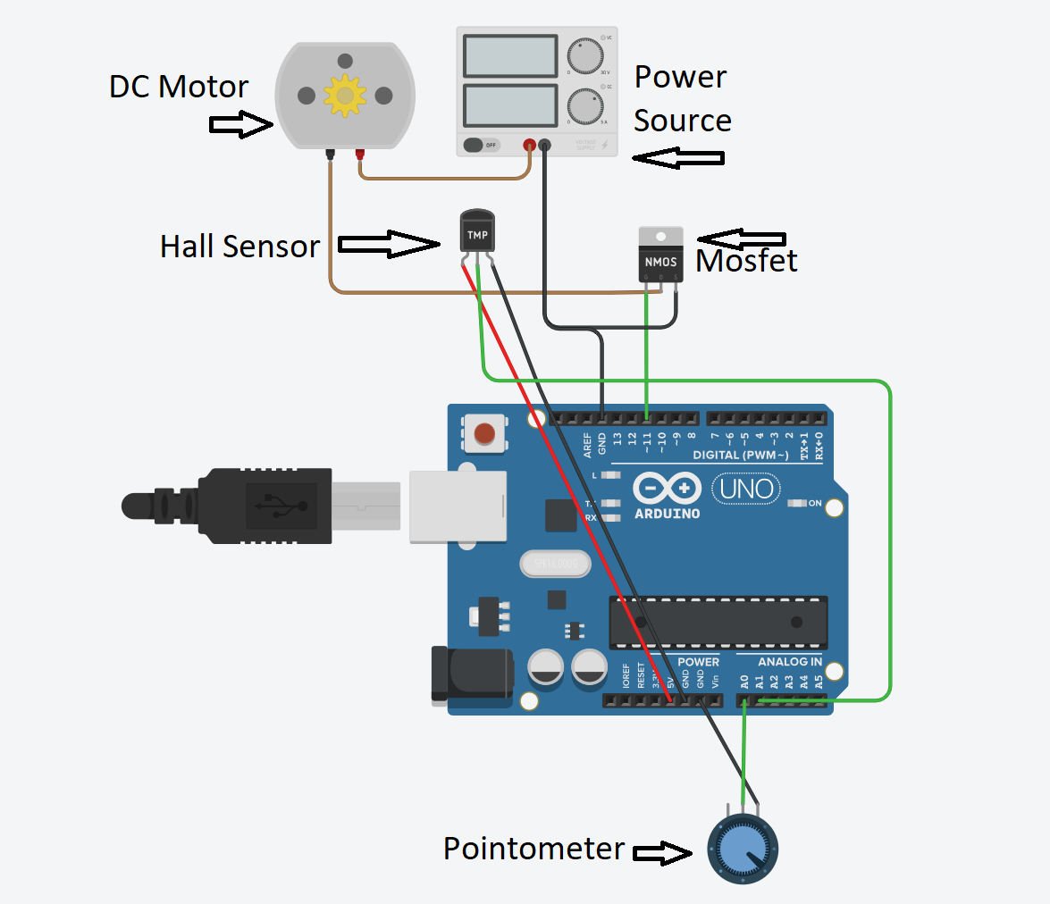
Figure 1: Arduino Set up
The system will be powered by a power source, such as a 12V battery pack. The multiple-speed DC motor will rotate the turbine attached to the rock sample, which can be seen in the next section of the report. The DC motor will be attached to the MOSFET, which, using Pulse Width Modulation (PWM), can control the power/voltage supplied to the motor in a cyclical manner. The following figure shows a typical cycle. In this case, the motor is off for 75% of the time and on for 25% of the time, resulting in a lower power supply to the motor, and ultimately a slower rotational speed.
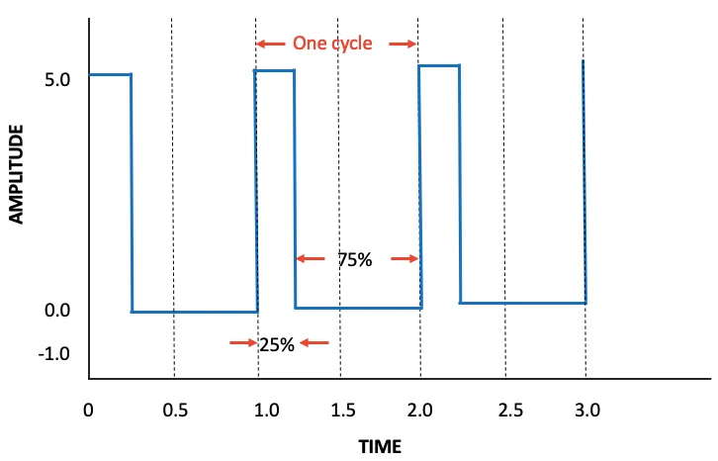
Figure 2: Pulse Width Modulation Graph (Koon, 2020)
The potentiometer on the bottom of the figure will be responsible for changing the speed of the motor by manually turning a dial which is in control of inputting more power to the motor. There will be a hall sensor which measures the RPM of the motor using magnetic fields and transmits the data to the user.
When running the design, the user can adjust the potentiometer dial, ultimately adjusting the amperage, as seen in the following figure.
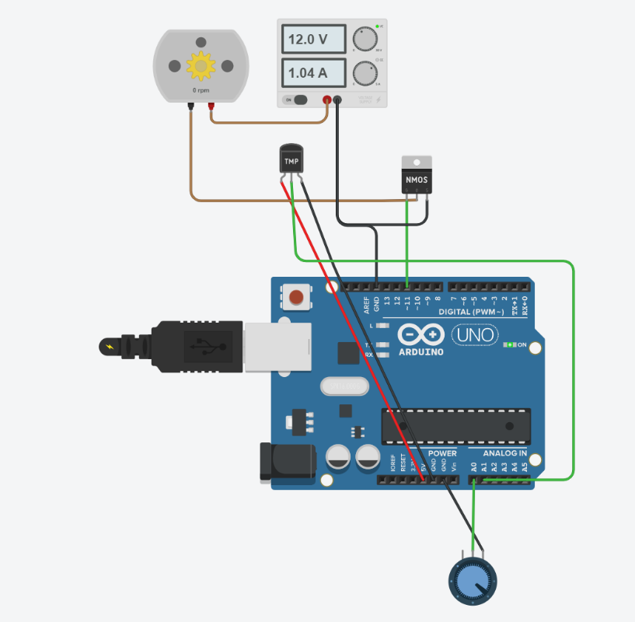
Figure 3: Arduino Simulation

As shown above, when the dial was adjusted, the amperage was increased significantly. This will result in a slower/faster motor. Being capable of adjusting and noting the rotational speeds will allow for our design to be very repeatable, which will be essential when users want to keep the speed constant.

Physical Set up
The main subsystems which will be used in our Prototype I are the jug configuration, attachment of rock to the turbine, and the content of the water. This prototype will be a focused physical test which will focus on the rock selected for erosion. The prototype consists of the following materials
- Home Depot Bucket
- DIY Steel rod turbine
- Shale sample attached with Zip ties
- Ryobi power drill
- Salt
- Selection of road sand and dirt
- Scale
- Safety Glasses
- Water
The following figures show the drill with the turbine and the sample, the setup of the bucket, and the sample after erosion.
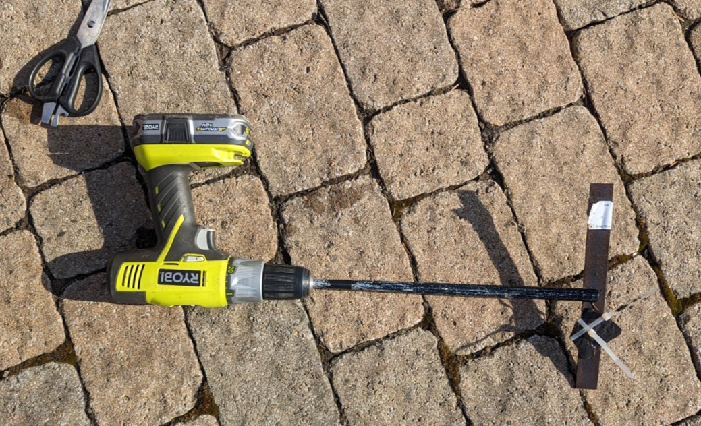
Figure 4: Drill with turbine and sample
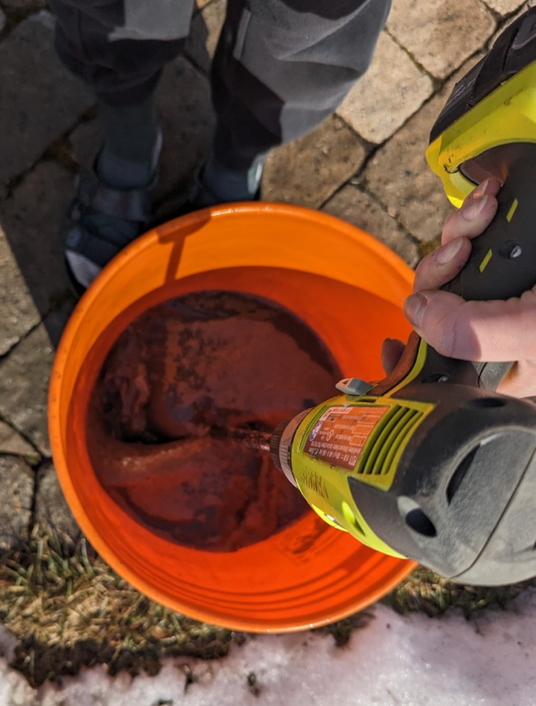
Figure 5: Bucket Set up

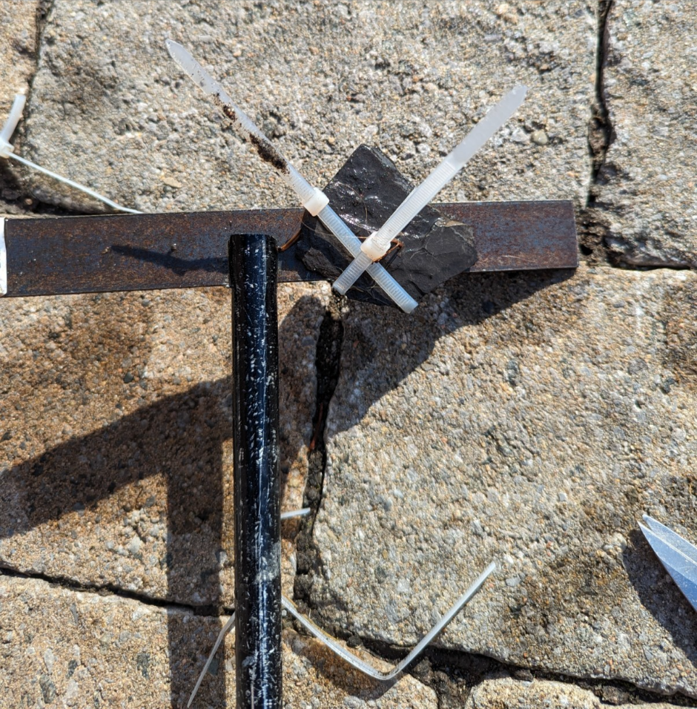
Figure 6: Rock adherence for Test 1
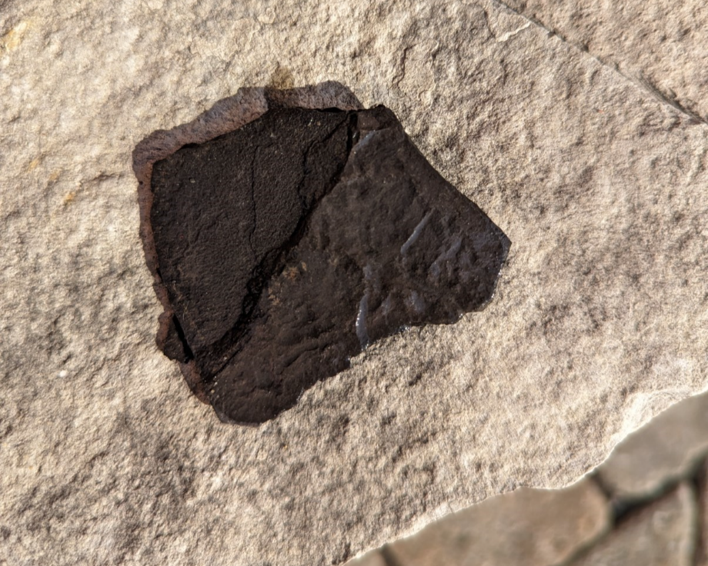
Figure 7: Rock sample after erosion

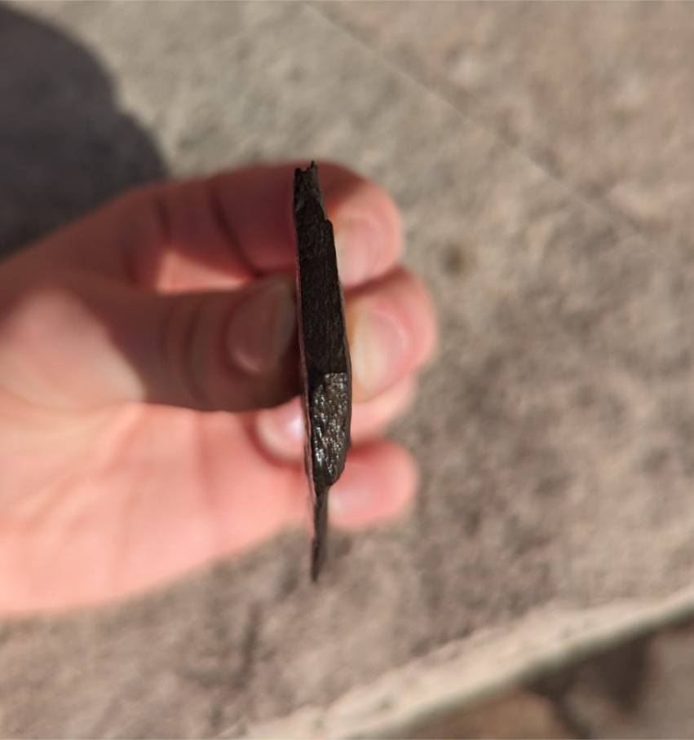
Figure 8: Side Profile Rock sample after erosion
The basin was filled 1/3 of the way with 35*C water, 1.5 cups of kosher salt, and 2 cups of various road dirt/sands. The rock was weighed and attached to the turbine, as seen in Figure 6 above. The drill began spinning at a slow rate, followed by a medium rate. After the medium rate was achieved, the rock sample fell off the turbine, leading to a loss of the sample, and a failure.
For the next iteration, the sample was attached to the base of the turbine and the shaft. The same process was repeated, and the rock stayed on for the 5-minute duration, showing signs of erosion. The sample was weighed after the test, and the results can be seen in Table 1 below.
For the third iteration, the same process was repeated, and the rock stayed on for the 5-minute duration, showing signs of erosion again.
The following table summarizes the results of the three tests.
Table 1: Prototype I Physical Test Results
 | Mass 1 | Mass 2 | Change in mass
Test 1 | 31 g | - | -
Test 2 | 23 g | 21 g | 2 g
Test 3 | 21 g | 18 g | 3 g

Feedback
Josiah Bigras, Electrical Engineering Student at the University of Ottawa reviewed the configuration and analysis of the Tinker CAD setup. He appreciated the setup's simplicity and its capability to vary the motor's speed. His concern was that the hall sensor may not be close enough to the motor, as it measures the magnetic field. When constructing our physical prototype, we will ensure that the hall sensor is close enough to the spinning motor to accurately measure the magnetic field.
Peter Vanikiotis (B. Eng) is a Structural and Bridge Engineer-In-Training at Parsons Corporation. His feedback on the system was generally positive, appreciating its inclusion of various additives which were used to induce erosion. He noted that the visibility of erosion was particularly impressive and appreciated that the model has a very similar set up to how the final prototype is anticipated to look. However, he raised a concern about the environmental impact of securing rock samples to the rod with plastic zip-ties and suggested that we consider more environmentally friendly alternatives. Additionally, he was curious if there was a way of stabilizing the rotational speed, as the drill was not kept at a constant speed. These suggestions will be taken into account for future prototypes, and the rotational speed will be stabilized with the use of the potentiometer in the following prototype.
Christopher Taylor 309a Electrician Foreman at Dielco Electric gave some feedback on the Tinker CAD set up and bill of materials. While his feedback on the overall Tinker CAD set up was positive, mentioning the simplicity of the set up was good, the only concerns were about the bill of materials. Specifically, the multiple speed motor and power source. With the multiple speed motor, he commented that the power source or battery might be unfit to support the multiple speed motor based off the horsepower. Other than that, there was no additional feedback. This feedback will be considered, and additional research will be done on the motor and power sources.
Amir Biswas, 4th year mechanical engineering student at University of Toronto, he had one main concern for the design. His main concern was that there was no cooling of the motor, as he thinks the motor could get damaged, or become hazardous if kept on for extended periods of time. He appreciated our focus on repeatability, by using the motor that has an adjustable speed.
Since we saw erosion in our first prototype that was only being tested for 5 minutes at a time, the device won’t need to be on for long to see erosion, but we will still make sure it does not stay for long.

Updated BOM
The complete list of required materials has been refined since the last deliverable. The required materials for prototype III are as follows:
- Multiple speed motor with pointometer (12-24V)
- Power source/Battery (12-24V)
- 10 Arduino male-male wires
- Arduino Board
- Weighing Scale
- Bucket
- Hall sensor to measure RPM of motor
- Microsoft Excel to track results
- Sheet of plywood
- Plastic Container for electrical components
- Propellor/steel rod
- Laser cut Baffles x3
- Rock Sample (Shale)
- Zip ties to attach rock sample
- Salt
- Sand
- Water
The complete BOM can be seen on the excel sheet attached.

Prototype Test plan II

Test ID | Test Objective  (Why) | Description of Prototype used and Basic Test Method (What) | Description of Results to be Recorded and how these results will be Used (How) | Estimated Test duration and planned start date  (When)
1 | Testing the battery life on the motor (Will it be able to run for extended periods of time) | Focused prototype:  Testing the single aspect of battery longevity when used for testing | These results will be used to determine if the battery indicated in our BOM can withstand testing for prolonged periods. | Mar 4, 2024
2 | Testing motor speeds | Focused Prototype: Testing the motor at different RPMs ensuring the potentiometer functions to ensure speeds remain stable throughout the testing | These results will be used to ensure the motor can remain stable through different RPMs for the repeatability aspect of the project These results will be used to ensure | Mar 4, 2024
3 | General safety testing | Low fidelity physical prototype: Test the general safety of the prototype by ensuring all regulations and boundaries set were met | Through this testing, these results should successfully follow each safety regulation by remaining within the bounds for rpm and temperatures. | Mar 5, 2024
4 | Client feedback | Comprehensive prototype: Determine using any final feedback from the client if the final prototype needs any alterations | Results will be noted from the client meeting to adjust our preliminary ideas. | Mar 6, 2024
5 | Feasibility of Arduino set up | Analytical comprehensive prototype: Testing the overall feasibility of the Arduino set up through testing | These results will indicate if any additional changes need to be made to the overall set up. | Mar 10, 2024

Conclusion and Next Step
In conclusion, our team has successfully developed and tested Prototype I. This prototype aimed to assess the repeatability of our tests and lay the foundation for subsequent prototypes. Using Tinker CAD for the analytical model and a physical setup involving a bucket, turbine, and rock sample, we evaluated the reliability and effectiveness of our design. The incorporation of various additives such as salt and sand facilitated the erosion process. Feedback from industry professionals and our peers highlighted areas for improvement and their suggestions will be considered in future iterations to enhance the sustainability and accuracy of our design.
Looking ahead, our team plans to address the feedback received and proceed with Prototype II testing. This next phase will involve further experimentation to test battery longevity, erosion effects, motor speeds, safety measures, and the feasibility of Arduino code implementation.

References
Koon, J. (2020, May 7). The virtues of PWM combined with a power MOSFET. News. https://www.allaboutcircuits.com/news/the-virtues-of-a-pwm-combined-with-power-mosfet/

