Prototype 1 and Customer Feedback

Introduction

In this deliverable we will be covering the development of our prototype from our initial guidelines to our future steps to improve our prototype. Based on our prototype guidelines and test plans we have built our first prototype. We have received insightful customer feedback regarding this prototype. We will be covering an in depth analysis of the responses from our potential clients about our prototype. We will use the information from creating this prototype to re-evaluate our previous schedule and design, and to plan for future iterations.

Prototype guidelines

Our first prototype is a proof of concept. Initially we planned to test whether the nutrient solution will be able to be distributed to each plant as shown in figure 1. But, with our limited materials we created a model based on our design concepts instead. From our project schedule and cost we had given ourselves 3 days to build and a budget of $0.00 - $5.00 to build it with. Our prototype will show potential customers the layout of our system and how the plants will grow.
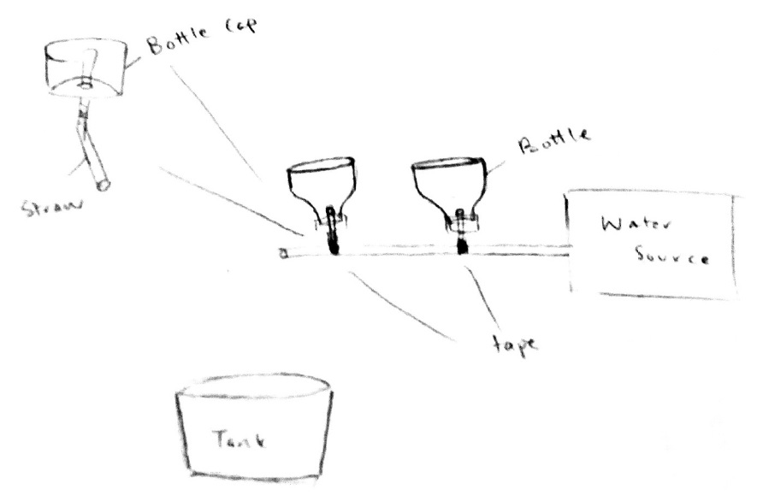
Figure 1. Prototype 1 design
To build our prototype we used scrap wood, straws, hot glue, and wooden sticks. The scrap wood was used as our base, the straws represented the piping system, hot glue was used to stick everything together, and the wooden sticks were used to provide support. The prototype holder was made using straws, hot glue, and an empty plastic bottle. The plastic bottle represents the holder and the straws was used to represent the piping system.

Prototype test plan

The purpose of the test is to ensure that the most crucial aspect of our system is running smoothly, which is the flow of the water through the system, that will be pumped by the air pump. We decided to test this aspect because it is the first step in building our full system. If we can learn about the flaws about the flow of the water of our system, then it will ensure us a functional system. This test leads us to the reason for building our prototype in the first place. The reason for which we are building a prototype is to ensure that the structure of our system is practical, that it is stable and able to stand on its own and it is possible to recreate in real life. Our prototype will be able to determine any major flaws in the design of the whole system. For example, the structure of our hydroponic system is made from horizontal pipes which will allow us to grow our plants vertically as to the traditional horizontal method. By making a conceptual prototype it allows us to determine whether growing plants vertically is possible by visually confirming whether the system is stable and effective at saving space and materials. The general objective of doing this test is learning about the flaws of our system, as mentioned above. By learning more about our system it will allow our group to fix the errors earlier and focus on other aspects of the system such as critical components, and aesthetics.

The specific test objectives are the water nutrient solution distribution and water nutrient solution maintenance. The objectives of the test is to determine if the water nutrient solution flows through each hole containing the plants, how often the user has to change the water, and how often the user needs to add nutrients to the water. These simple objectives will allow us to test the most vital aspect of our system.

What is being learned with this prototype is if the water flow can flow through each plant calmly. if we need another reservoir to calm the water before flowing through the roots of the plants. Also, we are learning how often the water should be changed or how much water we need to add to our system to run it calmly. We are also learning how often we need to add the plant nutrient and how much we are going to add.

The criteria for a successful test is that the water flows through the system calmly, at an average velocity, and allows the water to flow through each hole without overflowing or underflowing. The criteria for an unsuccessful test would occur when the flow of the water is too strong and it does not flow through each hole and/or it overflows.

The possible types of results from this test are: the system fails meaning the water flow is not adequate because it is either too strong or too slow to completely fill the holes; the system is not flowing any water and we are unable to determine the strength and speed of the water flow, meaning that is would be inconclusive; and finally, all goes well and the flow of the water is perfect and flows through every hole at the right speed.

These results will be used in the future to make the decision to add a water reservoir because if the flow of the water is too strong then by adding a water reservoir before the water flows through the holes of the plants will calm the water down so it won’t overflow the system or rip through the roots of the plants. These results will also be used to select concepts to change such as moving the position of the current water reservoir to a more suitable location like closer to the plant holes.

From a biological perspective, optimal concentration of nutrients and pH are required to maintain a favoured environment for plant growth. The concentration of nutrients and pH are dependent on the quantity of plants built on the pipe. This determines how much nutrients has to be added to the water tank. From an engineering perspective: a constant water flow and low pressure is required so the water will not damage the roots. Proper size and height of the water tank determines the number of pillars required to support the structure mechanically. Resistance of the water pipe and proper circumference and area of the opening in which the plants are built on is required for an effective system. From an economical perspective, labor cost, cost of material, and time are critical aspects that must be taken into consideration.

Flow rate meter can measure water flow pressure or we can use a simple method (bucket and a stopwatch) to measure the flow rate. Attach the pipe onto the spigot and see how long it takes to fill the tank. We can use the flow rate equation (flow rate= volume / time). Moreover, the content and pH of the nutrient solution can measured by a digital probe.

The materials that are required to make this prototype are drinking straws, thin wooden sticks, flat piece of wood and hot glue to mend all the materials to place. The cost as mentioned earlier is zero dollars since, we did not specifically buy any of the material for the project we used everyday household materials to build our prototype.

The results of this prototype is important for our next prototype as we will analyze the different components of the prototype.

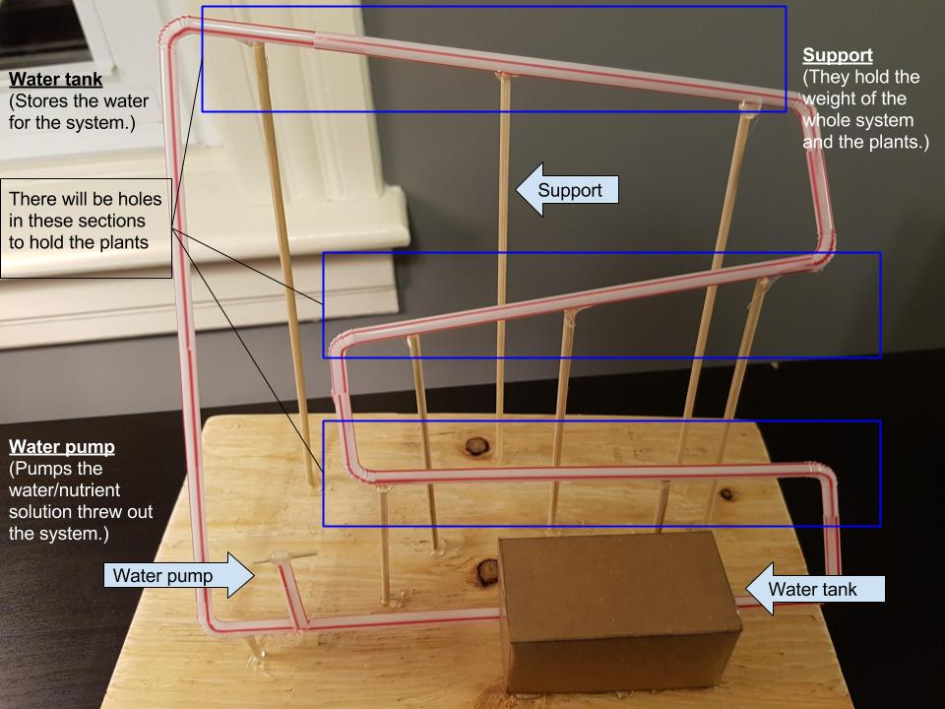
Figure 2.1. Prototype 1 Front View
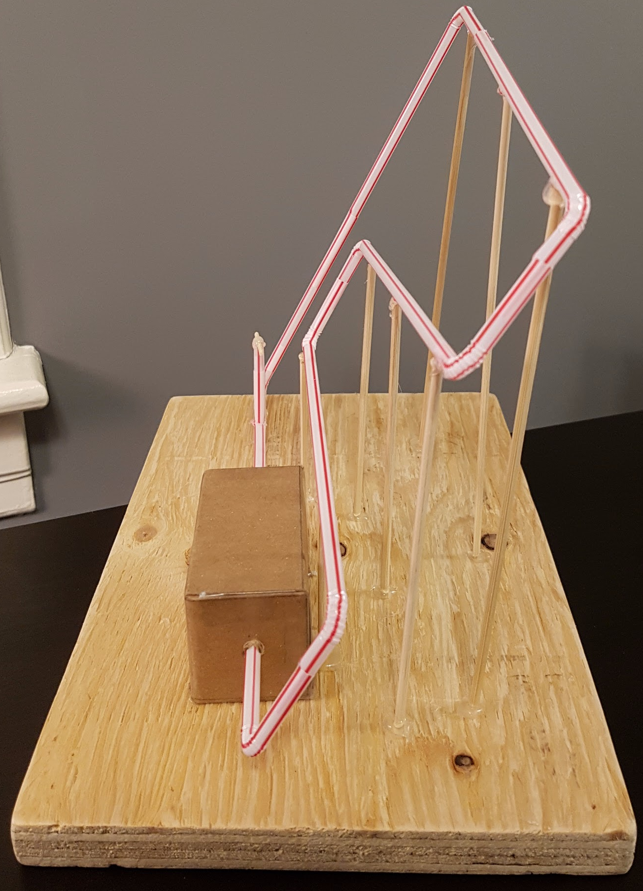
Figure 2.2. Prototype 1 Side View Figure 2.3. Prototype 1 Holder
Prototype analysis

The prototype is built from household materials because the purpose of this prototype was for understanding the concepts of our system and testing them. Since this prototype is built from household materials and we did not spend any money in purchasing the materials for this project. The main structure of the prototype is made from connecting drinking straws and using hot glue to connect them. Our first idea was to use plastic water bottles for the main structure of the system but then we came across the problem of how to bend the water bottles and then connect them, so we chose to use straws to make it simpler. Also, the air pump is built using straws because it is used for demonstration purposes such as demonstrating the location of the pump. We will be covering the air pump in depth in the upcoming deliverable. We used thin wooden sticks as support to hold the system up. We then glued everything to a wooden block for demonstration purposes. As a group, we decided to build a miniature, non-functional version of our system because it will allow us to determine if there are any major flaws with our system and we will be able to de-risk it.

Since our prototype is non-functional the possibility to make real life tests were not possible but as a group we have made the following assumptions to our prototype test. Without having prototyped the air pump, which we plan to prototype next, we assumed that the air pump is running properly which would allow the flow of water to run through the pipes of our system allowing the plants to feed on the water. The design of our system is to use the earth’s gravitational pull to aid the water flow cycle because the pipe from the air pump to the first plant is a vertical path (Figure 2.1) so the air pump would be the trigger of the flow allowing the water to flow to the top of the system then gravity would help the flow because our pipes are built at an 85 degree angle to the previous pipe allowing water to flow gently. It has come to our attention that a feedback we have received saying that the flow of the water may be too strong for the plants. So, we decided to add another water reservoir just before the water flows through the pipes containing the plants, to balance the speed of the water allowing a gentle flow. So, with that being said we assumed that our test was successful because the water would flow through each hole without overflowing after the addition of the water reservoir.

Feedback

We were able to find a potential customer and get feedback for our prototype. Our potential customer thought that our design was good and simple but could be improved. One concern was that pumping the water through the tubing could create a fast water flow which could damage the roots and the plants would be unable to absorb the nutrient solution. To prevent this, our prospect client suggested that we add a water reservoir at the top of our system. Water would be pumped into the reservoir and with an on/off valve we could let the water flow softly and at a constant rate from the reservoir. This option allows the user to have more control over the system and the user would not have to pump the water constantly.

The second suggestion was for the system to be able to grow plants from seeds and not saplings. If our system is capable of growing plants from seeds, it would make our system simpler and easier for the customer to use. Our current design does not allow this since the seed is too small for our holder. To fix this design flaw we are planning on testing a holder with growing media. The growing media will prevent the seed from falling out of the holder while also helping to distribute the nutrient solution.

The final comment was about the water/nutrient solution. The customer would like the nutrient solution to be easy to mix and easy to use. The steps for mixing are clear and precise as well as how often the water need to be changed, and how often do we need to add nutrients to the water. To implement this we will have the instructions on a sticker that will be placed on the finished product. To be able to make precise instructions we need to determine the capacity of our system which will only be found while doing prototype 3. The nutrient solution depends on the amount of water and how many plants. We will have complete, elaborate, clear, and simple instructions after testing prototype 3.

Reference to previous work

Looking back at the past deliverables, we followed the outline and schedule to a certain extent. However, we made minor changes to the predicted schedule in the past deliverable. Some tasks such as, building Prototype 1 did not take as much time as we expected. Similarly, another aspect such as the analysis of the critical components of the prototype required more time, group thoughts and effort.

Meanwhile, many of the functional requirements presented initially in the “Design Criteria” deliverable, such as the leak proof system, simplicity, and water/nutrient recyclability are present in this Prototype. Our prototype is leak proof due to the hot glue that seals the connections of the straws. Although in our final prototype we will not use hot glue, we will use a PVC adhesive which is a lot stronger. For the simplicity, our prototype is easy to use with very minimal instructions needed. Finally, our system can recycle the water/nutrient solution using the water pump to circulate the fluid.

Additionally, in our previous deliverable we stated that we needed the first prototype to have minimal costs while giving as many accurate concept visualizations as possible for our actual hydroponic system. The explanation behind this statement has been mentioned above.

What we need to do in the future

After completing our first prototype we identified improvements to our system, and improvements for our schedule. Those improvements include an additional water tank at the top of our system, a subsystem that will allow users to grow plants from seeds and simple and precise instructions to maintain the system.

Most of these improvements will be present in our final prototype and finished product. However, based on prototype 1 we have adjusted our schedule accordingly. We have allocated less time in putting together our prototype while increasing the prototype planning and analysis tasks.

The next step of our project is to make our second prototype. Our second prototype will be used to test a critical component of our system. This prototype will be used to test our pump. We will be testing if the pump will be able to bring water to the height of our system. This involves making a prototype plan to ensure that we spend our time effectively while building our prototype. Once the prototype will be completed we will then test it and analyze the results. We will also need feedback to find improvements that will make the user experience better. After the feedback has been acquired, we can identify what are the next steps to build our final prototype, which will be our final hydroponic system.

Conclusion

Our first prototype was a success. We were able to provide a proof of concept to show that it would be effective to grow plants, save space, and avoid the use of electricity. Also we were able to gather insightful information for improvement to our prototype. The most important aspect of the design for our potential user was the ease of use. For our system to be easier to use we are planning to implement the suggestions made by our prospective client such as, adding an additional water reservoir to decrease the velocity of the pumped water, improving our plant holders so they are capable of growing seeds as well as saplings, and lastly to provide instructions for maintaining the systems water/nutrient solution.

