PROJECT DELIVERABLE H:
PROTOTYPE III AND CUSTOMER FEEDBACK

Submitted by

Team D14

Cristie Kwan (300186315)

Fatmah Bayrli (300159193)

Bill Wu (300170086)

Michael Hetu (300209299)

Mashal Joyaa (300082650)

On

March 28th, 2021

Professor: David Knox
TA: Justine Boudreau
PM: Kaleb Mannion, Evelyn Wattenbarger

Introduction:

This deliverable is intended to summarize our final prototyping test plans and the results collected. The data that we have gathered through the prototype tests will apply to developing the prototype sequence. The tests performed gave us a better understanding of the prototype. By connecting the feedback received from our clients, we have justified and confirmed the functionality of several subsystems.

For the light subsystem, According to the feedback gathered from the previous prototype, the original LEDs that were selected to be used to line the outer shell of the device will remain unchanged, for these LEDs have proven to be able to light up an appropriate radius that is required for them. As well as this the bulb of each of these LEDs and the radius of the metal wires are of the appropriate size to the rest of the alarm case. They fit perfectly on the top of the box, are beautiful and uniform, do not take up too much space and are not just right. However, when the entire alarm is completely part of it, more tests will be conducted to further test the brightness, durability and functionality of the lamp.

The speaker that was used in the original prototype will be changed into another type of speaker. The one that will be replacing the current speaker will be a disc-like speaker and is around 40-50mm in diameter, which will be much more form-fitting than the original small cylindrical speaker used that acted as a basis. In addition to a shape and size that better fits the casing used for this test, it also happens to be able to produce more sound and runs on fewer watts. Further testing will be done with this test, checking on how much noise can be emitted, and perhaps check if this object could be heard behind a closed door in a separate room.

Changes and improvement based on the previous prototype

Based on the tests and results from our last prototype, the lights and speakers presented insufficient data as to our requirements. Due to this, the team has come up with new testing plans. Our final complete physical prototype includes a 3D printed cover, a speaker that reaches the required test levels and LEDs that complete the luminosity test. Since both the speaker and LEDs did not hit the range we aimed for, we decided to get a louder speaker and brighter LEDs for this prototype. The holes just outside of the walls of the 3D printed case are for M3 screws to mount on top of the drone.

One change that we made to this case is the separate speaker compartment. The separate compartment gives us a chance to hold the speakers in place, allowing the speaker to be right up to the external holes. This change makes the sound more amplified. From this placement, the electrical components can be wired in a more organized fashion, and the maintenance on the add-on can be easily accessed by the operator.

Prototype Testing Plan:
Table 1: The descriptions and test plans for our prototype

Test ID | Test Objective | Description of Prototype used and of Basic Test Method | Description of Results to be Recorded and how these results will be used | Estimated Test duration and planned start date
1 | Confirming that the sound subsystem performs as desired (44 dB at 2 m) | The prototype that we will use to test the sound subsystem for its performance abilities, will be the second prototype, and we will test the sound system’s alerts that are created. The audio will be attempted to be heard from different distances from the device, in order to get an understanding of how loud truly is relative to the environment. | The measured intensity of the sound, from increasing distance intervals, will be documented. This will serve to show the effectiveness of this subsystem in fulfilling its goal. | We plan on testing this on March 24th 2021 and will take approximately 30 minutes to test.
2 | Confirming that the light subsystem performs as desired (250 lumens in a dark room) | The prototype that we will use to test the sound subsystem for its performance abilities, will be the second prototype, and we will test the light system’s luminosity levels. We will observe the true luminosity of the naked eye in a darkened environment (mimicking night-time deliveries). | A test will be set up in a dark room, where the apparatus will be placed in the approximate centre and activated. The illumination of the LEDs on the walls will be measured in height from the ground up, to give a perspective on the luminosity of the LEDs. This will give a stronger indication of the abilities of the LEDs. | We plan on testing this on March 24th, and it will take approximately 30 minutes to test.
3 | Confirming that the 3D printed case performs as desired | Insert all components and verify that they fit. | Ensure all components fit appropriately, and all sections of the 3D-Printed case are compatible. | March 23rd when the 3D-Printed case is picked up, we can run this test. It is a quick 5-minute test.
4 | Weight Test | Measure the weight of our entire apparatus. | Confirm the weight of our apparatus. | March 28th when the entirety of the components for the prototype is gathered, we can run this test. It is a quick 5-minute test.

Uncertainty:

The key subsystem is the lighting and sound system. They are the main components and make up the entire prototype. Ensuring that all subsystems are functionally working is our goal. Checking the humidity and temperature of the area where JAMZ is flying gives us the idea of waterproofing, and we want to make sure to include it in the final prototype.

Stopping Criteria:

The stopping criteria helped us to acknowledge when to stop when our goal is achieved. To sufficiently meet the test objectives, we will check whether the LEDs and speakers to make sure they are working. Once we test the speaker at a distance of 2 meters, we get 44 dB, while the Led in a dark room gets 250 lumens we can conclude that the test target has been reached. Our goal weight is around 200 grams. Once the 3D printed case is waterproofed our final test is completed, and all objectives are reached.

Issues:

One issue we bumped into along the way of this prototype is printing the case. Initially, the top panel for the speaker component was too big. Since we did not have enough time to 3D print a secondary panel, the group came up with the solution to file and use temperature to our advantage to get the panel into the hole correctly.

Sound test:
Used Lux Light Meter app, Pixel 3XL light level sensor, indifferently lit rooms.

Table 2: The results of the sound test
Distance (m) | Recorded Average (dB)
0 | 78
1 | 67
2 | 64
5 | 56

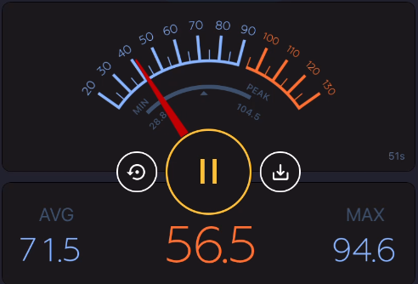

This test met our testing criteria and is considered successful. It also exceeded values of the previous test.

Luminosity test:
Used Lux Light Meter app, Pixel 3XL light level sensor, indifferently lit rooms.

Table 3: The results of the luminosity test to see how much light comes from our prototype
Room Brightness | Amount Light (lumen)
Lit Room + LED’s | 170
Lit Room | 20
Dark Room + LED’s | 260
Darkroom | 0.7

This test met our testing criteria and is considered successful. It also exceeded values of the previous test.

3D Printed Cover Test:
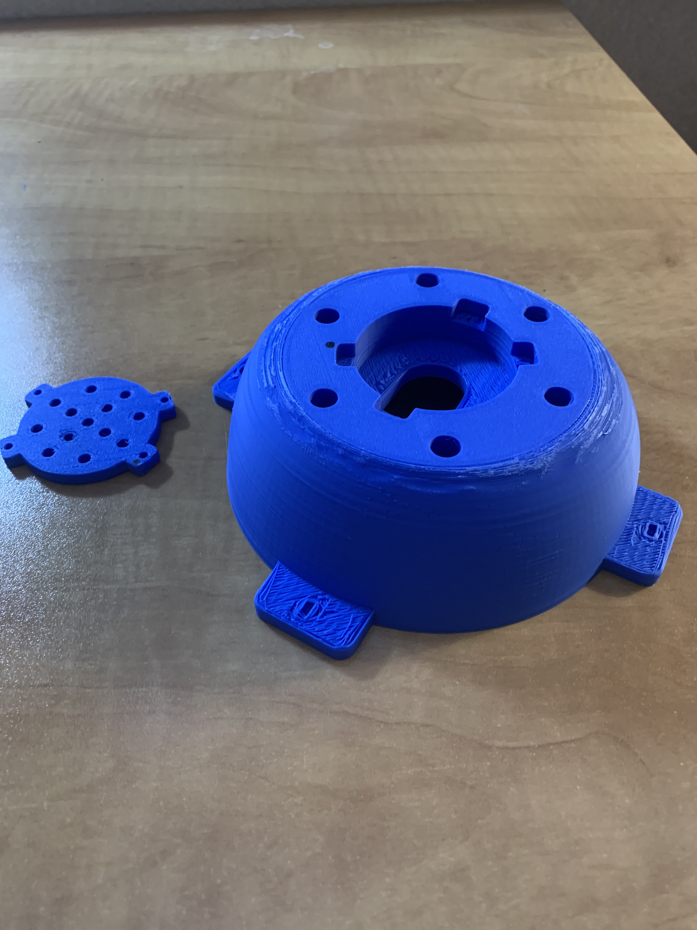
Figure 1: 3D printed Case of our prototype
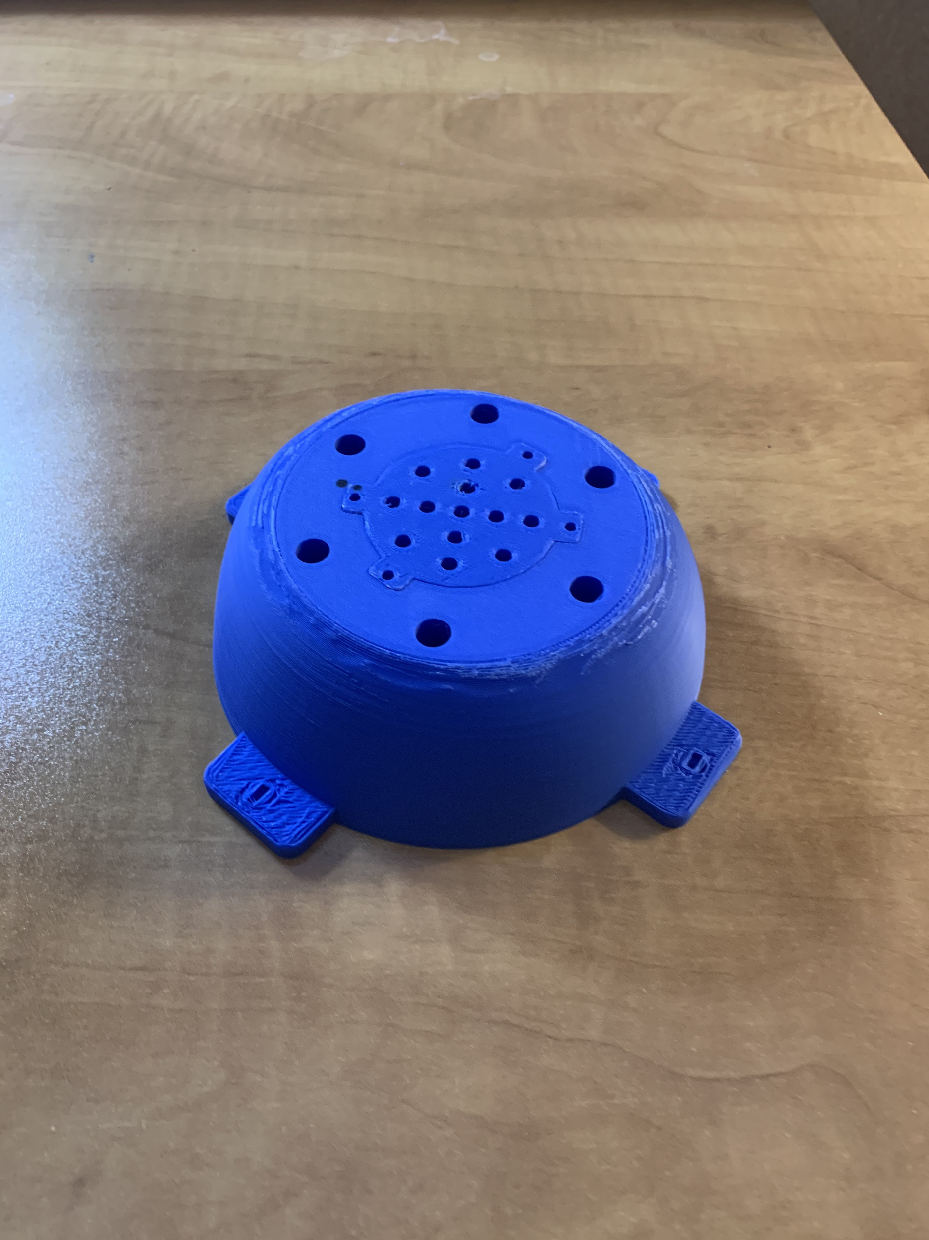
Figure 2: Another 3D printed Case of the final prototype
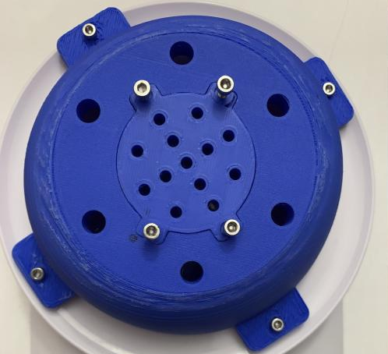
Figure 3: 3D printed Case included the Arduino inside and screws.

Weight:
Table 4: Weight of each part and total weight

Part (s) | Weight (g)
Arduino Uno | 22
3D printed case | 82
Speaker | 13
LEDs and Wires required | 10
Total: | 127

The total weight of 127g is much lighter than the weight limit of 1lb proposed by our customer.

Test summary:

Since this prototype has met all of the above testing criteria, the changes have been accepted and integrated into our final product. As this is the final prototype, there will be little to no changes implemented in the new few weeks leading up to the design day. The changes that are implemented will perfect the appearance and do not affect the software or data transfer.

Conclusion:

The purpose of this prototype is to improve our previous prototype, using this prototype to perfect each subsystem identified in the deliverable. This deliverable contains our final prototype and the results we obtained from the previous prototype, which tests the efficiency of the prototype's subsystem. We also included a project plan to evaluate our tasks to help us align with the rest of the tasks to create a fully functional and highly comprehensive final model of the product. To enforce the high standard in the final product, we will continue to test and improve until design day.

Appendix:
-Gantt Chart:
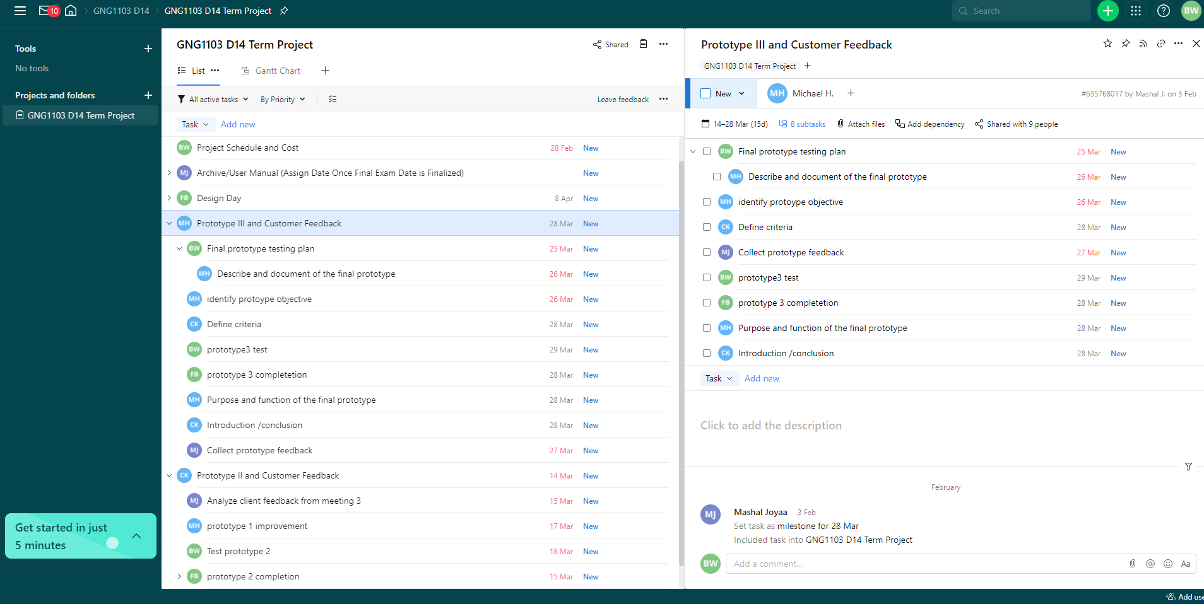
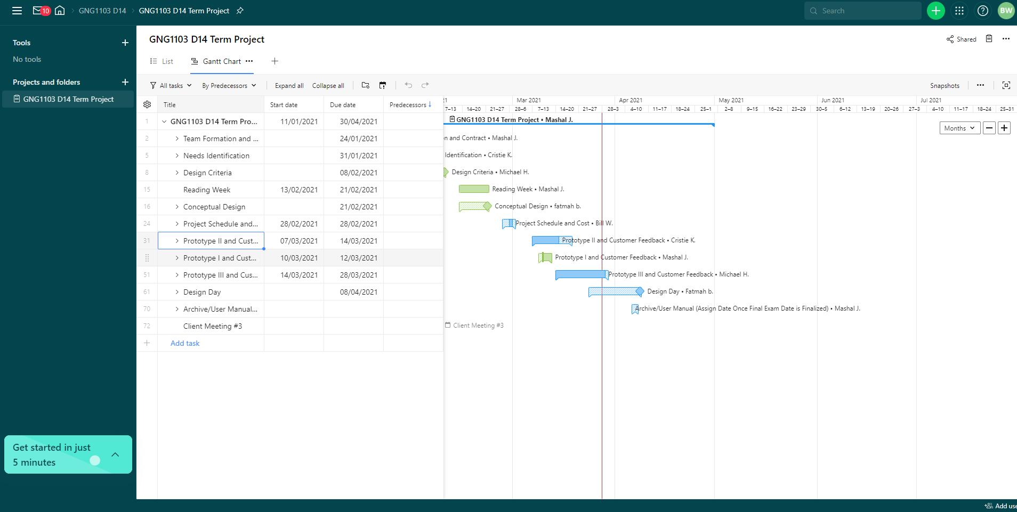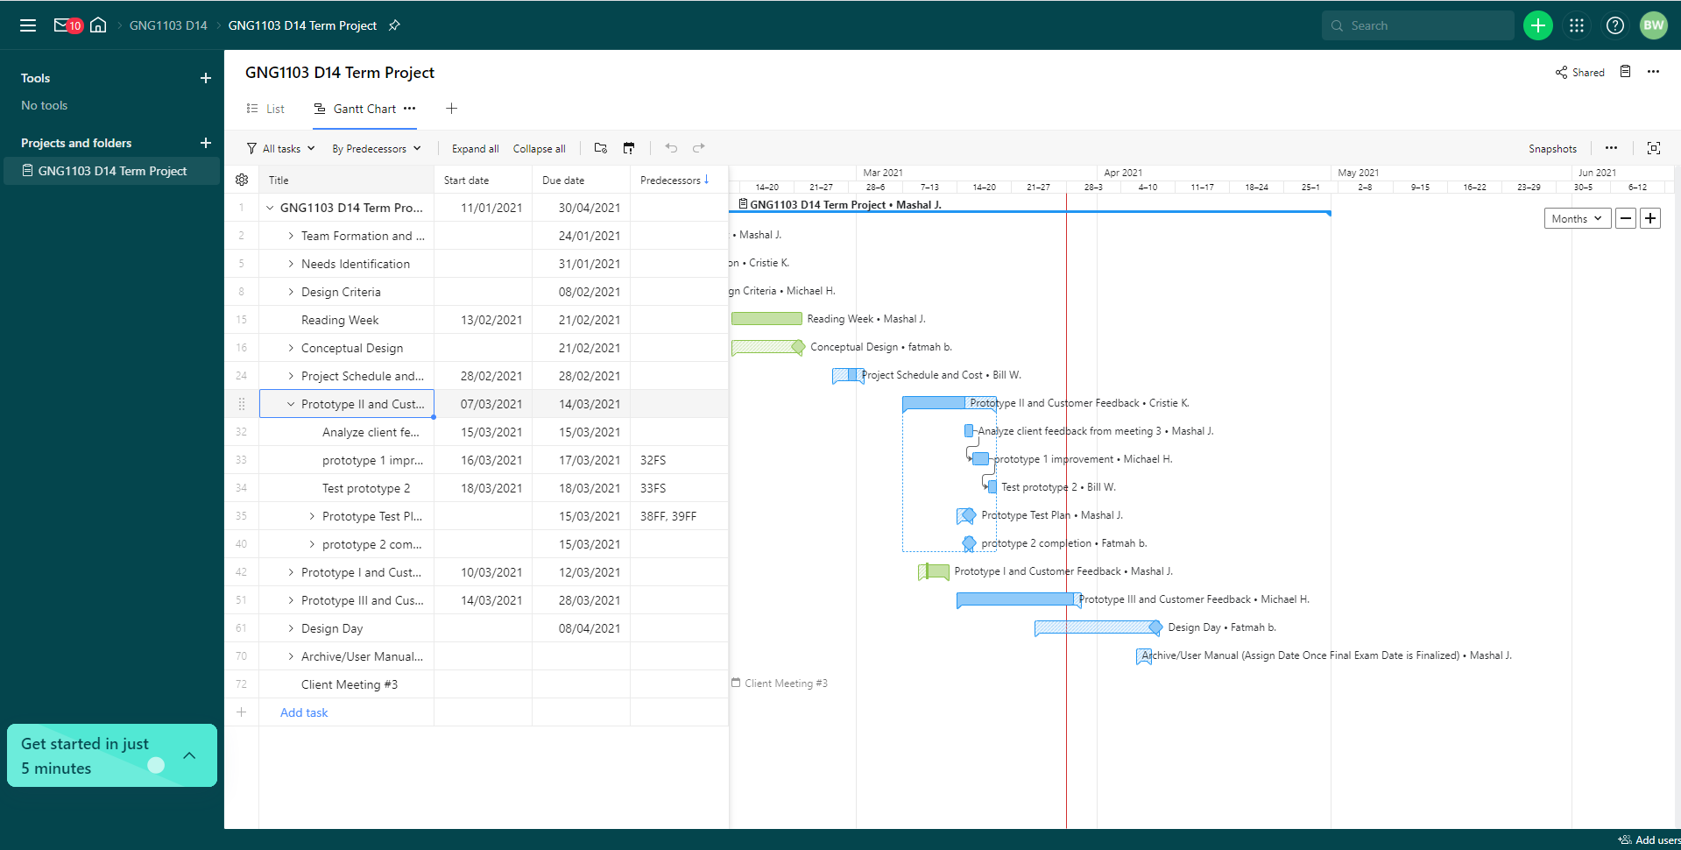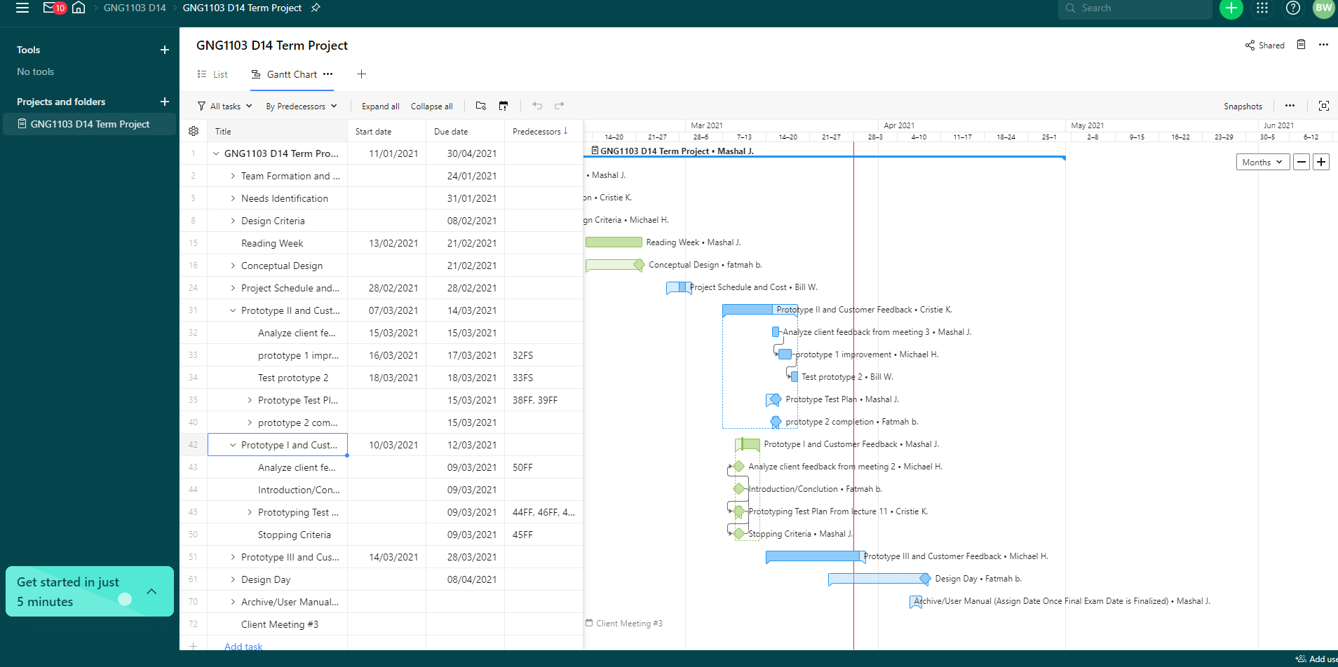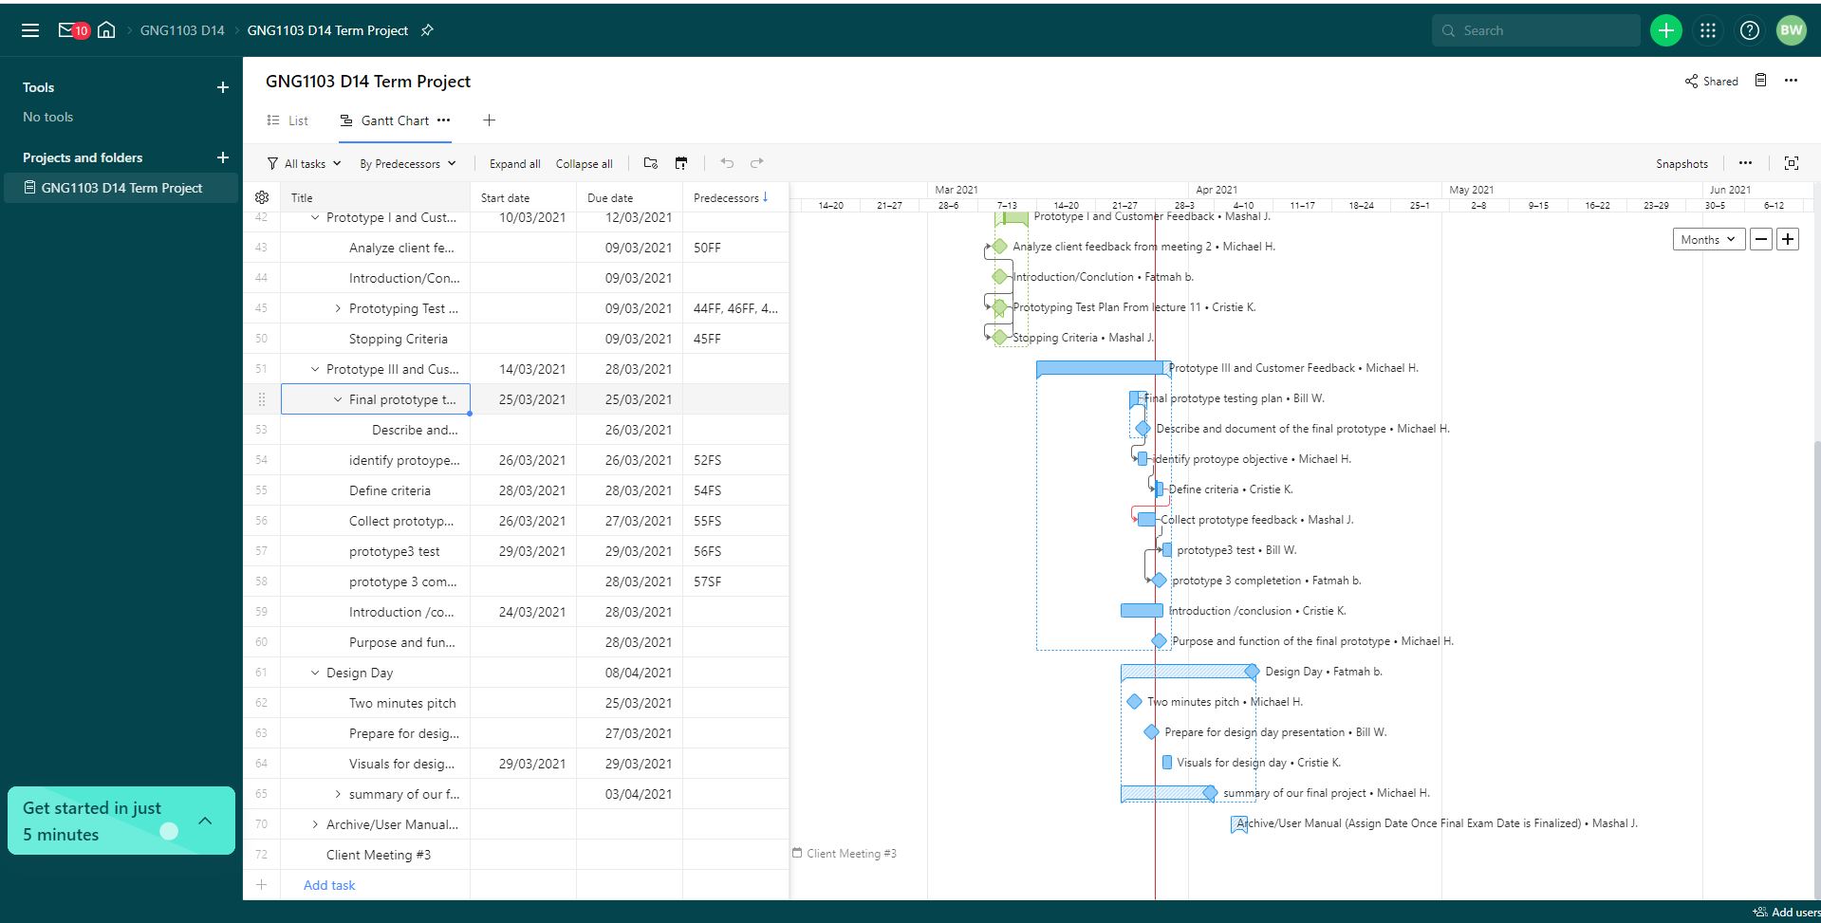

Here is our code for speaker-test :

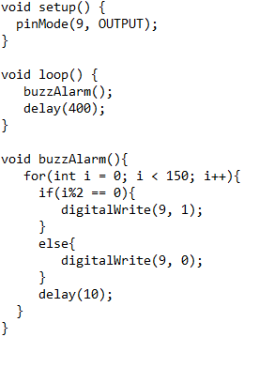

Here is our code for the LED-test:
