PROJECT DELIVERABLE G:
PROTOTYPE II AND CUSTOMER FEEDBACK

Submitted by

Team D14

Cristie Kwan (300186315)

Fatmah Bayrli (300159193)

Bill Wu (300170086)

Michael Hetu (300209299)

Mashal Joyaa (300082650)

On

March 14th, 2021

Professor: David Knox
TA: Justine Boudreau
PM: Kaleb Mannion, Evelyn Wattenbarger

Introduction:

This deliverable is intended to summarize the prototyping test plans and the results that are collected. The data that we have gathered through the prototype tests will apply to developing the prototype sequence. The tests executed give us a better understanding of our prototype. By connecting the feedback received from our clients, we have justified and confirmed the functionality of multiple subsystems. These subsystems include the speaker subsystem and the light subsystem.

Changes and Improvements:
The original prototype only had the sounds and lights that were emitted, with neither the speaker nor the LED is the same version of the final product, they are simply used to test if they could work for this alarm. This time we are implementing a protective shell that will house the Arduino, and the wires and allow the LEDs and the speaker to stick out to emit the noise and sound. The covering will be made of plastic that has been printed out by a 3D printer. Speakers from the prototype will also be switched out to a much larger one that will fit more snuggly into the plastic case to improve on the noise emission. Along with the speaker improved brighter LEDs will also be used for this. Both items will undergo the testing needed to verify that they have met the minimum requirements to properly fit the definition of an alarm. For example, the speakers will be tested if they can be heard from a certain distance and the LEDs will be tested on their brightness levels.
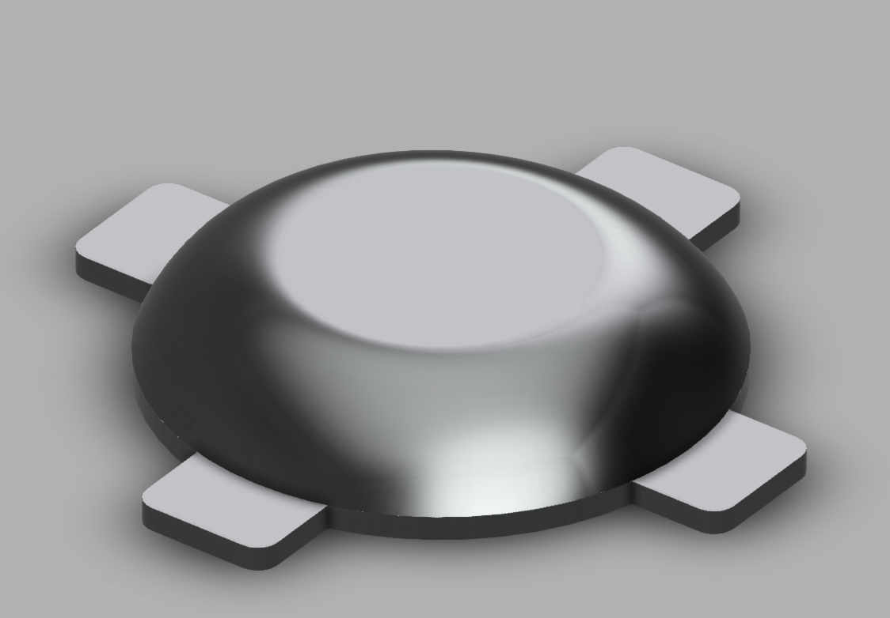
Figure 1: The beginning of the CAD model for the 3D printed case
Prototype Testing Plan:
Table 1: The descriptions and test plans for our prototype
Test ID | Test Objective | Description of Prototype used and of Basic Test Method | Description of Results to be Recorded and how these results will be used | Estimated Test duration and planned start date
1 | Confirming that the sound subsystem performs as desired | The prototype that we will use to test the sound subsystem for its performance abilities, will be the second prototype, and we will test the sound system’s alerts that are created. The audio will be attempted to be heard from different distances from the device, in order to get an understanding of how loud truly is relative to the environment. | The measured intensity of the sound, from increasing distance intervals, will be documented. This will serve to show the effectiveness of this subsystem in fulfilling its goal. | We plan on testing this on March 14th 2021 and will take approximately 30 minutes to test.
2 | Confirming that the light subsystem performs as desired | The prototype that we will use to test the sound subsystem for its performance abilities, will be the second prototype, and we will test the light system’s luminosity levels. We will observe the true luminosity to the naked eye in a darkened environment (mimicking night-time deliveries). | A test will be set up in a dark room, where the apparatus will be placed in the approximate centre and activated. The illumination of the LEDs on the walls will be measured in height from the ground up, to give a perspective on the luminosity of the LEDs. This will give a stronger indication of the abilities of the LEDs. | We plan on testing this on March 14th, and it will take approximately 30 minutes to test.

Uncertainty:
The critical subsystems are the lights and sound system. They are the main components and make up the entire add-on. Without these working subsystems, the add-on is rendered useless. An additional feature that is not as important as waterproofing. The add-on can be complete without the waterproofing component but out of the final client meeting, the group decided that this additional feature would be an asset to the add-on. Looking into the humidity and temperature of the areas that JAMZ is flying around gave us an idea of what our add-on would need to face.

Stopping Criteria:
The stopping criteria helped us to acknowledge when to stop when our goal is achieved. To sufficiently meet the test objectives, we will check whether the LEDs and speakers to make sure they are working properly. Once we test the speaker at a distance of 2 meters, we get 44 dB, while the Led in a dark room gets 250 lumens we can conclude that the test target has been reached.
Sound test:
Used Decibel X app, Pixel 3XL microphone, at different distances. Recorded average decibel value. Photos could not be taken due to the fact that the phone was used to measure the decibel values.

Table 2: The results of the sound test
Distance (m) | Recorded Average (dB)
0 | 55
1 | 44
2 | 40
5 | 35
Ambient sound level: 30db
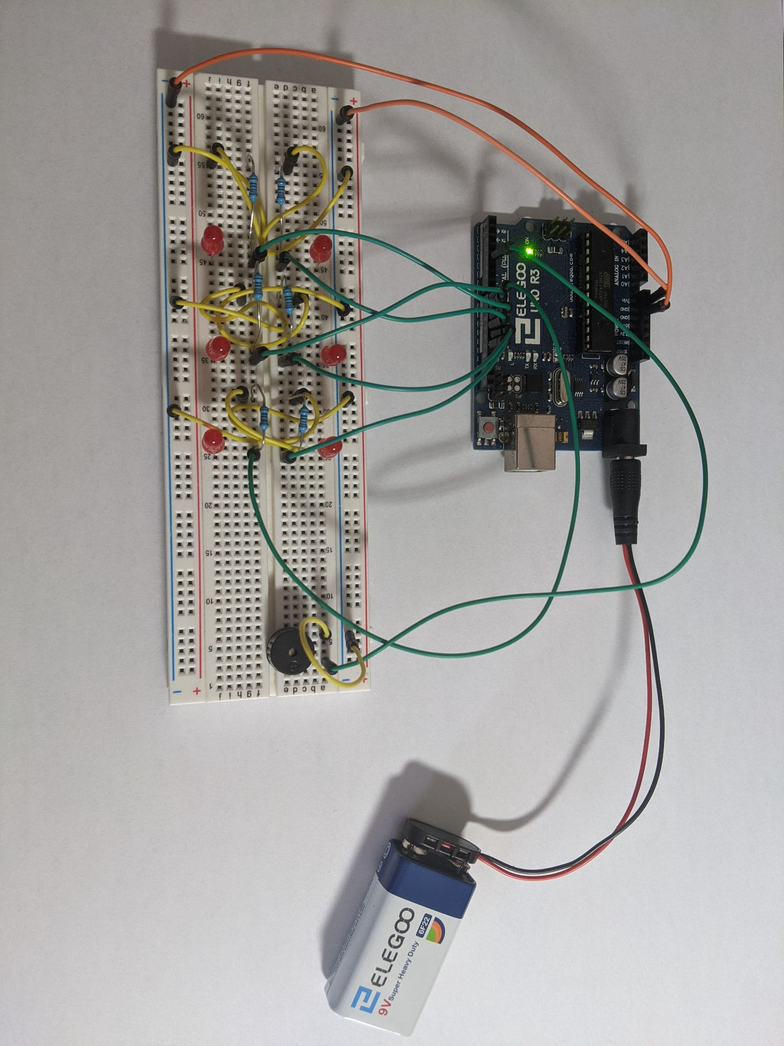
Figure 2: Prototype set up for the sound test
Luminosity test:
Used Lux Light Meter app, Pixel 3XL light level sensor, indifferently lit rooms.

Table 3: The results of the luminosity test to see how much light comes from our prototype
Room Brightness | Amount Light (lumen)
Lit Room + LED’s | 145
Lit Room | 10
Dark Room + LED’s | 190
Dark room | 0.3

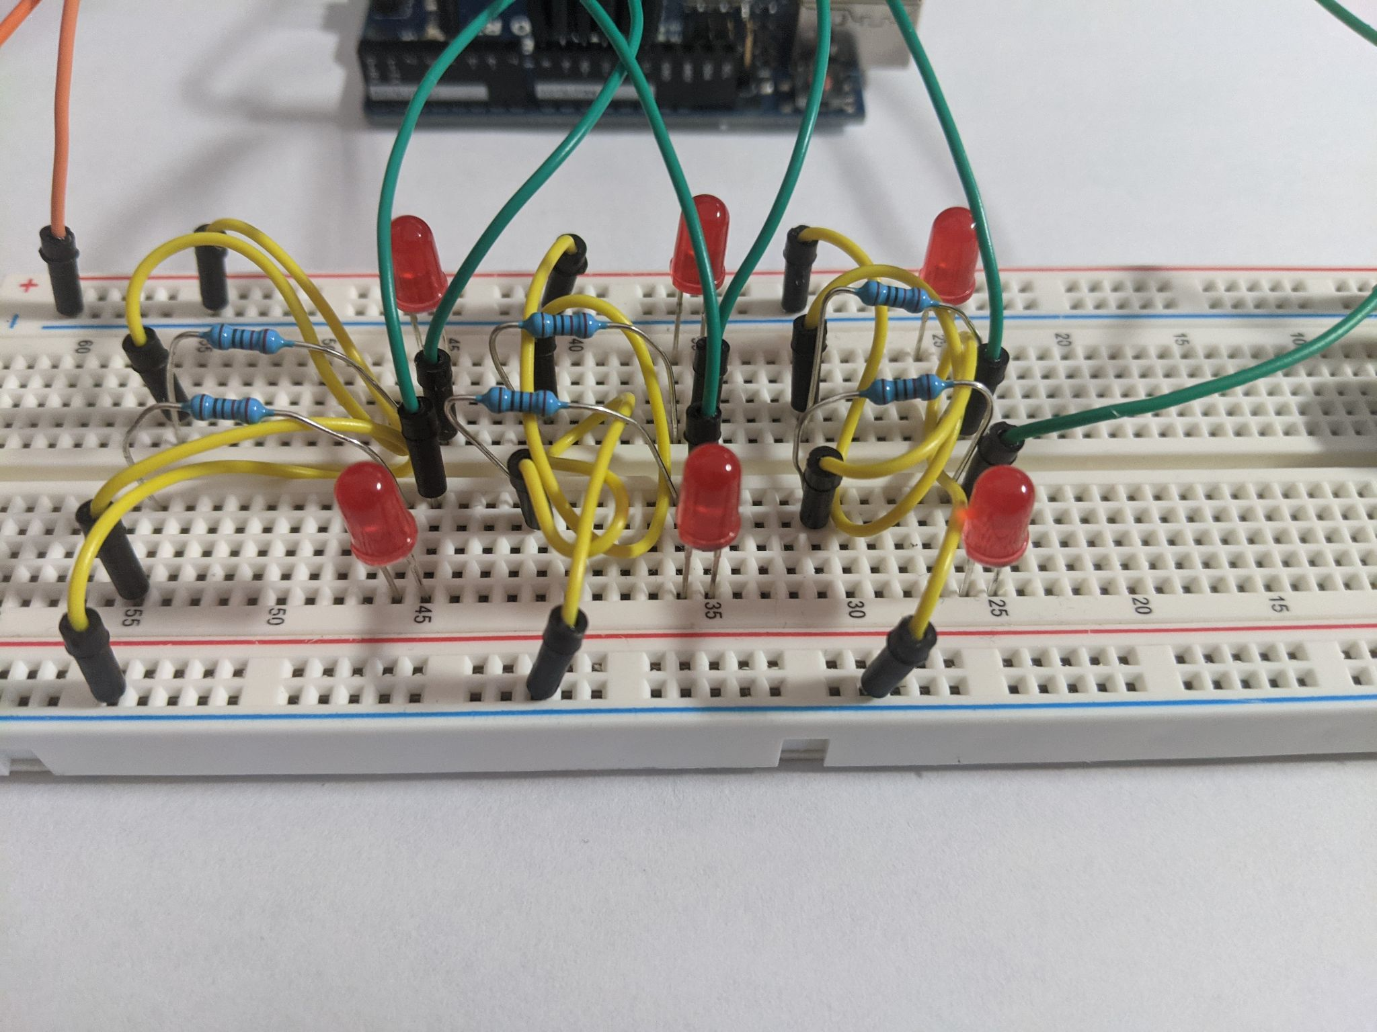
Figure 3: The prototype test with lights off
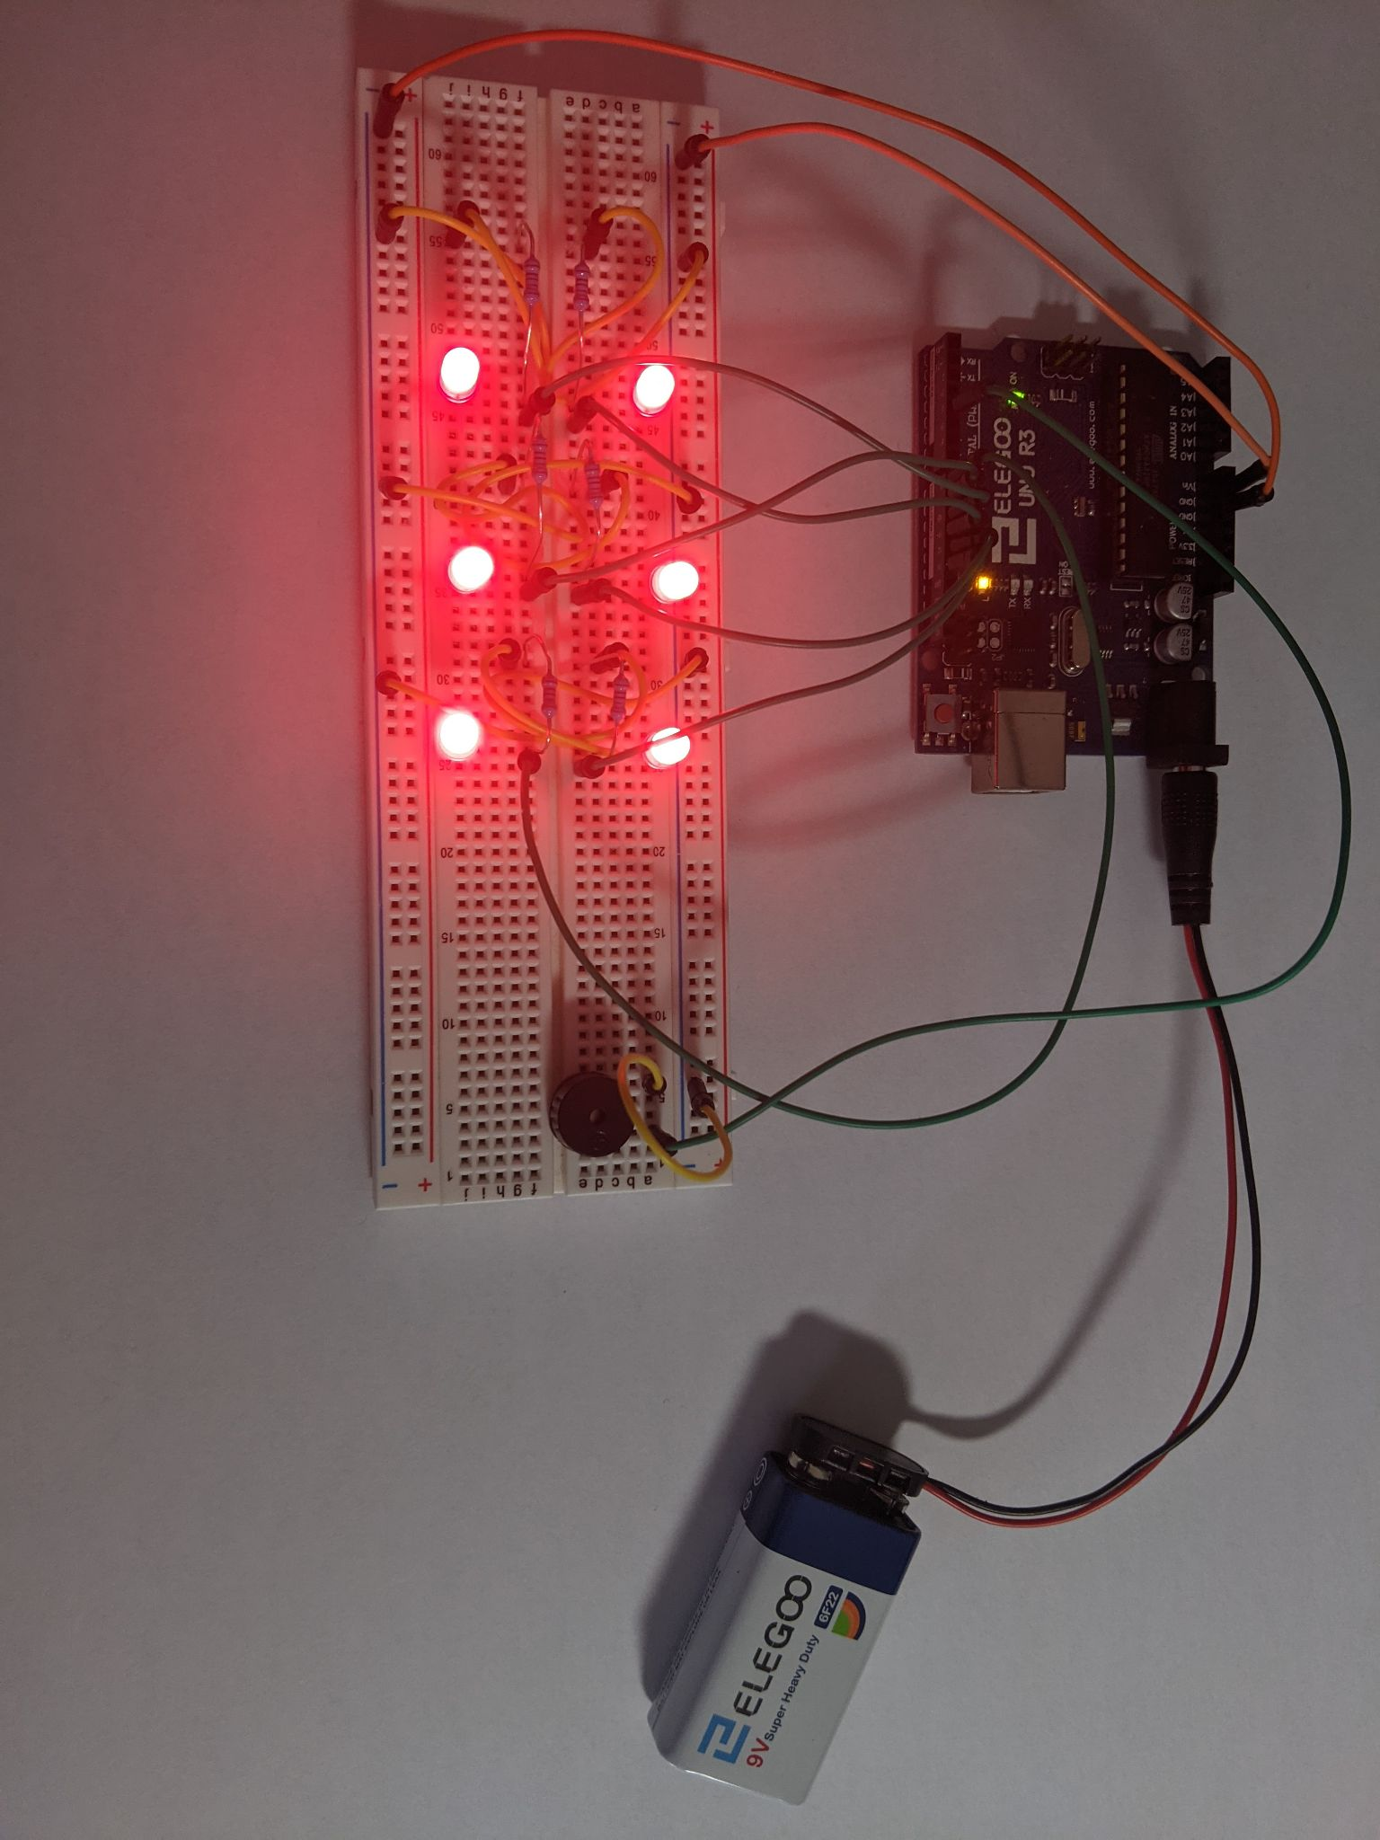
Figure 4: The prototype test with lights on

Test summary:
To summarize our test results, the prototype did not meet our stopping criteria. In this case, we need to improvise and explore how to reach the goals for the next prototype in order for it to reach or surpass the stopping criteria. Overall the test results were close enough to make small changes, and the overall prototype worked without issues

Client Feedback :
On Friday, March 12th, 2021, we met with our clients once again. We presented a 2-minute pitch of our solution, and all functioning prototypes up to that date and received client feedback afterwards. Our clients praised our development, and advancement of our solution. The client appreciated the new direction of the enclosure design, as it meets all their design criteria. There was no material feedback provided, as they proclaimed that we are on the right path in developing our solution, and important points they emphasized to us in previous meetings (making the case of the solution more aerodynamic friendly) we managed to accomplish in the prototype + design concept that was presented in this client meeting. They affirmed that the updated “dome” design we created was exactly what they were looking for and that our projected final solution is exactly what JAMZ needs from us.

Conclusion:
The purpose of this prototype is to improve our previous prototype using the customer feedback we provided to us when we showed our first prototype to the customer. This deliverable contains our second prototype and our results and development results we obtained from the previous prototype and test table were used to test the efficiency of the prototype's subsystem. We also include a project plan to evaluate our tasks to help us align with the rest of the tasks to create a fully functional and highly comprehensive final model of the product.

Appendix:
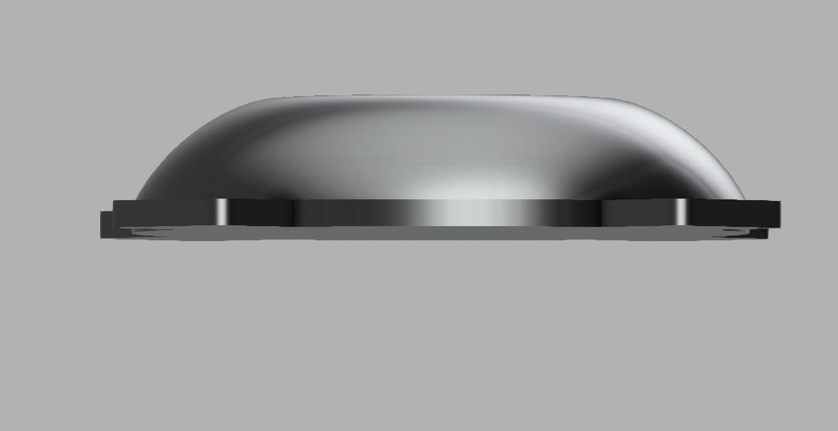
Figure 5 : Additional View of CAD
Code:
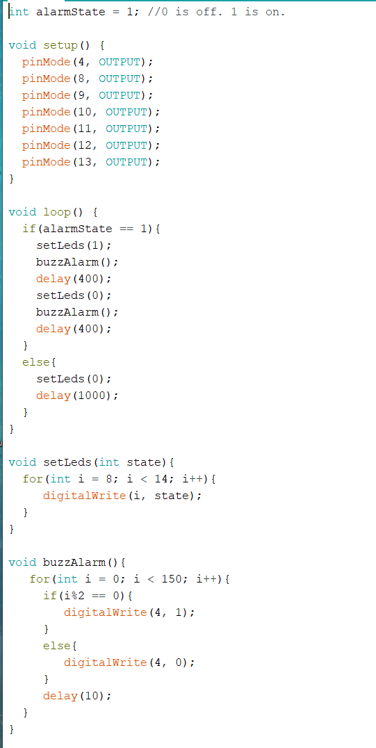
Figure 6: Code for testing the prototype

