PROJECT DELIVERABLE E:
PROJECT PLAN AND COST ESTIMATE

Submitted by

Team D14

Cristie Kwan (300186315)

Fatmah Bayrli (300159193)

Bill Wu (300170086)

Michael Hetu (300209299)

Mashal Joyaa (300082650)

On

February 28th, 2021

Professor: David Knox
TA: Justine Boudreau
PM: Kaleb Mannion, Evelyn Wattenbarger

Introduction :
In this deliverable, we outline a schedule for the development of our project plan. The following document includes prototyping and testing the solution based on our client’s needs and design criteria. As a team, we focus on the design appearance and function so the prototype can build according to the client's expectations. The first model will represent the basic concept and should cost very little from the project budget. The second prototype should represent an analytical subsystem to prove whether our design will work or not. Finally, the third prototype will provide the customers with a comprehensive description of our solution. This document will focus on the estimate of the cost and the modules used in the design. Cost management is one of the important factors of our project results. Ensuring that we plan according to the budget is a prerequisite. Cost management will allow us to make full use of our resources, make critical decisions about projects and hazards.

Project scheduling:

Hardware
- Cad model based on concept
- 3D Print case
- Gather all the components
- Assemble components
Software
- Create wiring diagram, define all pins and connections
- Create function controlling lights in an alarm state
- Create function controlling speaker in alarm state
- Create functions which will interpret GPS coordinates and set an alarm state based on them
- Create a function which will be able to receive an alarm state from the drone
- Create a function that will continuously feed the state of the module to the drone
Task list :

Task ID | Task Description | Estimated Duration (Days) | Member(s) | Dependencies
1 | Client meeting 3 | 0 | All
2 | Project Deliverable F | 7 | All | 3,4,5
3 | Analyze client feedback from meeting 2 | 2 | FB
4 | Proof of concept | 2 | CK, MJ
5 | Prototype testing plan and results | 2 | BW, MH
6 | Prototype 1 completion | 0 | All | 1,2,3,4,5
7 | Project Deliverable G | 7 | All | 8,9,10,11
8 | Analyze client feedback from meeting 3 | 1 | MJ
9 | Prototype 1 Improvements | 2 | MH
10 | Test prototype 2 | 2 | MH, FB
11 | Client prototype feedback | 3 | CK
12 | Prototype 2 completion | 0 | All | 7,8,9,10,11
13 | Client meet 4 | 0 | All
14 | Project Deliverable H | 7 | All | 15,16,17,18
15 | Final prototype testing plan | 2 | BW
16 | Identify prototype objectives | 1 | MH
17 | Define Criteria | 1 | CK
18 | Collect prototype feedback | 1 | MJ
19 | Prototype 3 Test | 2 | FB, BW | 13,14,15,16,17,18
20 | Prototype 3 completion | 1 | All | 14,15,16,17,18,19
21 | Project Deliverable I | 7 | All | 22,23,24,25
22 | Two minute Pitch | 2 | MJ, MH
23 | Prepare for design day presentation | 4 | All
24 | Visuals for design day | 2 | CK, FB, BW
25 | Summary | 1 | MJ
26 | Design day | 0 | All | 21,22,23,24,25
27 | Project Deliverable J | 7 | All | 28,29,30,31
28 | Prepare project summary | 2 | BW
29 | Summarize chosen concept | 1 | FB
30 | Trials lessons | 1 | CK
31 | Prepare for Presentation | 3 | All
32 | Final Presentation | 0 | All | 27
33 | Project Deliverable K | 7 | All | 34
34 | Complete project document | 7 | All

Light Cost :

 | Jackey Awesome Car Strobe Light | Super Bright LED LIGHT BAR | Yandu LED Road Flares | Adafruit Super Bright Red
Price | $20.99 USD | $34.99 CAD | $30.99 CAD | $8.00 CAD
Number of LED’s | 1 LED | 60-light LED light bar | 4 pack of LEDS | 25 pack of LED lights
Visability | White & Red Emergency Colours |  | Very strong visibility from the light produced by the beacons | Good illumination from the LEDs
Feature | - 3 suction cups for screen mount  - 18 different flashing modes  - On/Off Button, select pattern button | - 10k hours of average life | - Multiple flashing modes  - Have multiple intensity settings | N/A
Size | 9 x 5 x 3 inches | 49.6 x 8.4 x 5.4 cm; | 3.5cm diameter | 5mm (size works with our design)
Weight | 1 lb | 453.59 Grams | 170g weight

Jackey Awesome Car 16-led 18 Flashing Mode Emergency Vehicle Dash Warning Strobe Flash Light (Red & White)
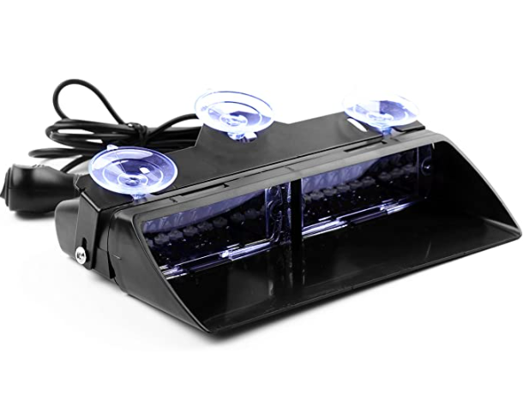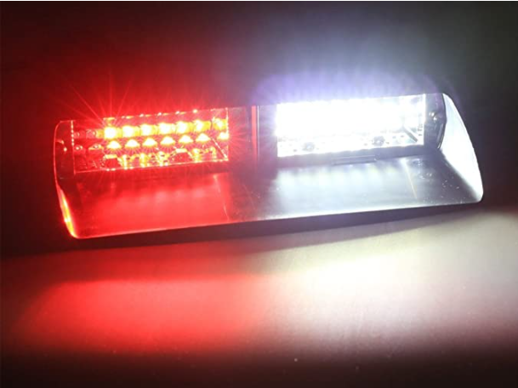

Super Bright LED LIGHT BAR , Rechargeable, Portable, SOS Emergency Light, 60 LED Light Bar, 2 Brightness Modes, 720 Lumen Output, With Kickstand and Carry Handle
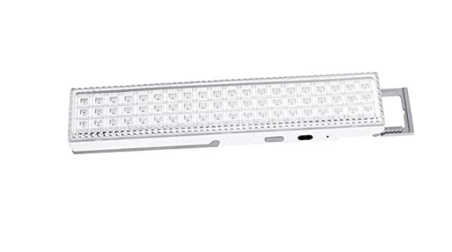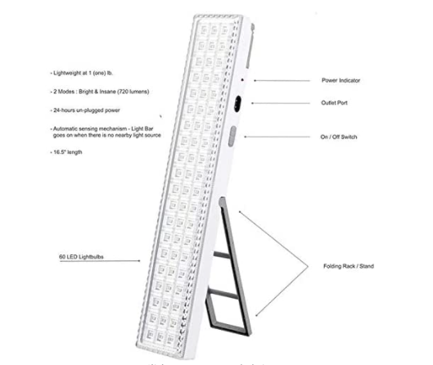

Yandu LED Road Flares (4 Pack) Emergency Beacon Safety Flare Flashing Warning Light for Car Truck Boat with Hook and Magnetic Base (4 Pack)

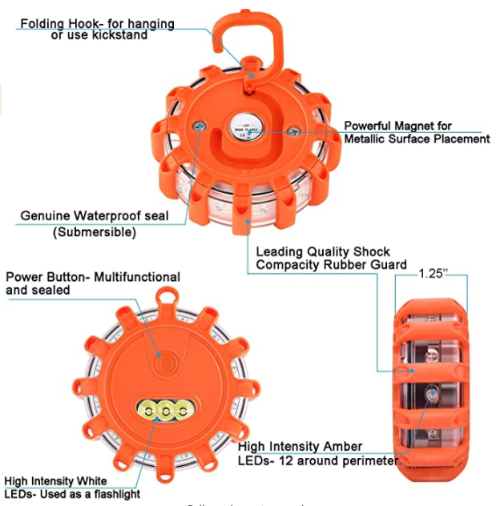

Adafruit Super Bright Red 5mm LED (25 pack)

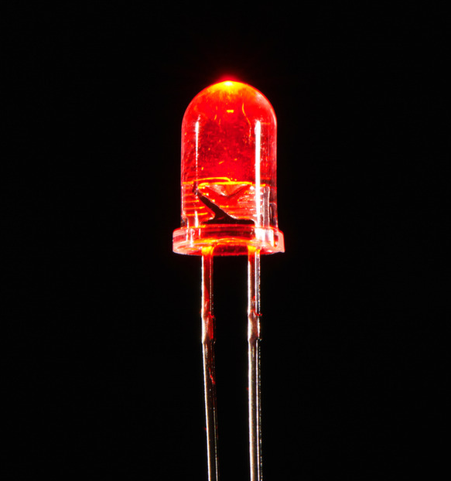
Speakers:
 | USB Powered Speakers | Speaker - 3" Diameter - 8 Ohm 1 Watt | Mini Oval Speaker | Mono Enclosed Speaker - 3W 4 Ohm | Speaker - 40mm Diameter - 4 Ohm 3 Watt | Mini Metal Speaker w/ Wires - 8 ohm 0.5W
Price | $9.95 | $1.95 | $1.95 | $3.95 | $4.95 | $1.95
Frequency Response | 70 Hz - 20 KHz | N/A | N/A | N/A | N/A | 600-10KHz
Power | 5VDC 1A peak(max) | N/A | N/A | N/A | N/A | N/A
Dimensions | 63mm x 90mm x 111mm / 2.5" x 3.5" x 4.4" | 77.8mm x 77.8mm x 25.49 / 3.06" x 3.06" x 1" | 30 x 20 x 5mm | 30mm x 70mm x 17mm / 1.2" x 2.8" x .7" | 40mm x 20mm | Diameter: 28mm  Height: 4.5mm
Weight | N/A | 50.48g | 1.4g | 26.4g | 27.3g | 6g
Amount | 2 each | 1 | 1 | 1 | 1 | 1
Ohms and watts | 4 Ohm. 3 watts each | 8 ohms, 1 watt | 8 ohm, 1 watt | 3W 4 Ohm | 4 Ohm 3 Watt | 8 ohm 0.5W

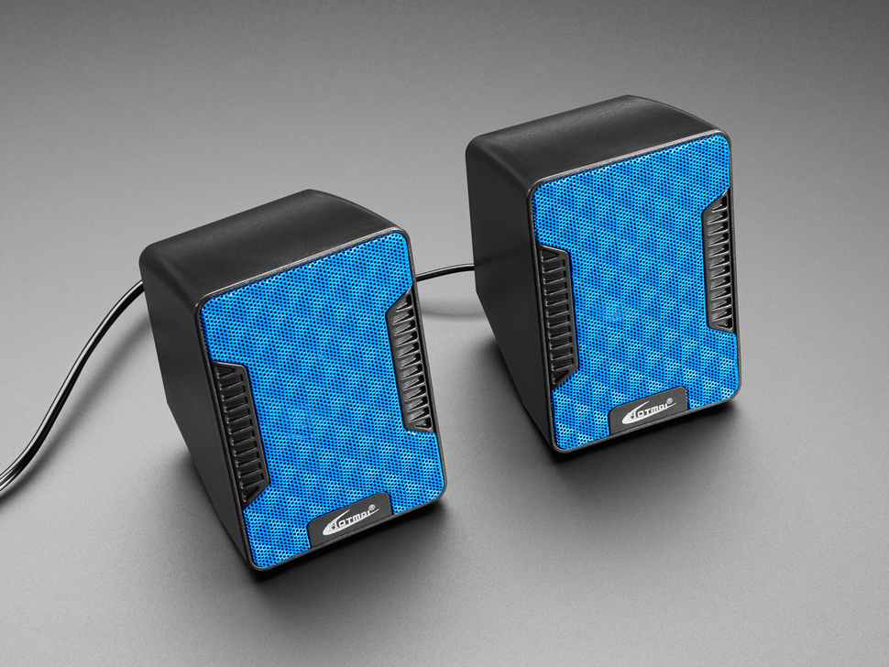
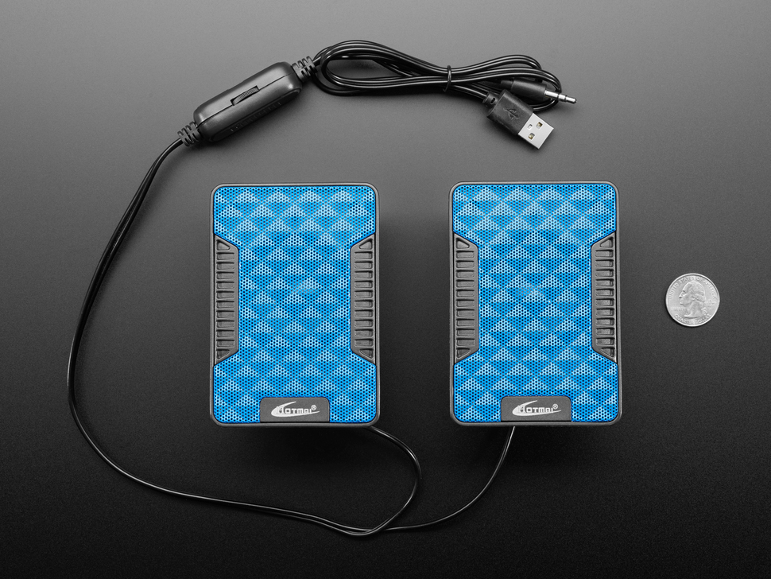
USB Powered Speakers:

Speaker - 3" Diameter - 8 Ohm 1 Watt

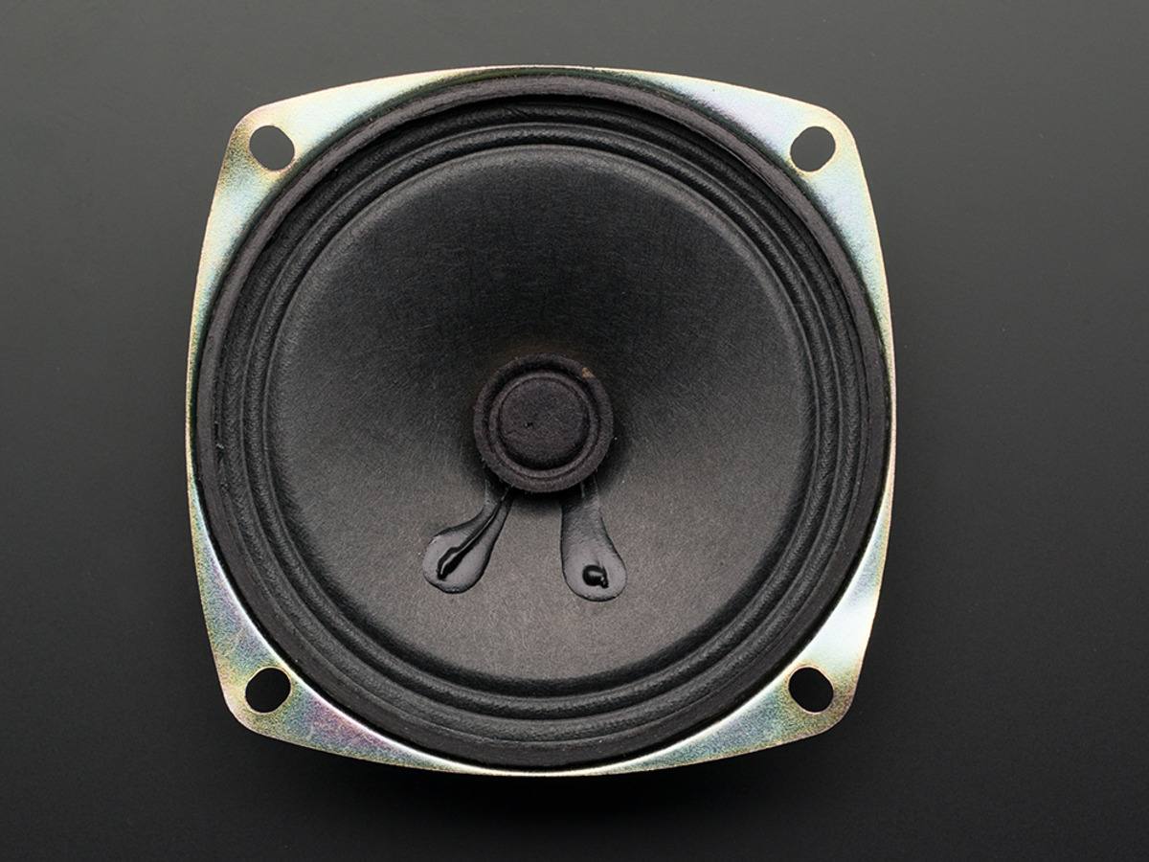
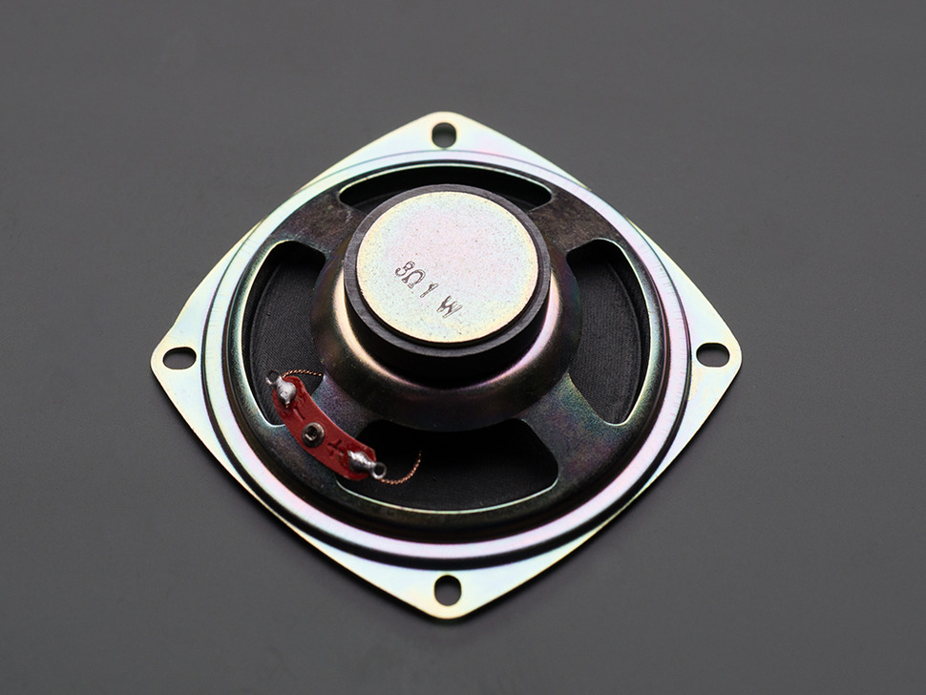
Mini Oval Speaker
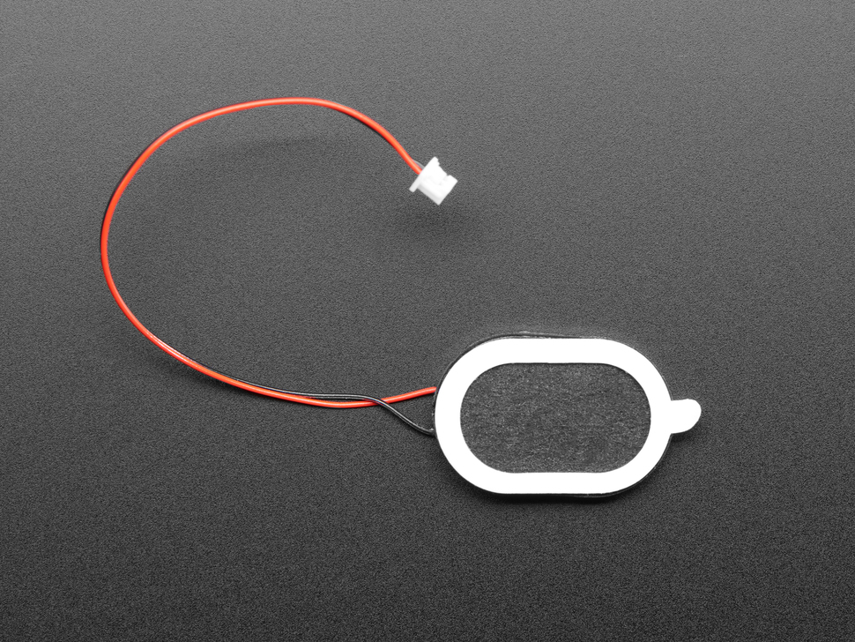
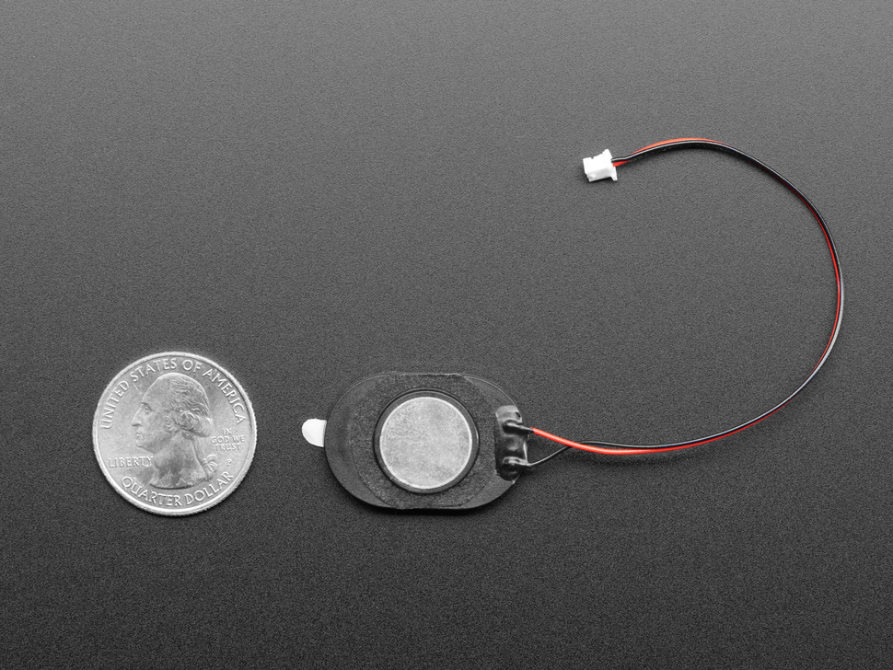

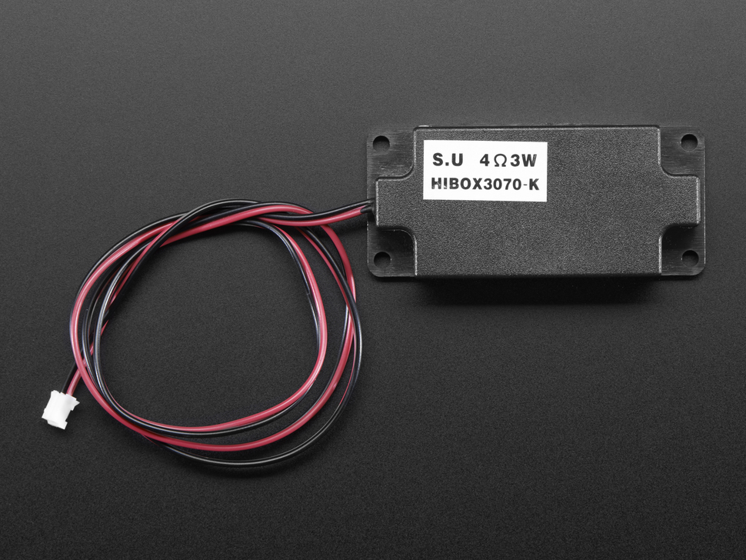
Mono Enclosed Speaker - 3W 4 Ohm
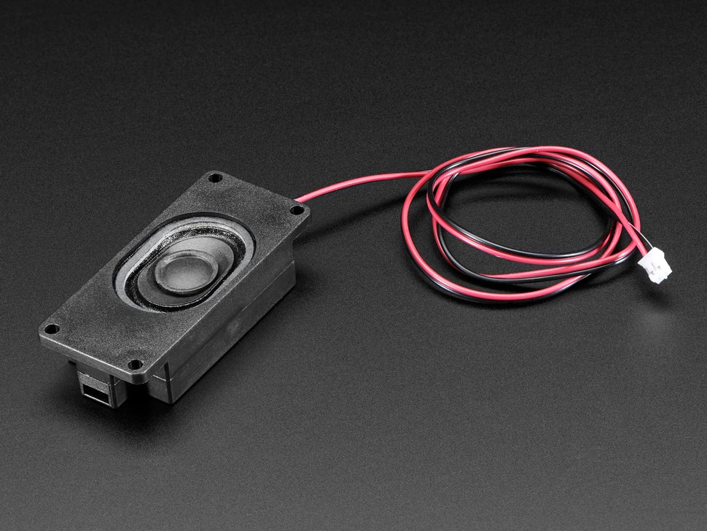

Mini Metal Speaker w/ Wires - 8 ohm 0.5W
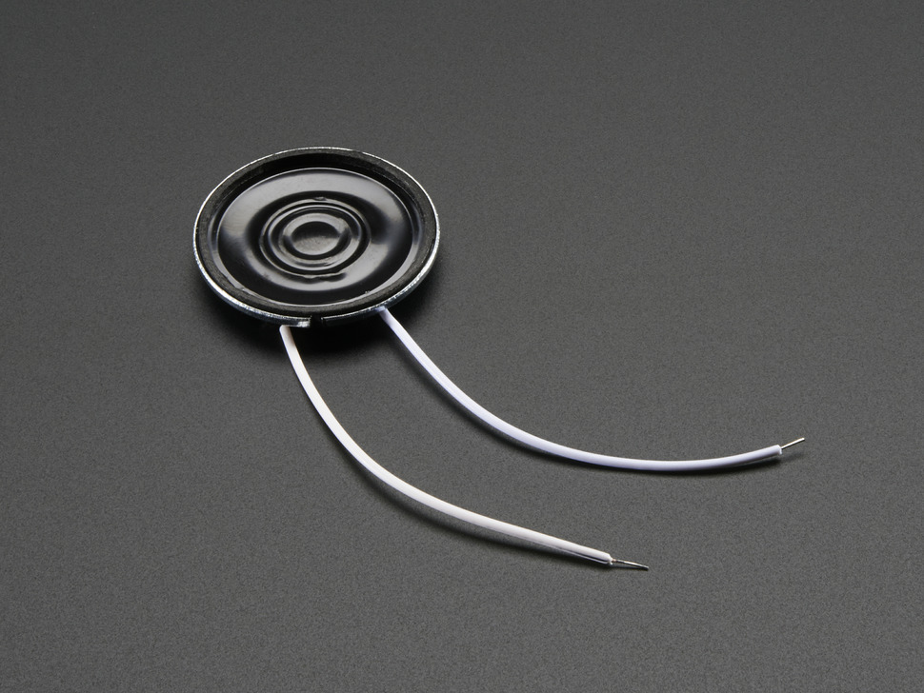
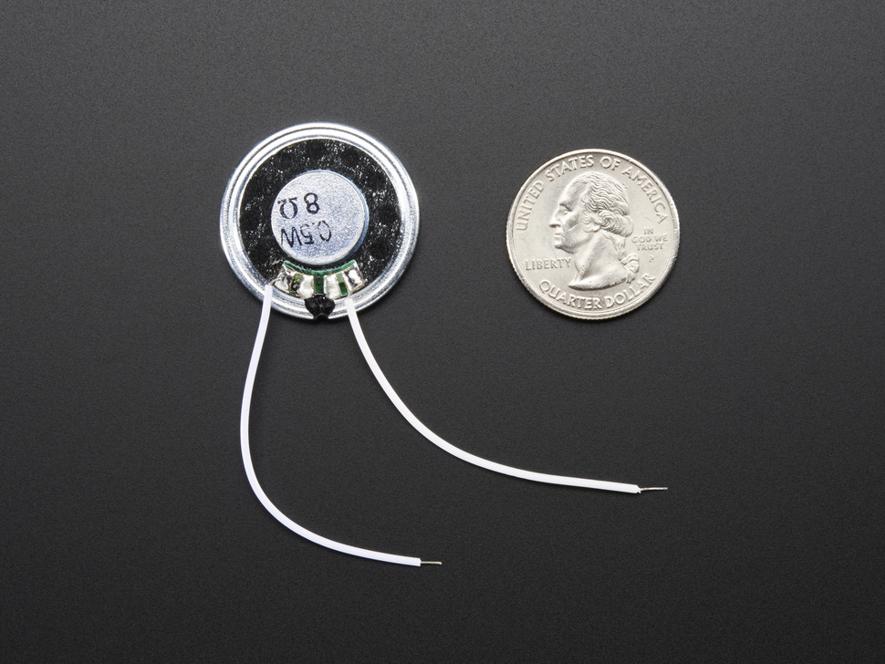
Hardware | Cost ($) | Quantity | Total Amount ($) | Link to the product
Arduino Uno | 0 | 5 | 0 | https://store.arduino.cc/usa/arduino-uno-rev3
Lights | 8/25 | 6 | 8 | https://www.adafruit.com/product/297
Speaker | 4.95 | 1 | 3.95 | https://www.adafruit.com/product/3968
3D printed case | 0 | 1 | 0 | N/A
Screws for mounting | 0.62/3 | 12 | 2.48 | https://www.homedepot.com/p/Everbilt-M3-0-5-x-10-mm-Plain-Metric-Socket-Cap-Screw-3-Piece-per-Bag-803188/204808024
Laptop | 0 | 5 | 0 | N/A
Wires | 10.99/120 | 50 | 10.99 | https://www.amazon.ca/120pcs-Multicolored-Breadboard-Arduino-raspberry/dp/B01LZF1ZSZ/ref=sr_1_9?dchild=1&keywords=arduino+wires&qid=1614540473&sr=8-9
LED holder | 0.95/5 | 6 | 1.9 | https://www.adafruit.com/product/2174
Insulating Glue | 8.28 | 1 | 8.28 | https://www.amazon.ca/Gorilla-4200602-Epoxy/dp/B07W6C9R4K/ref=asc_df_B07W6C9R4K/?tag=googleshopc0c-20&linkCode=df0&hvadid=335341764197&hvpos=&hvnetw=g&hvrand=15351581759843887137&hvpone=&hvptwo=&hvqmt=&hvdev=c&hvdvcmdl=&hvlocint=&hvlocphy=9001363&hvtargid=pla-835452876955&psc=1
Waterproof speaker mesh | 13.59/1.7m x 0.5m | 1 | 13.59 | https://www.amazon.com/Eboxer-Speaker-Protector-Waterproof-Protective/dp/B07LCMTMP6
Total: |  |  | 49.19

Software | Cost ($) | Quantity | Total Amount ($) | Link to the product
3D modeling software | 0 |  | 0 | https://www.blender.org/
C++ Programing IDE | 0 | 1 | 0 | N/A
Fusion 360 | 0 | 5 | 0 | https://www.autodesk.com/products/fusion-360/overview?term=1-YEAR&support=null
Total |  |  | 0

Project Risks and Contingency Plans:

We may encounter some problems when developing our prototype. One of the main risks is that we may not be able to complete all planned tasks within the set deadline. If this occurs, we will make a priority list and work on the highest priority tasks to get them done promptly. Another risk is that our code may not work to avoid this problem, we can test our code multiple times before. A large risk that can occur is if our materials do not come in on time, there is not much we can do if this scenario occurs, but if it does we can consider ordering new pieces.

Conclusion:

This document provides a comprehensive description of our planned strategy for the three models until the design day on which our final prototype will be presented. In addition to the established schedule, we also indicated the material schedule, which demonstrates the cost of the design. In this deliverable, we focused on developing the model based on previous customer meeting feedback and the concept of our progress in deliverable D.

References:
Https://www.adafruit.com/product/1363. (n.d.).
Industries, A. (n.d.). Speaker - 3" diameter - 8 ohm 1 watt. Retrieved February 28, 2021, from https://www.adafruit.com/product/1313
Industries, A. (n.d.). Mini oval speaker - 8 ohm 1 watt. Retrieved February 28, 2021, from https://www.adafruit.com/product/3923
Industries, A. (n.d.). Mono enclosed speaker - 3W 4 ohm. Retrieved February 28, 2021, from https://www.adafruit.com/product/3351
Industries, A. (n.d.). Mini metal SPEAKER W/ wires - 8 ohm 0.5W. Retrieved February 28, 2021, from https://www.adafruit.com/product/1890
Generic-Flashing-Emergency-Vehicle-Warning. (n.d.). Retrieved February 28, 2021, from https://www.amazon.com/Generic-Flashing-Emergency-Vehicle-Warning/dp/B00CPGGZNS
https://www.amazon.ca/ZCO-Rechargeable-Emergency-Brightness-Kickstand/dp/B0849TH5X7/ref=sr_1_39?dchild=1&keywords=emergency+lights&qid=1614384189&sr=8-39
Yandu led Road Flares (4 Pack) emergency Beacon SAFETY FLARE flashing warning light for CAR Truck boat with hook and magnetic base (4 PACK), SAFETY kits - Amazon Canada. (n.d.). Retrieved February 28, 2021, from https://www.amazon.ca/Yandu-Emergency-Flashing-Warning-Magnetic/dp/B081W7YDQY/ref=sr_1_8?dchild=1&keywords=emergency%2BLED%2Blights&qid=1614384437&sr=8-8
Industries, A. (n.d.). Super bright Red 5mm LED (25 pack). Retrieved February 28, 2021, from https://www.adafruit.com/product/297

