BUSINESS MODEL
DELIVERABLE F

GNG2101
Group B33
Oct.22nd, 2020

Business Model
Our business model is a direct sales business model. This means that our company, or some representatives, are responsible for selling directly to intended clients. This also means that our product is less likely to end up on retail shelves like those of Best-Buy or Walmart, but rather just being sold online or directly to consumers. The reason that this business model is ideal for us is due to the fact that the demand for our product to the general public is quite low as the majority of the population is not blind or visually impared. On the other hand, we believe that the demand for our product to our target market (those who are blind/visually impared) is quite high and thus will be targeting them much more intensely. To put it in perspective, if our product was indeed sold at a large retailer like Walmart, it would be very unlikely that an average customer who is not visually impaired will buy our products, seeing as they would have no use for it and thus just wasting money. Without a fixed retail location, our plan based on the business model would be to target organizations and companies that work with the blind as much as possible in order to advertise and sell our product as effectively as possible.

Canvas
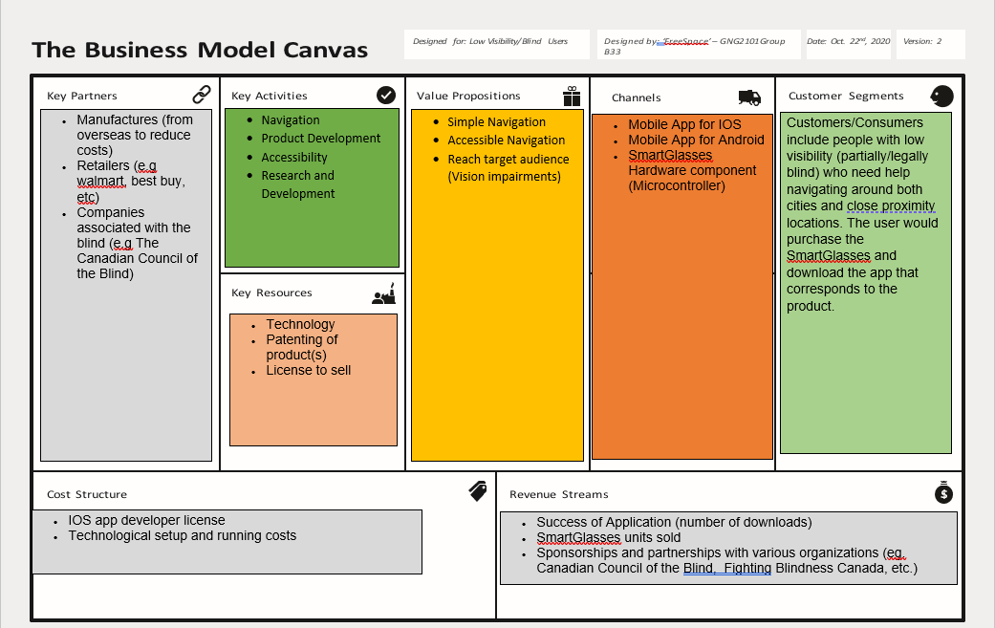

Key Partners:
- Manufactures (from overseas to reduce costs)
- Retailers (e.g walmart, best buy, etc)
- Companies associated with the blind (e.g The Canadian Council of the Blind)

Key Activities:
- Navigation
- Product development
- Accessibility
- Research and Development

Key Resources:
- Technology
- Patenting of product(s)
- License to sell

Value Proposition:
- Simple and accessible navigation
- Reach target audience (Vision impairments)

Channels:
- Mobile App for IOS
- Mobile App for Android
- SmartGlasses Hardware component (Microcontroller)

Customer Segments:
Customers/Consumers include people with low visibility (partially/legally blind) who need help navigating around both cities and close proximity locations. The user would purchase the SmartGlasses and download the app that corresponds to the product.

Cost Structure:
- IOS app developer license
- Technological setup and running costs

Revenue Streams:
- Success of Application (number of downloads)
- SmartGlasses units sold
- Sponsorships and partnerships with various organizations (eg. Canadian Council of the Blind, Fighting Blindness Canada, etc.)

Core Assumptions
- We will be an ethical and environmental company
- We will be making a navigation device
- We will develop future products
- We will produce our own product
- We will use a one time purchase system
- We will provide high quality products to our customers

Feasibility
The feasibility of the core assumption can help develop future goals, and improve your company. Since being an ethical and environmental company does not have a direct effect on our products quality. Therefore the feasibility is low. Developing future products, producing our own products, and one time purchase system, all have beneficial effects on sales. New products are more in demand, and the one time purchase system allows for higher device price, but lower app downloads. Based on this analysis we can say that this market is feasible.

