DELIVERABLE G - PROTOTYPE 2

Introduction to Product Development and Management for Engineers and Computer Scientists

GNG2101B

Team B33
Student Number |  | Name
300135914 |  | Josh Kang
300108328 |  | Mathias Urdanivia
300127888 |  | Zachery Nott
300138540 |  | akif ahmed

Date Submitted: July 4, 2020
Professor Mana Azarm
TA: Samuel Ezekiel
PM: Madeleine

Faculty of Engineering
Department of Mechanical Engineering
2020

Table of Contents

Table of Contents 2
Summary of Client Meet 4 3
Application Prototype Performance 4

Summary of Client Meet 4
- Prefer a sound system that allows users to still be able to hear their surroundings, vibrations would be ideal but our focus is on sounds for directing
- Another future development is be obstacle detection
- Would enjoy the ability to hear the word “left” if a left turn is upcoming but a buzz or specific sound to indicate a different signal such as there is an obstacle ahead or assuring you are on the right path (voice for direction, sounds for other)
- Different tones and different vibrations would be ideal, as long as it works for most people
- For app, ease of use so only need to enter destination
- Client requested modes that determines the feedback that the glasses give, for example just the directions, just the obstacle directions, etc
- Directions are not required to say the entire long direction, simply saying the direction of the turn is enough.
- Lighter sound for far obstacles, louder sounds for closer

Application Prototype Performance
The FreeSpace application is intended to gather both the destination and the location of the user, either via text or speech, and output the route, directions, and estimated time until the destination is reached. The information is then sent out to the microcontroller which delivers the directions to the user via bone conduction and audio, which will guide the user to their desired destination. The goal of this app is to make it accessible, and to avoid blocking out peripheral noise (so that the user can be aware of their surroundings while using the product).
Currently, the application is missing (and planning to add), the following:
- Estimated time until destination option
- Bluetooth connectivity with microcontroller
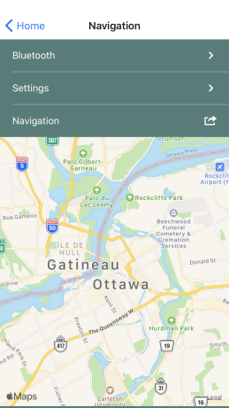
- Control panel/full settings tab
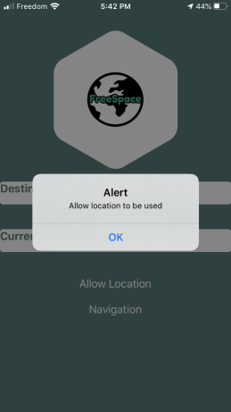
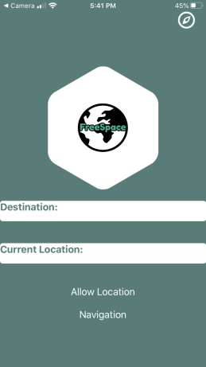

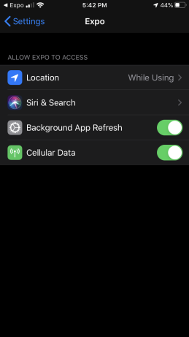

Software (Arduino coding) Prototype:
The software aspect of this prototype comes with certain challenges which have to do with the process of development. What we mean by this is that it can sometimes be hard to develop software when there is no real physical item that we can test it on. In this case, the development of our more comprehensive prototypes have begun, but are not yet able to fully be tested with code. As a result, we have developed a very structured model for the coding of the arduino microcontroller, such that it satisfies the requirements set out by the clients. These requirements have been previously stated, but the ones that are directly associated with this aspect of the prototype include the ability to receive data from our phone app, process such information, and then send out a signal to the glasses. In this case, our data will be retrieved in numerical values and the code includes many serial input functions. This data will now be processed by the microcontroller and, depending on the values, will determine whether to indicate a turn (if turn is equal or less than a specific distance) to the user from the bone conduction speakers. A basic rough draft of this idea can be seen here: 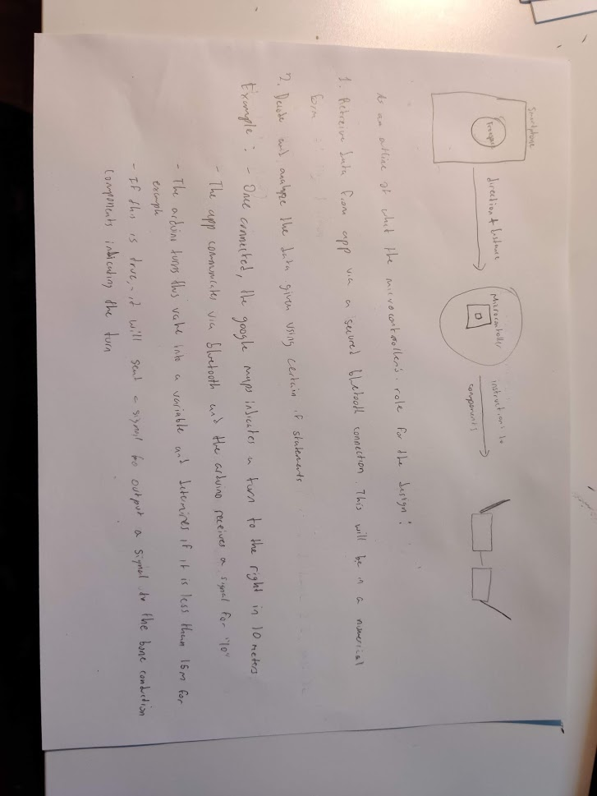

A sample of the code structure that will be used can also be found here:
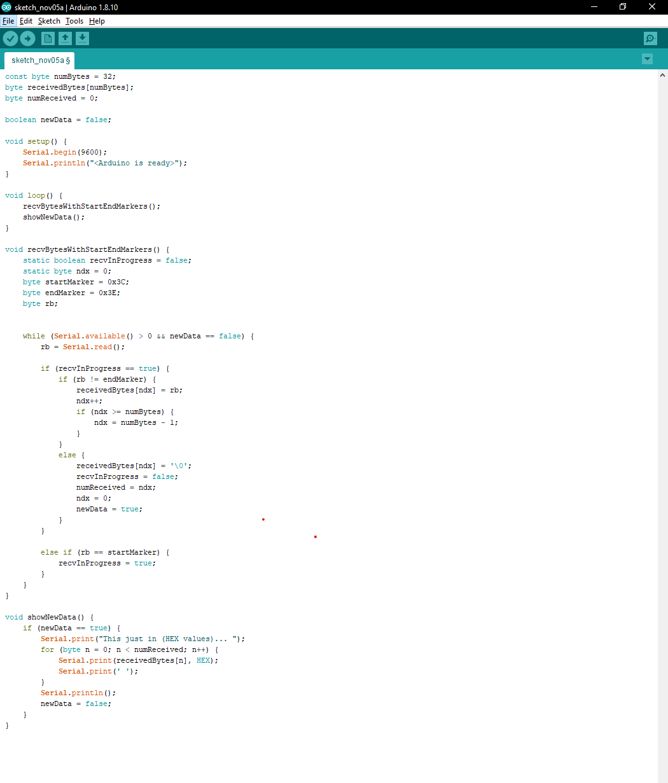
As we continue to develop the hardware prototypes, we plan to frequently test that the software is compatible with all of its required hardware components.

