University of Ottawa
GNG 1103: Engineering Design

Deliverable B- Needs Identification and Problem Statement
January 28th, 2023
Group F-12
Avery Taylor (300366472)
Emily Facette (300109170)
Rashad Nesar (300372555)
Annabelle Osazuwa (300361617)

INTRODUCTION
Ailsa Eyvindson from Canadian Nuclear Laboratories has requested a design for a highly accelerated erosion testing system for different materials. Accelerating the erosion process will aid the client in determining the properties of certain materials under different conditions in a much-shortened period of time, aiding in material selection. This report summaries the findings from the first client meeting.
NEEDS:
- DESIGN
- The prototype should be safe to use
- Affordability
- The prototype should be stable and able to accommodate with the high rotational speed
- The prototype should be durable

- FUNCTION
- The prototype set up should be used to accelerate erosion testing by rotating components.
- The prototype should be flexible enough to test variety of materials, temperatures, diameter of component, fluid viscosities, abrasion, and rotational speeds.

- THEORY AND TESTING
- Demonstrate your system and describe the features that accelerate the erosion with empirical proof
- The process should be repeatable
- Erosion should be visible in a week or two after testing started
- Minimal Maintenance

JUSTIFICATION:
Ailsa emphasized the importance of safety both directly and indirectly. She said safety should be our priority, and she has provided specific design criteria to enforce this principle, including temperature constraints not exceeding 40°C and rotational speed limited to 10 rpm. Operating within the confines of a limited budget of $100 requires us to select our materials carefully. Alisa has further emphasized the importance of ensuring the stability of the apparatus to prevent potential spillage. This is low on the list of priorities as it is easy to implement this requirement into the design. In the client meeting, Alisa mentioned durability but did not state an expected time of usability. The device needs to accelerate the erosion of materials and incorporate adjustable parameters such as temperature, rotational speed, and varying liquid compositions. Recording and reproducing erosion rates from different parameters is vital for testing erosion theories. Ensuring consistent and reproducible outcomes is fundamental to maintaining the integrity of our experimental findings. Alisa needs to quickly see results of erosion, so she can apply the findings to decide what materials she should use. Alisa did not address if there would be maintenance for the device, thus the apparatus will be designed as though it will not be maintained. Based on these considerations, we were able to quantify the different needs presented by the client.

CONSTRAINTS:
  - No hot liquid (above 40 degrees Celsius);
  - No Corrosive liquids should be used in the testing apparatus;
  - Rotational speeds should be within a safe range (<1800 rpm);
  - Ambient pressure conditions.
PROBLEM STATEMENT:
The client has tasked us with designing and developing an erosion testing system which is safe, economic, durable, and stable. The system must be flexible and repeatable to accommodate different testing parameters. The goal is to create a design which will allow for a deeper understanding of how different factors affect the rate of erosion.
BENCHMARKING:

CSIRO Jet Stream (Beckett and Faria, 2023)
The 1952 CSIRO accelerated erosion test was the first to appraise the quality and durability of earthen construction materials by measuring erosion resulting from a spray of water delivered at a set pressure and distance from a nozzle of controlled geometry. However, it is now acknowledged that this test falls short in simulating the diverse exposure conditions that an earthen structure might encounter over its lifespan.
The Rotating Erosion Testing Apparatus (RETA) (Bloomquist et al., 2012)
The RETA involves using a water-filled rotating outer cylinder around a sample to generate shear stress and measure erosion. The sample is placed into a larger diameter cylinder, creating an annular space filled with a fluid, typically water. Rotation of the cylinder induces flow in the annulus, causing shear stress on the sample's outer surface. After a specified rotation period, the cylinder stops, and the mass of eroded material is measured. By knowing the sample's mass density, test duration, and the dimensions of the sample and cylinder, one can calculate the average eroded surface thickness, erosion rate, and average shear stress on the sample's outer surface. Below can be seen a cylindrical testing apparatus and the RETA.
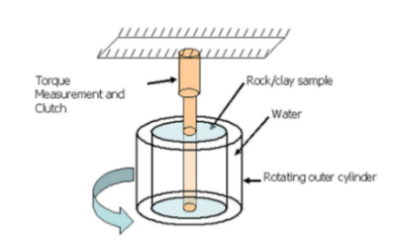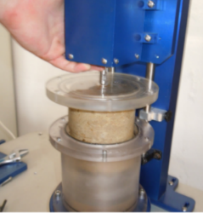
ASTM D1587
ASTM D1587 erosion test consists of connected tubes where the tested material is placed within the cross section of these tubes, while a pump drives water through the cross section at adjusted speeds. One end of a tube is placed on the bottom of a connected piston where it can push the sample back up into the cross section when needed. The water flow is constantly monitored using a flow meter. The advantage to this method is it is able to test a range of materials including soils using Shelby tubes straight from the field. It can similarly give the erosion function directly. Though the drawbacks would be it is an expensive device, and material samples cannot exceed larger than 40 mm. The following images show the placement of the piston in accordance with the water flow cross section of the ASTM D1587.
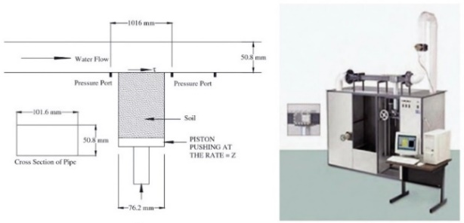
UNIDENTIFIED NEEDS:
Following the initial client interview, we were wondering what the product's expected life should be. This would affect how durable we create the design.
CONCLUSION:
To summarize, the accelerated erosion testing system designed for the client, Ailsa Eyvindson at Canadian Nuclear Laboratories, will prioritize safety, cost-effectiveness, adaptability, and replicability. The system must be flexible enough to accommodate various testing parameters and materials. The needs of the client were broken down into design, function, as well as theory and testing, to refine the needs of the client. Our design will navigate the constraints of temperature, liquid corrosiveness, rotational speeds, and ambient pressure. Benchmarking against existing methods such as the CSIRO Jet Stream, the Rotating Erosion Testing Apparatus (RETA), and ASTM D1587 provides insights into different approaches. Overall, this report lays the groundwork for the design and development of the effective erosion testing system.

REFERENCES:
- Bloomquist, D., Sheppard, D. M., Schofield, S., & Crowley, R. (2012). The Rotating Erosion Testing Apparatus (RETA): A Laboratory Device for Measuring Erosion Rates versus Shear Stresses of Rock and Cohesive Materials. Geotechnical Testing Journal, 35(4), 104221. https://doi.org/10.1520/gtj104221
- Beckett, C., & Faria, P. (2023). Defining a generic accelerated erosion testing method for earthen materials. E3S Web of Conferences, 382, 05002. https://doi.org/10.1051/e3sconf/202338205002
- Briaud, J., Shafii, I., Hc, C., & Medina-Cetina, Z. (2019). Relationship between erodibility and properties of soils. In Transportation Research Board eBooks. https://doi.org/10.17226/25470

