Project Deliverable F: Prototype I and Client Feedback
GNG 1103C – Engineering Design
Faculty of Engineering – University of Ottawa

Completed by Group C11:

Cédric Bohémier - 300081078
Alyssa Gomez – 300322778
Lilia Lahssaini-Benhima – 300286444

Table of Contents
Introduction 2
Client Meeting Feedback 3
Prototype I 3
1. Environment 3
2. ID Pins 4
3. Posters 5
Prototyping Test Plan 6
Testing results and improvements 7
Preparation for Prototype II 8
Conclusion 8
Wrike Snapshot 8

Figure 1:: Character moving through the landscape. 4
Figure 2: View of the alleyway with colored materials to differentiate from the streets. 4
Figure 3:Identification Badge Design 5
Figure 4: Identification badge worn by model (representation, not yet implemented in the texturing) 5
Figure 5: Warning sign one (1) 6
Figure 6: Warning sign two and three advertisement signs 6

Introduction
The purpose of this deliverable is to reflect on outcomes and lessons learned from the conception of the first prototype. This report presents the key findings, and the hypotheses that will be verified in the second prototype. We also outline the project plan for the upcoming two weeks.

Client Meeting Feedback
At the time of submitting this deliverable, we have not yet met the clients for a third time. The most recent client feedback was given in the previous deliverable (E). We summarize these findings in this section.
Our second client meeting's purpose was to present the two most promising concepts. The feedback received from the clients then served to help distill down to a final concept. The first idea was the one we developed in deliverable D. Namely, a VR experience that would contrast how things would change from a “regular” warzone to a world were killer robots are legal in a state of war. However, within a single minute there is a risk that it is too much information to digest to the user, and the message might be unclear. Another touchy subject we would have had to deal with was how are we – university students in our twenties – in anyway qualified to highlight how killer robots would change war. There is a serious risk of us mis-representing this very real-world problem in a way that would be cliché, diluting or outright discrediting our pitch. Further, if a VR experience has many different things the user can focus on, this will lead to different people coming out with different takeaways. Of course, because within a single minute they may not have focused on the same elements of the simulation. The purpose of the product should give as close to a homogenous experience to everyone to amplify effectiveness.
Our second proposition was to pick a single way people would adapt to killer robots. The strength of this approach is it makes the message much more coherent to the user. We chose a simple idea that intuitively feels like a very logical societal decision: giving citizens identification badges that can be read by robots. We expanded on the idea and proposed to the clients to explore a satirical approach. We propose a world where Autonomous Killer Robots (AKR) are deployed, and the only way for citizens to be protected against their own country's AKR is to always have the badge clearly showing. Because of this, companies have started advertising products to enhance the readability of the badges. These take the form of cleaning products, LED strips around the badges, magnifying glasses that can be installed in front, etc.
The VR experience would therefore present to the user an alley way that the user must navigate. To guide the user, they will be instructed to get to the end of the alley way to get a coffee or a drink from a vending machine. On the way there, they are exposed to both visual and auditory media. Posters are plastered on the walls – excessively- advertising products that promise to ensure your badge being readable. Government issued messages are played on a loudspeaker system, instructing you to always wear your badge, ensuring the user understands what is at play.

Prototype I

Environment
The initial environment created focuses on the development of the main scene, an alleyway situated within an urban city. This was done using the blender 3D software, enabling us to generate a 3D building layout. Following the integration of the landscape in the scene, we are familiarizing ourselves with the various assets and techniques required in Unity. We added an NPC character and programmed it to circulate around the user.

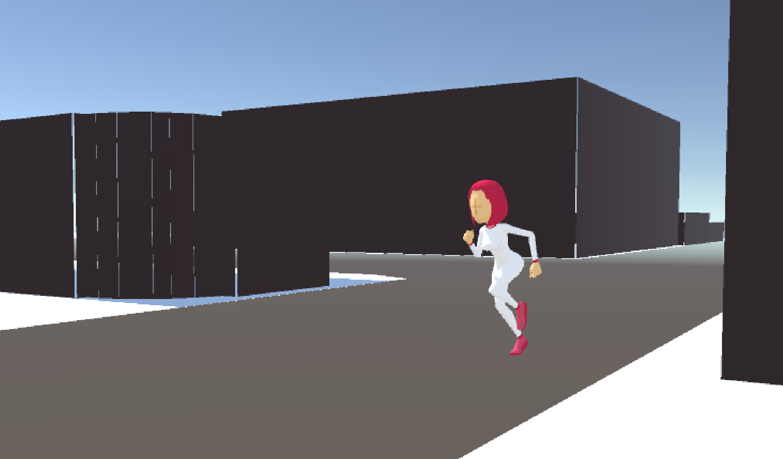
Figure 1:: Character moving through the landscape.
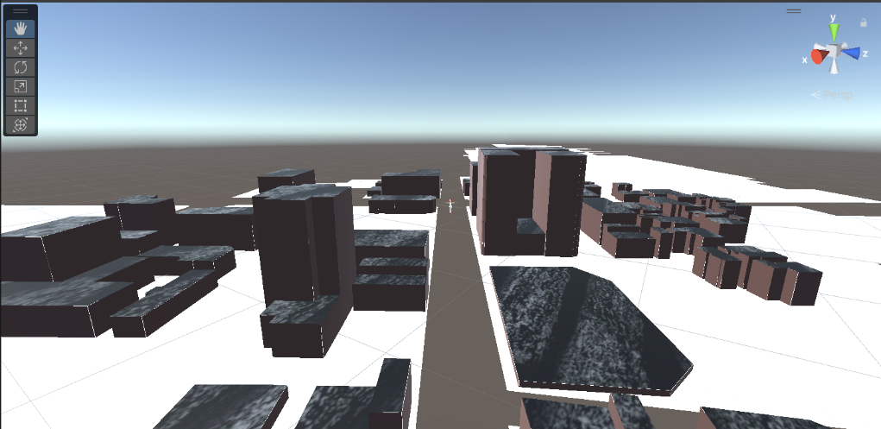
Figure 2: View of the alleyway with colored materials to differentiate from the streets.

ID Pins
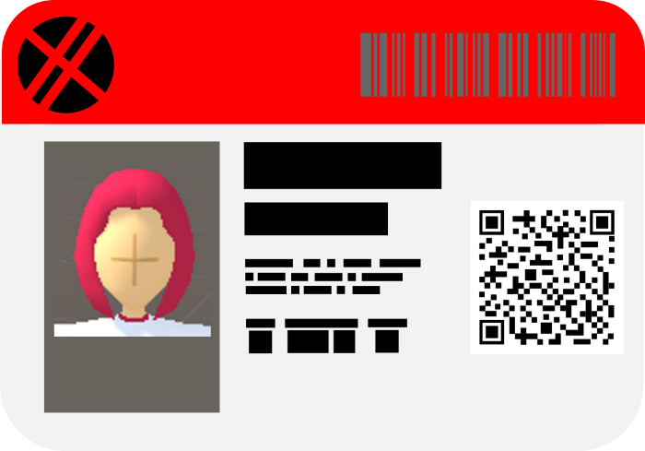
Figure 3:Identification Badge Design
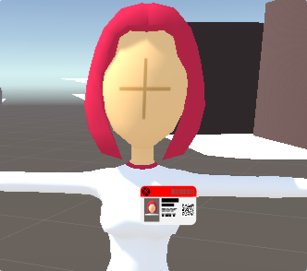
Figure 4: Identification badge worn by model (representation, not yet implemented in the texturing)

Posters

We opted to use a combination of warning posters and advertisement posters. The existence of the government-issued messages will orient the user while the ads will instead play on the irony of the situation. We tested a few styles and arrived at the following propositions.
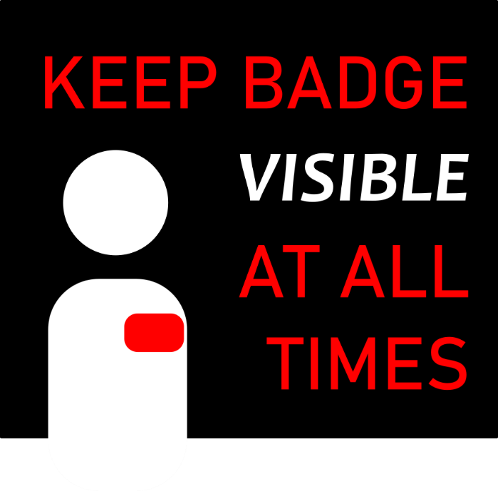
Figure 5: Warning sign one (1)
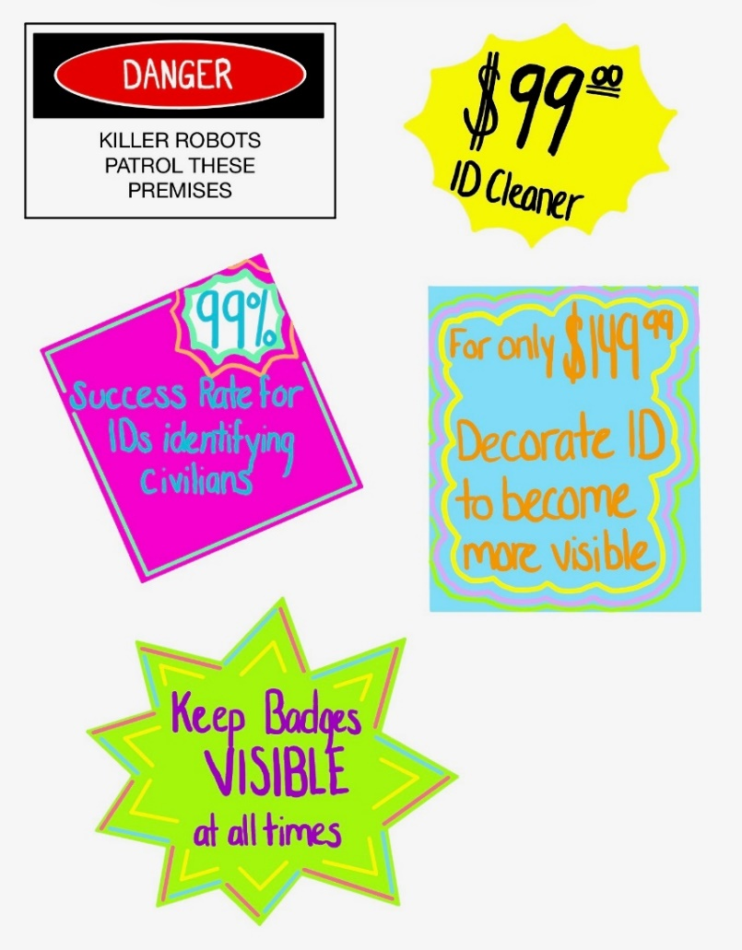
Figure 6: Warning sign two and three advertisement signs

Prototyping Test Plan

Testing results and improvements

Test ID | Test Objective  (Why) | Description of Prototype Used & of Basic Test Method  (What) | Description of Results to be Recorded and how these results will be used.  (How) | Estimated Test duration and planned start date.  (When) | State
1 | To show the risks of killer robots | Prototype one and two will be used. The test will be to see if our project met the client’s needs. | We will record the results by seeing whether it was achieved or not. The results will be used by reviewing the user meeting notes. | The test will span over both prototypes. This will grant us the opportunity to make sure that we stay on the path and follow the client's needs. | Not yet verified / client meet 3 required
2 | To allow the users the chance to experience this environment | The second prototype will be used. The test will be that the user is able to see everything in the environment clearly. | We will record the results by seeing if this was achieved or not. The results will be used to see if any changes must be made to the coding. | This will be done during the second prototype because prototype one will allow us to work on specific details. So that in prototype two we can make sure everything is working smoothly. | Not yet verified / prototype 2 required
3 | To demonstrate the clarity of ID pins | The first prototype will be used and will feature the landscape with at least 2 NPC characters implemented with ID pins on. The test will be that the ID pins are clearly visible and distinct on the character as the user walks around | We will record the results by noting if this was achieved or not. We will also join a snapshot of the ID pins along with the results, as it is a visual test. | We will start this in the first phase of our prototype, as it is the main element used to demonstrate our message. It will be done repeatedly throughout the development of the first and second prototype and should last 15 seconds because it would simulate the duration our user would spend looking at the ID pin. | Verified / Completed in prototype 1
4 | To verify that the NPC characters move accordingly | The second prototype will be used and will feature the landscape and all NPC characters. The test that we run will highlight any troubleshooting issues or bugs in the code. | The results will be flagged in the Visual Studio code and will be copy pasted in a separate document. These results will be used to understand where our issues are so that they can be fixed. | This will be done during the second phase of our prototype to make sure all additional characters run smoothly in the simulation. We will run this test for the duration of our simulation, which is 1min and we will perform it multiple times during the development period of the second prototype. | Not yet verified / prototype 2 required

During the first prototyping phase, we’ve encountered some issues while creating our landscape. Multiple methods were used to gather data directly from google maps, such as Google Tiles 3D and using a RenderDoc software to capture the images, which all failed. We decided to go with the GIS blender add-on, which scanned the google maps area to generate the buildings and roads, without any texturing or materials. For the next prototype, it will be crucial to finalize the detailing of the landscape to maintain a realistic effect through the simulation. We also were able to insert our first NPC character in the Unity landscape. We were able to test for the duration of the animation by changing the restrictions of the movement of our character to never exit the state. That way, throughout the simulation, each character will perform their task until the simulation is over. In the next prototyping phase, it will be important to set a specific distance for certain NPCs to move and to ensure that distance doesn’t loop until the simulation is over, which will be tested.
We were also able to test the visibility of our ID pins by placing them on the character form an approximate user view distance. By collecting those results, we concluded that the ID pins are immediately visible. In the next prototyping phase, we will test out the maximum distance that the user can be to still notice the ID pins. This will ensure the placement of our scene is accurate.

Preparation for Prototype II
Going into the second prototype phase, we wish to verify a few salient hypotheses. Namely, we wish to verify:
Hypothesis One – We wish to have the NPCs loop around the environment on a one-minute basis.
What – Verify if we can make NPCs loop on a deterministic schedule
How – We will make a proof of demonstration on a smaller time scale.
How Long – We give a maximum of two hours to try this. If it takes longer will remove the looping and instead have the NPCs vanish/appear.
Hypothesis Two – We require a physically realistic audio recording to play during the simulation.
What – Can we create a realistic echo effect on an audio recording
How – We will use audio mixing software such as Audacity
How Long – We give a maximum of three hours to try this, as it is important for the immersivity.
Hypothesis Three – The posters are appropriate for the message we are trying to send.
What – Verify the posters are not inappropriate for the target audience
How – The client meeting three will give us valuable feedback
How Long – This should take less than one minute of the presentation time.

Conclusion
The prototype one gave us valuable insight into the main challenges and limitations of VR work to achieve our chosen concept. We now have a proof of concept of a city landscape with looping character actions. We also have designed a few posters that will later be incorporated into the modelling.
Going forward, we are preparing for the third client meeting. We will be looking for additional feedback now that we have had the time to create a prototype of what we wish to deliver by the end of the semester. We are hoping that we will be able to better convey our idea to the clients and clarify any misconceptions. From there we will be able to calibrate.
We have a clear plan for prototype two and we are on track as of the delivery of this report.

Wrike Snapshot
https://www.wrike.com/frontend/ganttchart/index.html?snapshotId=xSooYH1RH2wENSOGPjHlwhGoNa3J9GP7%7CIE2DSNZVHA2DELSTGIYA

