Hot Car Emergency: Prototype II and Customer Feedback

Briana Archdeacon (8222069)
Alexander Gayowsky (300075283)
Ronan Mackrell (300231301)
Jasmine Wang (300006737)

November 11, 2021
Abstract
This document begins with an introduction to the second prototype, which includes crucial context and a discussion of motivating factors. This introduction is followed by a formalized list of prototyping objectives. The constituent sub-prototypes are then documented. Addressing the results of our testing, feedback, and analysis, we developed test plans and objectives for the final prototype, which is due on the 25th of November. The overall project task plan is also appended.

Table of Contents
Introduction 3
Prototyping Objectives 3
Prototype II 3
TinkerCAD Model 4
Arduino Model 4
Arduino Code 5
Testing, Analysis, and Feedback 7
Test Plan for Prototype III 8
Project Task Plan 9
Conclusion 10

Introduction
Our first prototype, which was a non-functional mock-up, provided sufficient feedback for the construction of our final design’s true physical shell — the structure that will house all the device’s internal components. Importantly, however, if we wish to construct a ‘comprehensive’ prototype (i.e. one that is truly representative of our final design), we must have all of those internal components in working order. Consequently, it was decided that our second prototype would focus entirely on functionality. We hoped to create a representative circuit, which would allow us to investigate the performance of our modules while verifying the feasibility of our device’s proposed functions.

Prototyping Objectives
“Why” Objectives:
- Institute bluetooth communication from product to portable device
- Identify ideal design for mobile alert application
- Ensure functioning circuit that will remain relatively uniform across future prototypes
- Determine whether size of casing is suitable for both the contents safety as well as user satisfaction

“What” Objectives:
- Simulate the creation of a circuit that will involve a bluetooth communication component
- Create an app that is able to receive signal from associated arduino
- Create functioning arduino circuit capable of sending and receiving instruction
- Place arduino setup in laser cut casing, initiate durability test for contents and assess portability

“When” Objectives:
- Casing to be applied to product thus confirming dimensions and durability - November 15
- Perform response test with bluetooth components - November 16
- Test completed arduino circuit to ensure efficiency and consistency from product - November 16
- Finalise the functionality of the product, acquire results when tested with app - November 17

Prototype II
The second prototype consists of two models: a virtual model that was constructed using TinkerCAD, and a physical model that was constructed with the aid of a breadboard. Both models are based upon the Arduino Uno. The first model was mainly used to understand what the circuit might look like and how the product intends to function. The second model helped to test the working conditions of the individual sensors and further developed the coding from the first model.

TinkerCAD Model
Before assembling the Arduino prototype, we used a virtual model on TinkerCAD to better understand how the components would work together. This virtual schematic, however, was slightly inaccurate as the TinkerCAD website lacked some of our specific components and the alternatives it offered had to be coded differently from our physical modules.

For instance, to replace the missing Bluetooth module, we used a Piezo Buzzer to simulate the response system. We also altered the codes for the temperature and gas sensors to suit the exact product models used on the website. Apart from those changes, this virtual model was relatively similar to what was intended for the physical prototype.

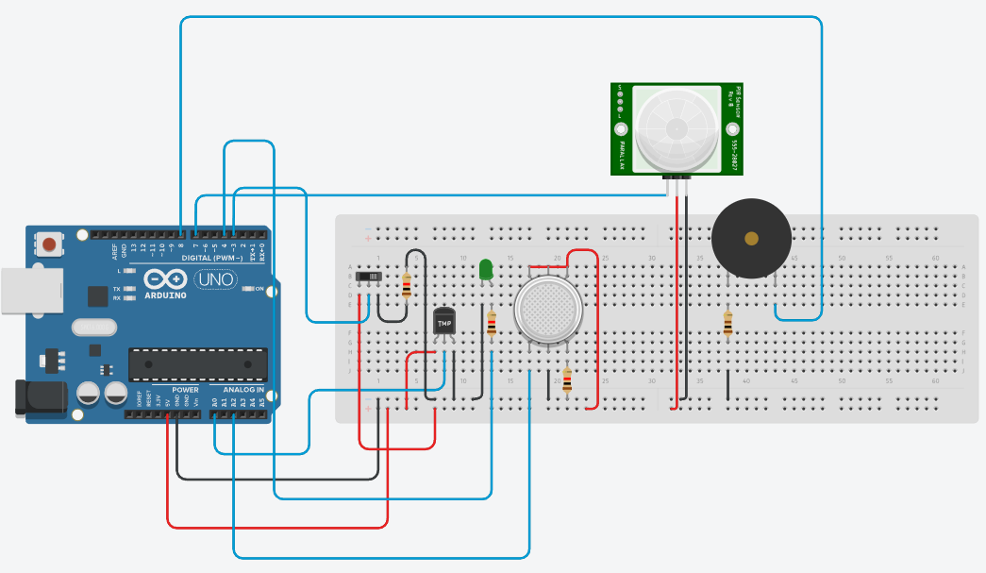
Figure 1. Schematic of the TinkerCAD model. The model and its code can be accessed at https://www.tinkercad.com/things/kSHndXANs8q-prototype-2-tinkercad-model/editel?sharecode=uR4hrOQdTDxzSGg94VRBApikeX6VILCxOyR7UyQEudk.

Arduino Model
Once the TinkerCAD model was complete, the physical prototype was made in a similar fashion. We started with testing each component individually with separate codes. This was necessary to ensure that each module was working as intended and to reduce the risk of failure due to faulty components.

Jumper cables are used to connect the modules to the breadboard and, in turn, to the Arduino. For the final product, it should be noted that the Arduino UNO will be substituted by the compact Arduino NANO and the breadboard replaced by a protoboard to allow for solid soldered connections. This means that the form factor and overall appearance will change greatly from this model to the final product.

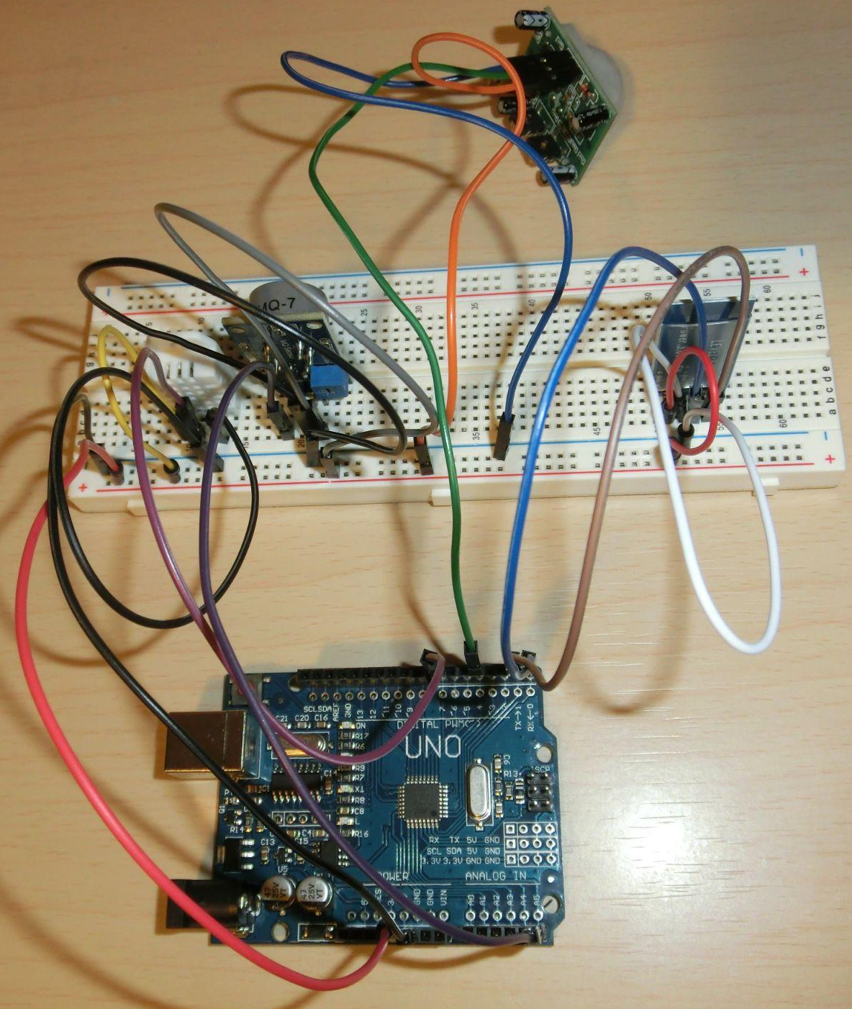
Figure 2. Top-down view of the Arduino circuit to demonstrate wiring.

Arduino Code
Coding was done using the Arduino IDE software. We started with individual codes for each component to test for functionality. We referenced much of the code from datasheets and from other projects; we attributed the creators of each code at the beginning of the code. We then compiled the individual codes to form one program that would connect the components and set up the basic logic structure for the response. Currently, the response system will only activate if either the temperature or gas levels surpass a certain threshold (30°C and 250 ppm, respectively) and if there is motion detected in the backseat (to ensure there is someone in the car). These threshold levels are based on existing literature regarding carbon monoxide poisoning and high heat indices¹ ².
For prototype II, we successfully interfaced all of the components except for the Bluetooth module, as we cannot yet test for its functionality without setting it up via mobile phone application. This is thus a large priority for the third prototype due on November 25.

1 /* GNG Prototype II Group B06
2
3 DHT Library by Michaelis Vasilakis (2015)
4 DHT22 Temperature Monitoring Code by Muhammad Afzal (2016)
5 MQ-2 Gas Sensor Code by Aritro Mukherjee (2016)
6 PIR Motion Sensor Code by DIY Electronics Projects (2020) */
7
8 #include <DHT.h>
9
10 // Sensor Pins
11 #define DHTPIN 7
12 #define DHTTYPE DHT22
13 DHT dht(DHTPIN, DHTTYPE);
14 int gasSensor = A5;
15 int motionSensor = 4;
16
17 // Sensor Thresholds and Statuses
18 int motionState = LOW;
19 int motionStatus = 0;
20 gasThreshold = 250; // based on existing literature and
baseline CO levels (in ppm)
21
22 void setup() {
23 pinMode(gasSensor, INPUT);
24 pinMode(motionSensor, INPUT);
25 Serial.begin(9600);
26 dht.begin();
27 }
28
29 void loop() {
30 // Temperature Sensor
31 float hum = dht.readHumidity();
32 float temp = dht.readTemperature();
33
34 // CO Gas Sensor
35 int gasLevel = analogRead(gasSensor);
36
37 // Motion Sensor
38 motionStatus = digitalRead(motionSensor);
39
40 if (motionStatus == HIGH) {
41 if (motionState == LOW) {
42 Serial.println(“Motion detected.”);
43 motionState = HIGH; //change state to HIGH
44 }
45 }
46 else
47 if (motionState == HIGH) {
48 Serial.println(“No motion detected.”);
49 motionState = LOW; //reset state to LOW
50 }
51 }
52
53 // Serial Monitor (for testing - to remove once app has been
implemented
54 Serial.print(“Humidity: ”);
55 Serial.print(hum);
56 Serial.print(“ %, Temperature: “);
57 Serial.print(“ Celsius, CO: “);
58 Serial.println(gasLevel);
59
60 // Basic Response System (WIP - need to interface w/ app)
61 if ((gasLevel > gasThreshold || temp > 30) && motionState ==
HIGH){
62 Serial.println(“DANGER!”); //add app response under
63 }
64
65 delay(5000); //delay 5 seconds to improve performance
66 }

Figure 3. Arduino code used for prototype II.

Testing, Analysis, and Feedback
- The TinkerCAD circuit was coded and tested to understand how the sensors would work in conjunction. We determined that the carbon monoxide and temperature sensors may be redundant in the overall system, but they can be useful together to ensure that there is a failsafe sensing mechanism in case of failure by one of the modules. Following the client meeting, it was also brought to our attention that we require one more module or function to detect the presence of a driver to prevent false positive responses. This will thus need to be addressed in the third prototype. Another upgrade suggested during the client meeting is a rechargeable battery. Although this would indeed be quite convenient, it cannot fit into our budget, and the consensus among course coordinators seems to be that this specific component is not necessary.

- The Arduino model was put together. As mentioned, we tested and coded each individual component, one-by-one, to ensure that they are all in good working condition. We used basic print statements to test for their sensing capabilities and to determine baseline levels. These baseline levels were then compared to existing literature to determine threshold levels. We found that our carbon monoxide sensor was quite sensitive, and that it is not practical for its output values to be treated as true ppm values (following common guidelines is not reasonable). Otherwise, the modules functioned as expected.

- Upon completing the individual component testing, we merged the codes and electrical connections to form one cohesive system. We then developed a basic logic structure and tested it, again by using a print statement. We tested the functionality of the Bluetooth module as well and it seems to be in working condition as it is possible to connect to it via Bluetooth. However, we have yet to develop the mobile phone application to properly incorporate it into the rest of the system. So, the Bluetooth function will have to be tested more thoroughly once we complete the app.

Test Plan for Prototype III
Test  ID | Test Objective  (Why) | Description of Prototype used and of  Basic Test Method  (What) | Description of  Results to be  Recorded and  how these results  will be used  (How) | Estimated Test  duration and  planned start  date  (When)
1 | Establish and communicate methods for bluetooth connection to mobile phone | Create a virtual circuit that includes bluetooth communication | Effectiveness and range capabilities of bluetooth connection to mobile phone | Test duration: 1 minute, planned start tuesday November 16
2 | Verify feasibility of driver detection method | Physical model of bluetooth module able to detect driver mobile phone signal within a specified range | Detect driver presence using bluetooth range capabilities | Test duration: 1 minute, planned start tuesday November 16
3 | Communicate expected design of mobile app | Create a basic mobile app and user interface using thunkable | Mobile app that is able to issue a push notification upon the detection of an emergency variable provided by the Arduino | Test duration: 1 minute, planned start Wednesday November 17
4 | Reduce uncertainty surrounding final circuit connections and design. | Physical circuit using Arduino Nano and soldered connections. | Functional Arduino Nano circuit that is able to detect motion, temperature, and CO concentration. | Test duration: 1 minute, planned start tuesday November 16
5 | Reduce uncertainty surrounding product dimensions | Physical product casing using laser cutting techniques | Product dimensions, will be used to evaluate car mounting options | Test duration: 5 minutes, planned start Monday November 15
6 | Verify feasibility of car mounting method | Physical comprehensive prototype able to attach to the back seat of a car | Product straps support weight of product, are stable and are able to attach to all vehicle types. | Test duration: 1 minute, planned start Wednesday November 17

Figure 4. Test plan for prototype III. The stopping criteria for all tests is as follows: test yields desired specifications or fails to reach the desired functionality by Thursday, November 25.

Project Task Plan

For the third prototype that is due on Thursday, November 25, we will develop a fully functional model of the project. We have scheduled a meeting to discuss the most important components of the third prototype, being the mobile app, the bluetooth connection, and driver detection methods as these are the three components that contain the most uncertainty. A Gantt chart of the upcoming deliverable and prototyping plan is provided on the next page:

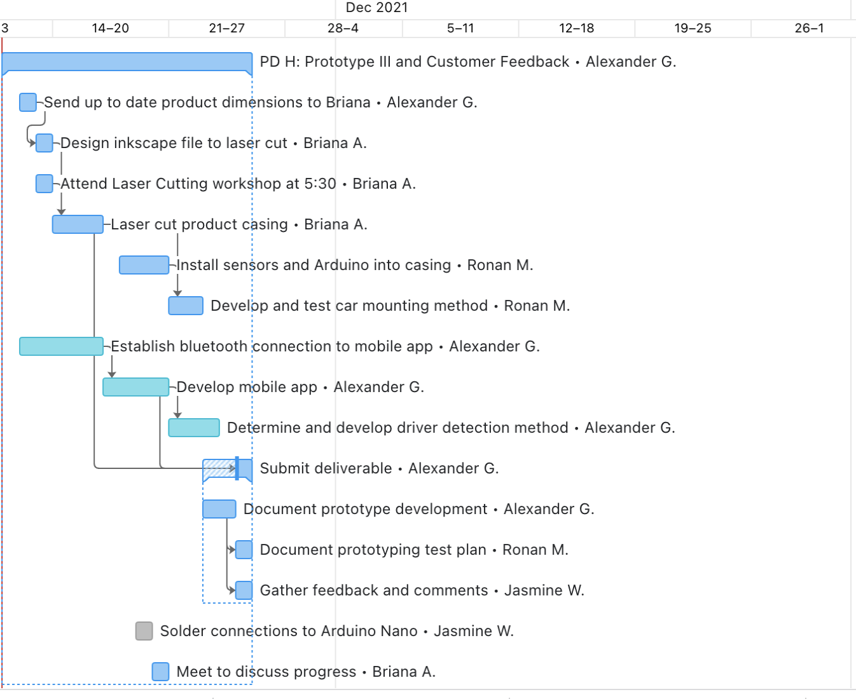
Figure 5. Gantt chart outlining the overall project task plan for Deliverable H: Prototype III and Customer Feedback.

Conclusion
To summarize the contents seen in this document, the initial objectives of the project included the implementation of bluetooth, the creation of a physical arduino circuit, the production of a box casing and the development of an app. These components were then tested for compatibility including fitting circuit into casing, applying bluetooth to circuit and testing for app results in response to outside signals. With the success of prototype II, the project plan was established for the following project alongside scheduling, setting a potential final product in motion.

References
1. Consumer Product Safety Commission. (n.d.). Carbon-Monoxide-Questions-and-Answers. CPSC.gov. https://www.cpsc.gov/Safety-Education/Safety-Education-Centers/Carbon-Monoxide-Information-Center/Carbon-Monoxide-Questions-and-Answers
2. National Weather Service. (n.d.). Heat Forecast Tools. Weather.gov. https://www.weather.gov/safety/heat-index

