Project Deliverable D: Conceptual Design

University of Ottawa

GNG1103: Engineering Design

October 15 2023

Group 6

Name: Student Number

Oreofe Oluwatayo (300240663)
Betselot Delnessahou Tadesse (300320450)
Tharshaon Thirukumaran (300297258)
Sohan Udayashankar (300323950)

Abstract
This deliverable demonstrates the team process on creating a global concept that most efficiently covers the client’s needs. After creating a list of subsystems as a team, each team member created their individual concepts for each subsystem where they saw best fit. Afterwards, the team created 3 unique global concepts consisting of different combinations of individual concepts. These 3 global concepts were compared and contrasted against the interpreted needs and rated based on importance and the best global concept of the three was chosen.

1. Introduction 5
2. Individual Concepts 5
2.1. Sohan 5
2.1.1. Robot Design 5
2.1.2. Storyline/Conflict 6
2.1.3. Sound Design 6
2.1.4. Environment 7
2.1.5. Adaptations 7
2.1.6. User Interface 8
2.1.7. Accessibility / Accommodations 8
2.1.8. Messaging/Themes/Call to Action 8
2.2. Tharshaon 8
2.2.1. Robot Design 8
2.2.2. Storyline/Conflict 9
2.2.3. Sound Design 9
2.2.4. Environment 10
2.2.5. Adaptations 10
2.2.6. User Interface 10
2.2.7. Accessibility / Accommodations 10
2.2.8. Messaging/Themes/Call to Action 11
2.3. Betselot 11
2.3.1. Robot Design 11
2.3.2. Storyline/Conflict 11
2.3.3. Sound Design 11
2.3.4. Environment 12
2.3.5. Adaptations 12
2.3.6. User Interface 12
2.3.7. Accessibility / Accommodations 12
2.3.8. Messaging/Themes/Call to Action 13
2.4. Oreofe 13
2.4.1. Robot Design 13
2.4.2. Storyline/Conflict 14
2.4.3. Sound Design 14
2.4.4. Environment 14
2.4.5. Adaptations 15
2.4.6. User Interface 15
2.4.7. Accessibility / Accommodations 15
2.4.8. Messaging/Themes/Call to Action 15
3. Global Concepts 15
3.1. Global Concept #1 15
3.2. Global Concept #2 16
3.3. Global Concept #3 16
4. Comparison of Global Concepts 16
5. Final Global Concept 18
6. Conclusions and Recommendations for Future Work 18

Introduction
In this deliverable, we developed a set of conceptual designs for your problem statement. We were based on the previous benchmarking and the list of prioritised design criteria for a VR experience for Mines Action Canada. Our team members individually created concepts for each of the subsystems that were necessary for the design. These subsystems include Robot Design, Storyline/Conflict, Sound Design, Environment, Adaptations, User Interface, Accessibility / Accommodations, and Messaging/Themes/Call to Action. We then proceeded to combine the subsystems into 3 global concepts to evaluate against different design criteria based on our client's needs (consult deliverables B and C for further details). The best concept is then chosen for the development of this project.

Individual Concepts

Sohan

Robot Design
The autonomous robot is a small drone, about the size of a smartphone, that has four propellers that enable it to fly. It has a camera that can be used for facial recognition and identify its targets. It also has a small explosive attached to it which it can use to autonomously kill. The robot kills by ramming into the head of its target and detonating the small explosive. The robot was originally built by weapons contractors to deal with high priority targets while minimising collateral damage.
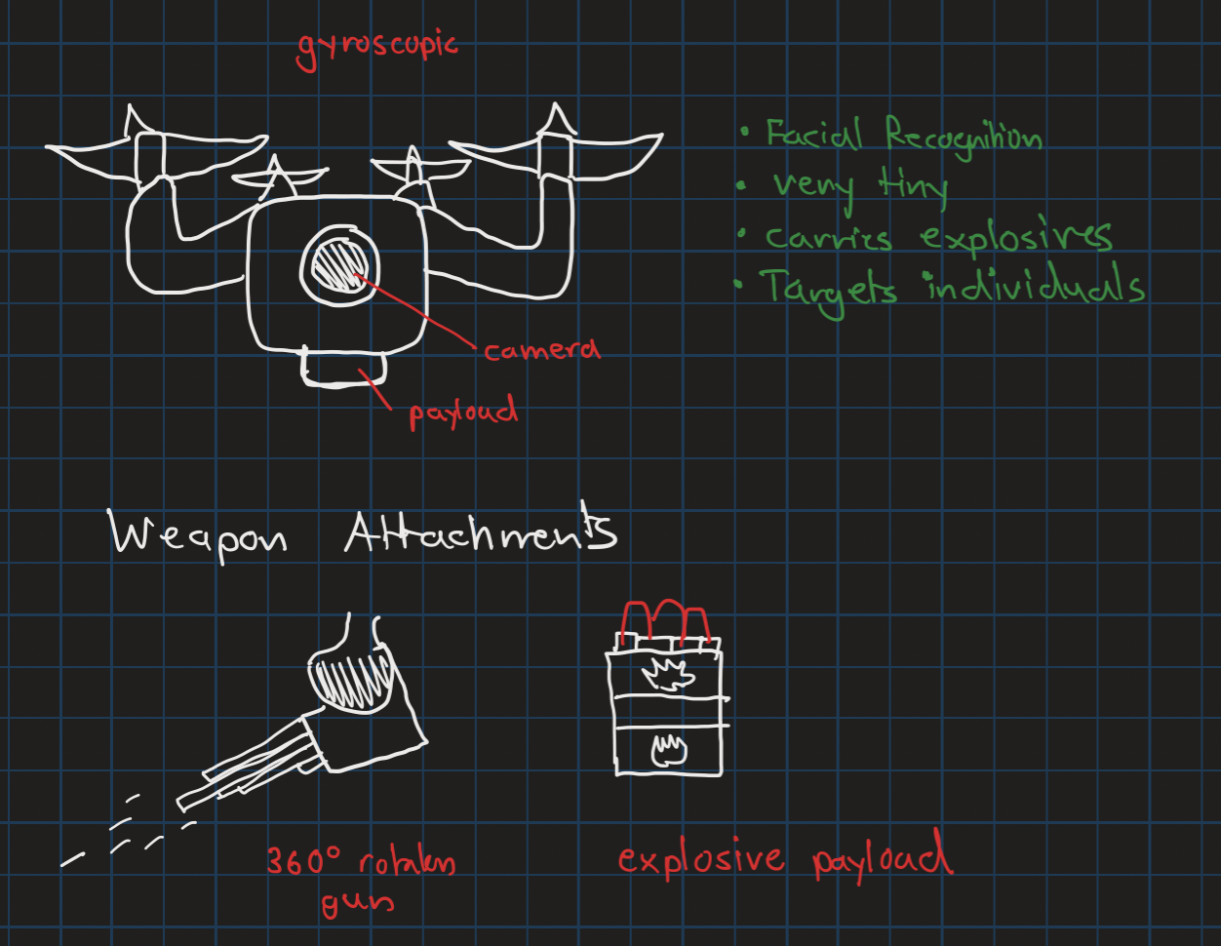

Storyline/Conflict
Terrorists have seized the drones from weapons manufacturers and have hijacked the software to target politicians and everyday citizens in developed nations. Therefore, the setting of the VR experience will take place in a major metropolitan city and showcase the adaptations that society has taken to adapt to this “new normal”. The plot of the experience follows an everyday citizen from their house to their workplace. Along that trip we see how people, stores, houses and governments have adapted to the threat of AI robots.

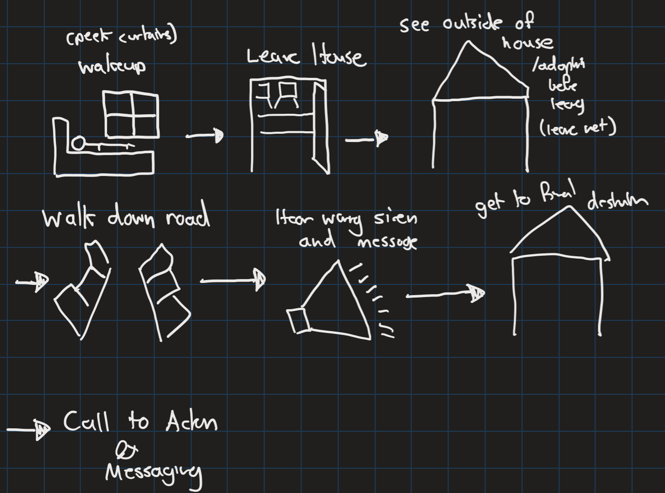

Sound Design
This concept will use many different sounds to make the VR experience immersive. Firstly, there will be ambient sounds to give the user the feeling of being in a city. This includes the sounds of cars, footsteps, low chatter, etc. Furthermore, there will be specific sound designs for warning sirens and the buzzing of the robot drones. Another aspect of this concept will include a brief podcast/radio snippet where two individuals are discussing a random topic and making a joke about drones. The point of this is to highlight how society has adapted to these drone attacks and how it has become the new normal in society. There will also be some narration at the end of the VR experience that will serve as a call to action.

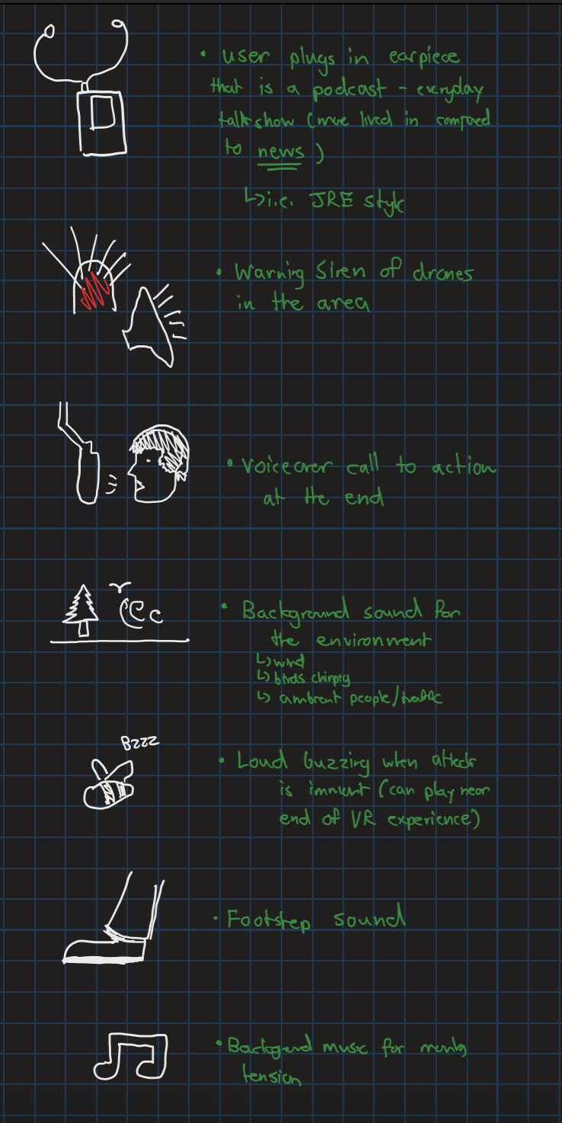

Environment
This experience will occur in two major locations. It will start in the bedroom of the user. The room will help orient the user as to what is currently happening in the world but it doesn’t reveal too much. The user will then leave their room to enter into a large metropolitan city. The user will then be introduced to the state of the city and the adaptations that have taken place. The city will be recognizable and will not show many signs of war related damage. Instead there will be signs, advertisements, security measures that all highlight the response society has taken to these autonomous killer robots.

Adaptations
As a result of the robot drone attacks, countermeasures have been implemented to mitigate their effectiveness. Full face coverings, and face paint have become a norm to prevent the robots from identifying targets. Nets have been placed over buildings and surrounding buildings to interfere with the movement of the drones. Anti-thermal clothing and paint have are used to mask the heat signature of civilians. Decoy posters and dummies are placed in the city to draw the attention of drones that may be lurking the surrounding area. Signs are placed around the city to warn civilians of threats. The city has become a surveillance state as cameras have been installed everywhere to monitor drones. Sirens and large lights have also been placed to warn civilians. Windows are installed with one way mirrors to prevent drones from identifying people within buildings.
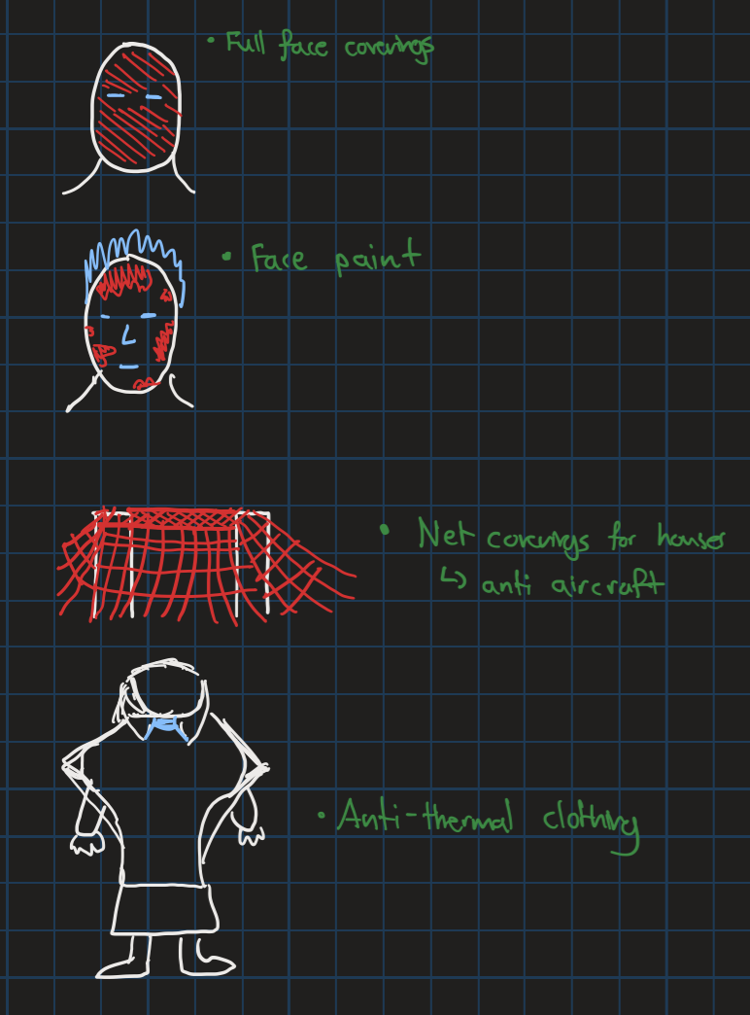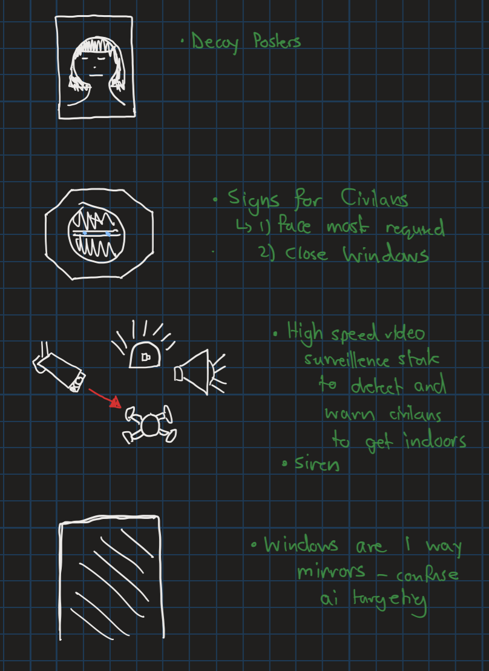

User Interface
The user interface will be simple. The perspective of the VR experience is first person. There will be some interactable objects in the environment but the experience will primarily involve static elements.

Accessibility / Accommodations
To accommodate the hearing impaired, subtitles will be implemented.

Messaging/Themes/Call to Action
The primary messaging of this concept is to demonstrate the threats that ordinary civilians may face from autonomous robots, even far away from an active warzone. The VR experience is intended to be relatable to city dwellers and highlight how the “new normal” might look like. The call to action will state how “this reality is not too far away” and how we can prevent this future by preemptively banning autonomous robots.

Tharshaon

Robot Design
The art of facial recognition, detection and targeting start with surveillance. In this scenario the army has mounted and stationed surveillance cameras equipped with onboard recognition systems and a built-in attack system. The cameras use an array of infrared, ultraviolet and regular cameras with motion sensors and send its data to its on-board artificial intelligence. Once it finds a matching individual based on general parameters pre-fed remotely, it activates an on-board, highly concentrated laser beam focusing directly at its target. This laser beam is not on the visible light spectrum and invisible, making it hard to detect by enemies but creates concern and fear in civilians as they do not know where attacks come from.

Storyline/Conflict
In the near future, a rebel group has risen from within to protest against a country’s unorthodox laws and is slowly taking land to create a home state. The government is slowly taking back land but realises that rebels have planted sleeper agents within cities, greatly damaging their progress. To gain the upper hand in a high priority area, the government has started to employ artificial intelligence surveillance-strike robots in a small but densely packed town to neutralize specific targets within high population cities. With the military ensuring no one comes in or leaves, the citizens have grown uneasy with accidental isolated attacks on civilians and made their own precautions to avoid detection. To make matters worse, the government and armed forces refuse to take responsibility for the accidental civilian deaths and unethical approaches to keep the rebels out.

Sound Design
Sound design will largely be sound effect-based to truly capture an immersive experience where the subject feels the fear and concern as they traverse the robot-controlled landscape. The environment will be filled with normal ambient noise (wind, birds chirping, rain, muffled conversations from homes) but also ambient noise indicating the presence of a conflict (steady hum of security cameras, faint droning of helicopters and planes in the distance, occasional gunfire).

Environment
The environment here will capture the nondestructive yet lethal capabilities of the surveillance-strike cameras with a main focus on the unkempt environment due to citizen safety being a higher priority. The simulation is set in a moderately sized town outside of the downtown core with a mix of densely packed residential and commercial buildings and a city square in the middle. As our targeted audience generally have not experienced war zones with buildings reduced to rubble, most infrastructure damage is captured through general disrepair to show realism and for the user to imagine that destruction in a place familiar to them. Small craters and burn marks scattered throughout the city capture the precise lethality of the lasers as well as the lack of care the government has to environmental damage and endangerment of civilians. The presence of the military is shown through checkpoints, army trucks and army supply tents to show physical armed presence that address concerns the cameras cannot handle.

Adaptations
The adaptations relate to how civilians live their everyday life while reflecting their cautious and diminishing trust in mitigating detection and being targeted. This involves active and passive measures: active measures shown as jammers connected to servers to disrupt the camera’s connection to the network and as well as destroyed cameras within the environment. Passive measures include reflective clothing and tarps blocking windows, shielded corridors, underground tunnels and secret rooms. Outside of these measures, there is also evidence the civilians are resisting this change and altering it for better use with signs of cameras being taken apart and reverse engineered.

User Interface
The user interface (UI) will be relatively simple and the UI will mainly be focused on the visuals of the environment. The user will be seeing the environment through a first-person view (FPV) to understand life as a civilian. A menu or pause menu will be necessary when including accessibility settings. The use of specific controls for the Meta Quest 2 will be explored in future deliverables.

Accessibility / Accommodations
Accommodations and different accessibility options will be included for movement, visuals and audio. Subtitles will be included along with basic controls. In terms of visuals, there will be settings to adjust colour settings for the colourblind and warnings if any flashing lights are displayed. Arm movements required will be minimal and limited to below the waist.

Messaging/Themes/Call to Action
Since this simulation will be directed towards decision-makers and people with power to avoid this, the message will be “a reality or just a simulation, it’s up to you.” This signifies the fine line between this remaining as a solution if action is taken or observing this reality come to existence.

Betselot

Robot Design
The robot will have a scary non-human-like body with a surveillance camera. It will be armed (firearms or explosives) and will have wheels instead of legs. It will be programmed with everyone's record and will kill people on command but sometimes it makes its own decisions (the system glitches).

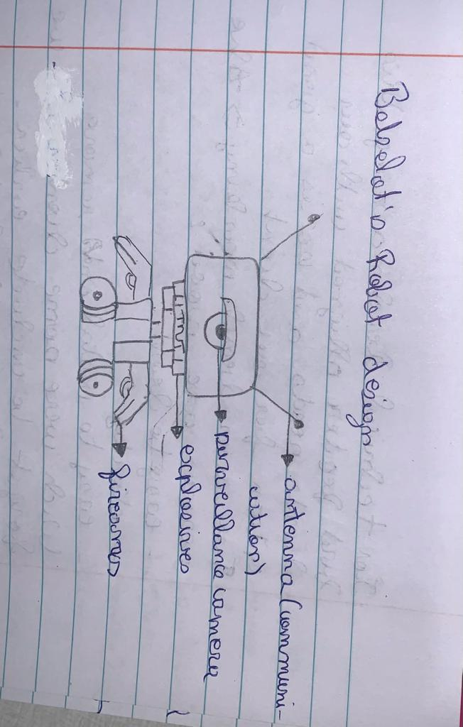

Storyline/Conflict
September 12, 2025;
After the killer robots have been normalized by the government in wars and for regular patrol, the morning news announces the death of the military commander. Although the people were sorrowful, fear and terrors took over the city. It suddenly turned into a ghost town….

Sound Design
Narration: The narration could be done by one of our teammates. The other option is to use an AI voiceover that represents the robot's voice. Sound effects:
We could use a beeping sound that represents the robot if we don't show it in our VR experience. We could also add sirens (bombing sirens), firearms, and explosive sounds, to amplify the terrors.

Background music:
We could use suspense and mystery soundtracks that build up the tension of the scenes. We can also not put on any music if we feel that it will overtake the point of the experience.

Environment
The scene should be located in a famous European country, preferably near a famous landmark in France (Tour Effiel, Arc de Triomphe,..) or Germany (The Berlin Wall,...). Showing these usually busy and touristic areas abandoned will help us make a point. It should be located in a technologically advanced country that has the resources and power to use killer robots. The background should be an abandoned ghost town with unsustained and worn-down buildings. There should be little to no people in the street. There are surveillance killer robots patrolling the streets looking for potential threats.

Adaptations
My scene doesn't really happen in an active war, the killer robots are used for patrol. The people try to maintain their regular lifestyle but still live in fear of the unknown as it is a relatively new technology, fear of getting falsely identified and killed by the robot. The people who haven’t fled the area do the bare minimum to survive while trying to be safe.

User Interface
The camera can be from the robot's point of view through the surveillance camera. This idea can be beneficial to use later in the development of the game because we don't have to show the robot.
The camera should be from the main character's point of view. The main character is a civilian walking in a snow covered street of this abandoned town.
The camera can also be a street surveillance camera that captures the acne from a third person's point of view.
The camera can also be pointing at a TV screen where the scene takes place like a trailer of a movie.

Accessibility / Accommodations
We should use colours that are easily recognizable by colour-blind people ( red and blue).
We should add subtitles for deaf people.
We should add narration and some background music or sound effects for blind people.
Generally, it should be simple enough to be used by anyone ( easy and basic function for the judges on design day).

Messaging/Themes/Call to Action
At the end of the video, there should be a slogan like “Stop before it's too late “, or “More humanity” … or we can use an existing one from Mines Action Canada.
We should write “This message was brought to you by Mines of Canada” at the end of our VR experience and the video. Or we could place it at the top right or left corner during the entire experience.

Oreofe

Robot Design
Seeing that the technology for robots with legs has only been perfected by Boston Dynamics as of now and that it is a private company, it is very unlikely that AI robots will look humanoid. Instead I think it will be a more simple design of four wheels, tread, or a half track. On top of that would be a simple rectangular shape that contains guns or bombs or whatever weapon the machine would carry and on top would be the method of identifying targets. This would include the camera, thermal vision, microphones, night vision etc. Drones with AI are also a possibility.
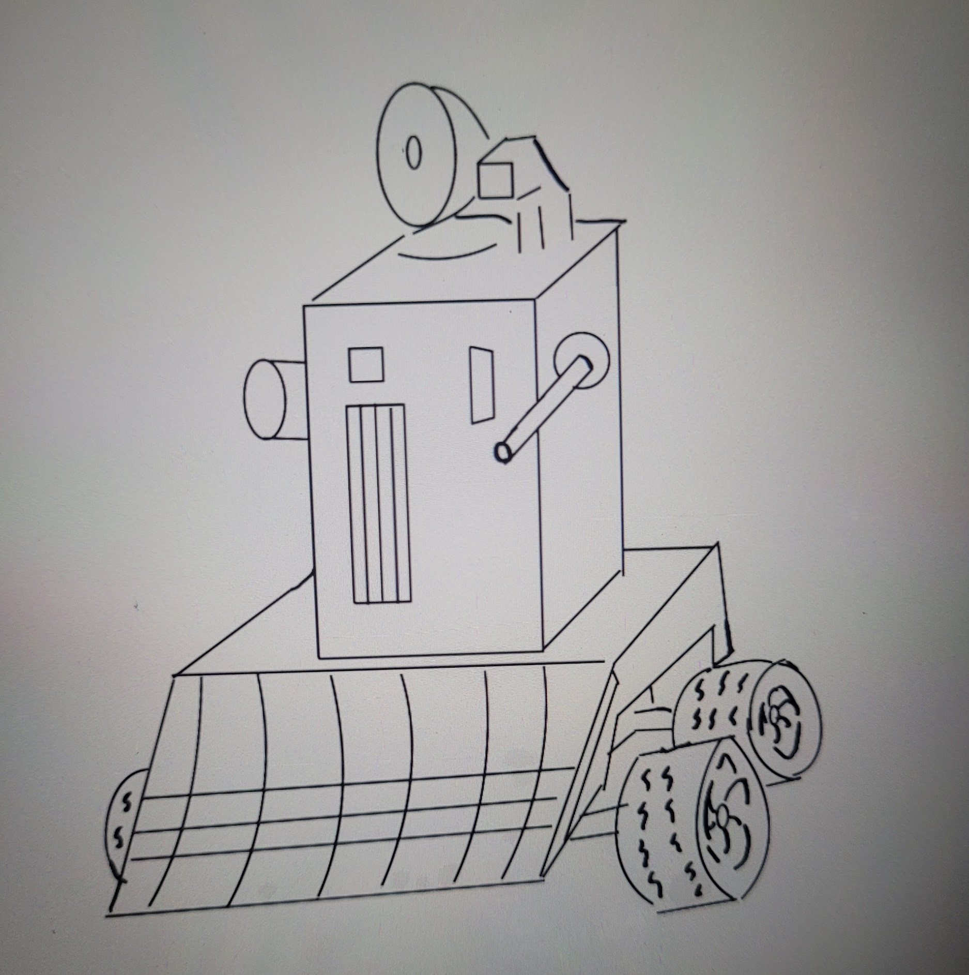

Storyline/Conflict
- The fight would have to be between two countries since no other group of people would have the firepower or resources to develop these kinds of weapons.
- Types of Conflict-I think a territorial conflict would be the most likely to require these kinds of autonomous robots.
- I don’t know how to make it show, but I don't think a country that has a sufficiently powerful military would make these autonomous weapons it would probably be a country that is fairly small in terms of population and these robots are so supplement numbers
- I think a civil war could also warrant these kinds of weapons as well

Sound Design
- Narration
  - Nation A vs Nation B, Nation A has cleared a certain civilian area of Nation B, but has intel that there are either rebels or there are reinforcements coming so Nation A must distinguish between enemy combatants and civilians. I think that either having nations that are largely multicultural being at war or a civil war, would be better to show the flaws in the robots because when you are not looking for a certain race or group identity it makes it a lot harder to pinpoint who you are fighting against
- Sound effects
  - Since we are not showing robots attack, it should just be sounds of vehicles, planes flying overhead, maybe some drones, but otherwise it would just be daily life. During war the terrain doesn’t scream war unless there has been bombings, it looks like normal its more so a feeling of perpetual terror than a audible sound. (How can you simulate the feeling of death being around the corner)
- Music (songs vs soundtrack)
  - None

Environment
- Landscape
  - City environment - again the countries that have the advancement for this are countries that are pretty well off
  - City will be somewhat unkept, not dilapidated but unkempt
- Objects
  - Clothes and shoes and broken glass and signs of struggle but not full bombardment

Adaptations
- Human adaptations
  - The cloths to not be seen by drones
  - Plain clothes to not be confused as combatants
  - Optical illusions painted on buildings to confuse robots
  - Roads littered with spikes to prevent machines that use wheels
  - Windows covered
  - Tin foil on windows and doors

User Interface
- Since the whole thing is recording, I think it should be a flying camera, in fact I think it should be a freeze frame of what is going on and we are just looking through a frozen environment, kinda like a wax museum. No need to be a person in the scene, just observe how insane it would be

Accessibility / Accommodations
- It should be fairly easy to put subtitle where words are needed for the call to action
- Changing colour palette should be fairly easy as well

Messaging/Themes/Call to Action
- Stop it before it starts and we don’t know who to blame

Global Concepts

Global Concept #1
Military contractors have developed autonomous drones that can identify high value targets and kill them with minimal collateral damage. This drone is about the size of a smartphone and is equipped with a camera, facial recognition and a small payload that explodes as the drone crashes into their target. The design for this robot has been stolen and terrorists have gotten their hands on the blueprints. The robots have now been re-engineered to target politicians and civilians in major cities around the world. As a result of this new threat, societies have adapted by implementing nets, face masks/coverings, mirrored windows, anti-thermal clothing, surveillance systems and detection-warning systems. The VR experience follows the user as they wake up in the morning and head off to work. At this point, society has been living with this threat for a few years now and the situation has become the new normal. The city is similar to ours in the present, but many of the adaptations are unsettling and freedoms have been limited. It is a future we would like to avoid by taking action today by banning autonomous killer robots.

Global Concept #2
The second concept makes use of the ground robots and the situation is a civil war within one very advanced country. In this situation you would have a territory that has been conceded to the other side, but there is intelligence that there are rebels amongst the civilians. The caveat is that this country is a multicultural country so it is more difficult to isolate the allegiance of any citizen based on their ethnicity. This environment would make it difficult for both soldiers and AI to differentiate friend, foe and civilian. Windows will be covered up with tin foil, there will be limited movement in the streets, people will be putting up graffiti, optical illusions, blocking roads, all in an attempt to hinder the forces of the opposing side and to prevent themselves from being targeted by the AI. The war has been going on for quite a while, but the people in the area have not been conquered for so long that their spirits are broken so for the most part they do not rebel for fear of their lives, but there are many conspirators.

Global Concept #3
The third concept is with the surveillance AI system that is equipped with lasers, guns and other weaponry. These AI systems for the most part wouldn’t be mobile, but will be connected to buildings. Resembling a security system, these cameras will be stationed in an area of an ongoing war where the soldiers of the opposing nation have already taken over the area, but the AI system is still active and trying to purge the invasion. In an attempt to do that, it identifies people who are sometimes civilians and other times real enemies soldiers and fires at them. The people will take to hiding underground in abandoned subways, the private sector will be brought to a halt leading to the declining appearance of the city. There will be burn marks from the lasers, bullet holes and signs of struggle and conflict but not a full scale bombing with broken buildings and craters. Among those who live above ground people will cover windows and wear reflective clothing. In an attempt to protect themselves from these AIs some people will try to disarm them, hack them and remove vital circuitry. This territory change is a somewhat recent occurrence and people are in a state of disarray and are scrambling to do whatever they can to make life as manageable as possible despite being under the rule of a foreign military.

Comparison of Global Concepts
The three global concepts were compared and benchmarked against the design criteria established in the previous deliverable (C). The concepts were compared against each other and given a score between 1 and 3, with the best concept given a 3. The scores were then multiplied by the importance of the design criteria. A final weighted sum was totaled and the best concept was chosen based on the highest score. Based on the design criteria, global concept #1 had the highest score and will be used to proceed with this project.

Design Criteria | Importance | Global  Concept 1 | Global  Concept 2 | Global  Concept 3
The VR experience is accessible | 3 | Subtitles - no flashing elements  3 | Flashing elements as lasers  1 | Tunnels claustrophobia  2
The VR experience is easy to set up and use | 2 | Simple city - minimal interactive objects  2 | Many static elements - few interactive options  3 | Complicated environment with tunnels and city  1
The VR experience is realistic to the setting described and civilian experience during conflict | 5 | Takes place in metropolitan city  3 | Takes place in country affected by civil war  2 | Takes place in occupied country  1
The VR experience can be highlighted as a video in 30 seconds | 2 | User’s bedroom and one street  2 | Mix of civilians and rebels in city  1 | Occupied city and tunnels  3
The VR experience shows how humans adapt to their living conditions | 4 | Citizens adapt to new normal  3 | Citizens live amongst rebels  2 | Citizens forced to live underground  1
The VR experience generates an emotional response and empathy | 4 | Relatable to most people living in cities  3 | Relatable to those in military states  1 | Relatable to those who have directly experience war  2
The VR experience portrays a strong message | 5 | Narration at end of experience  2 | Narration and voice over  3 | Subtitles  1
VR experience informs the user of the dangers of AI | 3 | Robot threat obvious today and terrorist threat is a current issue  3 | AI robot tech somewhat Scifi  1 | AI robot is relatable and threat obvious  2
Total Score |  | 75 | 51 | 42

Final Global Concept
Each of the three global concepts developed presents a unique take on the dangers of autonomous killer robots. Concept #1 highlights the threat of this technology falling into the wrong hands and the effects it would have on non-combattants. Concept #2 demonstrates how these killer robots could be turned against a countries’ own inhabitants. Concept #3 involves how these robots can be used to control an opposing nation and their citizens. Ultimately, concept #1 was chosen to be the global concept that will be used for future development as it best demonstrates the impact on everyday life to a typical citizen and the unfortunate measures people will have to take. What makes this concept unique is that the experience does not occur in an active war zone but rather in their own backyard. Furthermore, with the current Israeli-Hamas conflict, the themes of terrorism are in the public mind and will strike a visceral response in users. Concept #2 was ruled out because a civil war and the use of ground robots is not relatable and does not have enough focus on adaptations based on AI killer robots. Similarly, living in underground subway systems will not create much of a connection to the user, making the simulation seem like a distant, fictional future. However, concept #1 demonstrates urgency since this type of threat seems possible today if the technology falls into the wrong hands. Therefore, Concept #1 will be chosen for the future of this project.

Conclusions and Recommendations for Future Work
Using our predetermined subsystems and the client’s needs, we created three global concepts and selected one that best represented Mines Action Canada’s vision of an autonomous killer robot-dictated future. Global Concept #1 explores the dangers of autonomous killer robots falling into the wrong hands and being repurposed to the detriment of society. When comparing all three global concepts using a weighted criteria, Concept #1 stood out as being able to resonate with the user the best. Therefore, we will develop the rest of this project using this global concept.

