Project Deliverable G: Prototype II and Customer Feedback

GNG 1103 – Engineering Design

Faculty of Engineering – University of Ottawa

By: Zaineb Wadood, Rebecca Heller, Matthew Schroeder,
Benjamin Kelly, Cameron Caudle

March 9 2024

Objective: Programming the Arduino to turn on

Motor/Shaft selection reason:
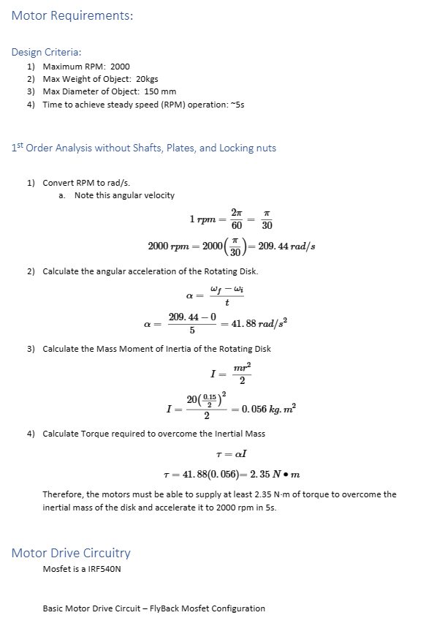

Construction Steps:
Flowchart to follow when writing Arduino code
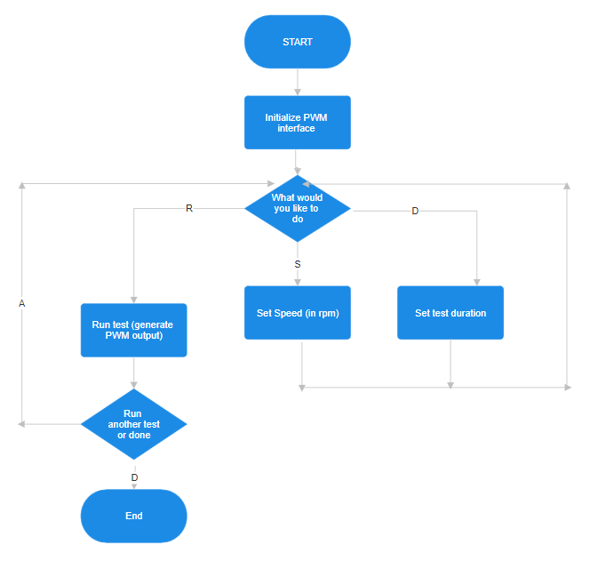

Use the following code for PWM Arduino
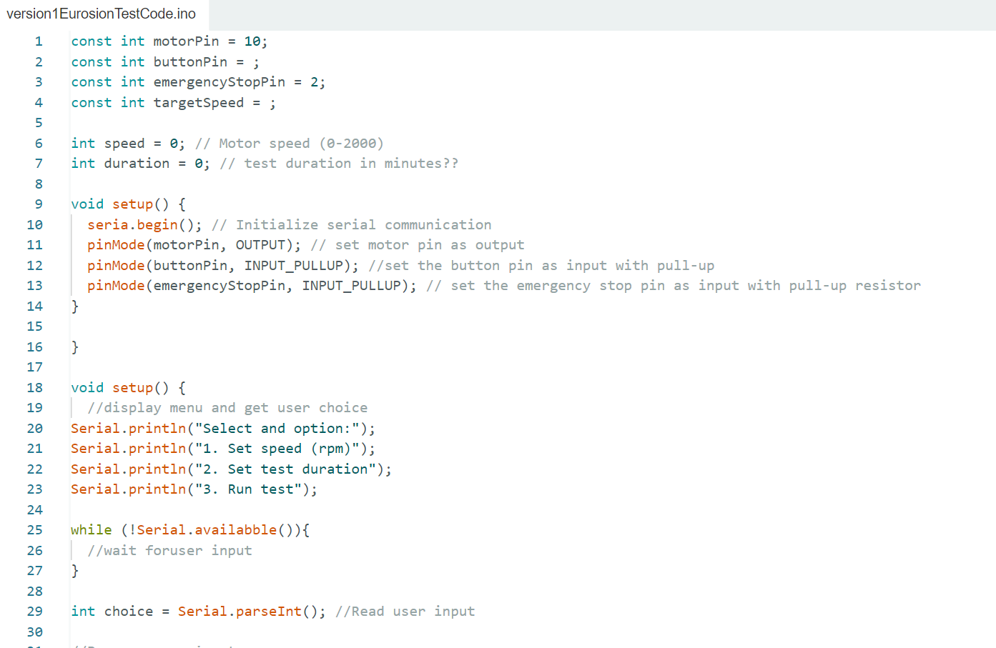
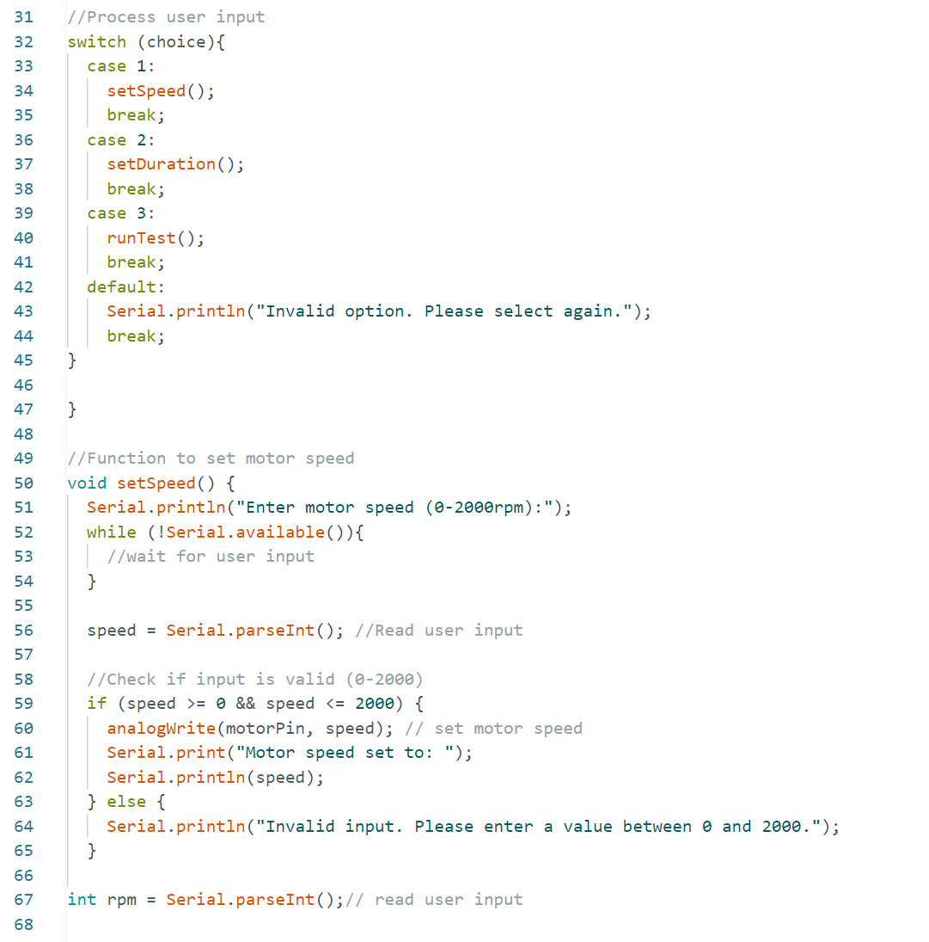
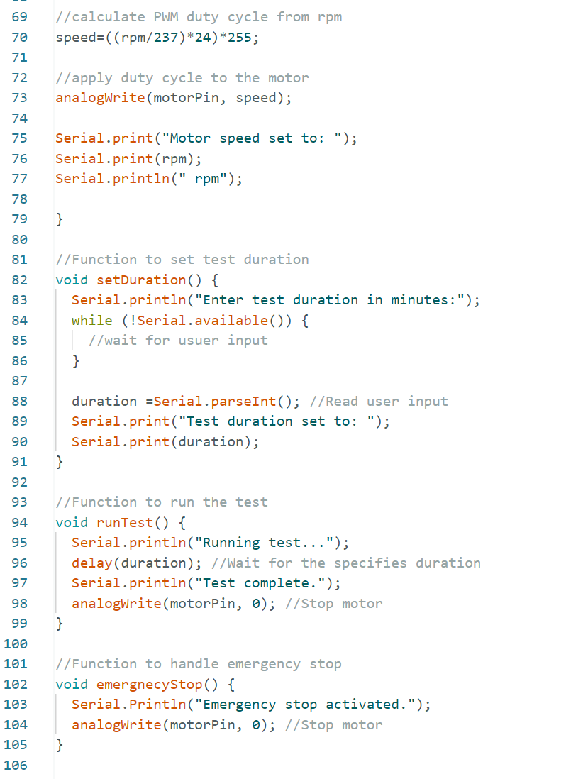

Feedback from clients/users:

Positives:

- Realism of the sample design and real world application
- Detailed CAD models that show each part

Areas for Improvement:

- Square shaped container could cause issues with sediment flow
  - Possible fix: bevel inserts to the corners

Prototyping Test Plan:

Test ID | Test Objective  (Why) | Description of  Prototype used and of  Basic Test Method  (What) | Description of  Results to be  Recorded and  how these results  will be used  (How) | Estimated Test  duration and  planned start  date  (When)
1.0  Test the water tightness of the acrylic tank system | Make sure tank is waterproof | Fill tank with water, and let it for an hour. | Qualitative | 1hour  24/02/24
2.0  Arduino control | PWM motor control functions | Test to insure that arduino is producing correct PWM signals for motor drive circuitry | Qualitative | 30min  29/02/24
2.1  Arduino control | Emergency stop | Test to make sure emergency stop functions, by cutting the power. | Qualitative | 10min  29/02/24
3.0  Motor lid assembly | Looking for excessive current draw and vibration | Initial operation of motor and stub shaft a low rpm (100rpm) | Qualitative | 15-20min  1/03/24
3.1  Motor lid assembly | Looking for excessive current draw and vibration | Operation of motor and stub shaft max rpm | Qualitative | 15-20min  1/03/24
3.2  Motor with sample shaft | Looking for excessive current draw and vibration | Operation of motor and shaft at low rpm (100rpm) without sample | Qualitative | 15-20min  1/03/24
3.3  Motor with sample shaft | Looking for excessive current draw and vibration | Operation of motor and shaft at max rpm without sample | Qualitative | 15-20min  1/03/24
3.4  Morot with sample shaft and sample | Looking for excessive current draw and vibration | Operation of motor, shaft, and sample at nominal rpm with sample | Qualitative | 15-20min  1/03/24
4.0  Erosion acceleration test | Looking for excessive current draw and vibration | Operation of motor and shaft at max rpm without sample | Qualitative | 1 week  10/03/24

The red highlighted part of the project is already completed and was our prototype 1, which proved a success with no flaws. The green highlighted part is our next week’s prototype.

Prototyping Test Plan for Motor Lid Assembly:

Objective:
The objective of this test plan is to validate the functionality and effectiveness of the motor lid assembly for our prototype. By testing the motor with the lid assembly in various configurations, we aim to ensure smooth operation and proper sealing of the container.

Test 3.1: Motor Lid Assembly

- Objective: To assess the proper alignment and attachment of the motor to the lid assembly.
- Procedure:
- Securely attach the motor to the designated mounting points on the lid.
- Ensure proper alignment of the motor shaft with the designated opening on the lid.
- Verify the stability and firmness of the motor attachment.
- Measurements/Assessments:
- Alignment of motor shaft with lid opening.
- Stability of motor attachment.
- Acceptance Criteria:
- Motor shaft is centrally aligned with the lid opening.
- Motor attachment is secure and does not wobble or shift.
- Expected Outcome: Motor is correctly mounted and aligned with the lid assembly, ready for further testing.
- Stopping Criteria: If the motor attachment is not secure, or if the alignment is significantly off, the test will be stopped for re-evaluation and adjustments.

Test 3.2: Motor with Sample Shaft

- Objective: To evaluate the motor's functionality when attached to the sample shaft.
- Procedure:
- Attach the sample shaft securely to the motor shaft.
- Activate the motor to rotate the sample shaft.
- Observe the rotation speed and stability of the sample shaft.
- Measurements/Assessments:
- Rotation speed of the sample shaft.
- Stability and smoothness of rotation.
- Acceptance Criteria:
- Sample shaft rotates at the desired speed without erratic movements.
- Rotation is smooth and consistent.
- Expected Outcome: Motor effectively rotates the sample shaft, demonstrating its functionality for the intended purpose.

Test 3.3: Motor with Sample Shaft (Load Test)

- Objective: To assess the motor's performance under the load of the 3D sample.
- Procedure:
- Load the designated sample material onto the sample shaft.
- Activate the motor to rotate the loaded sample shaft.
- Observe the motor's ability to maintain rotation with the added load.
- Measurements/Assessments:
- Rotation speed and stability with the loaded sample shaft.
- Motor temperature during operation.
- Acceptance Criteria:
- Motor maintains rotation speed within acceptable parameters with the load.
- No signs of overheating or strain on the motor.
- Expected Outcome: Motor demonstrates the ability to rotate the sample shaft -effectively even under the load of the 3D sample, indicating suitability for intended use.

Analytics of Critical Components:

Cost Spreadsheet (BOM):

Item# | Material | Element | Quantity | Dimensions | Unit Cost | Total Cost | Getting from
1 | Sand | Abrasive | 1 cup | None | $0.00 | $0
2 | Acrylic | Tank | 1 | 350x350mm | $8 | $8 | Boreal Power System
4 | Motor | Rotates Shaft | 1 | 78x100mm  RPM at Nominal Voltage: 5600  Stall Torque:5Nm | $50.00 | $50.00 | Boreal Power System
5 | Stainless steel rod | Shaft | 1 | 12.5mmx115mm | $8 | $8 | Boreal Power System
6 | aluminum/rubber | Coupler | 1 | 40x30mm | $3 | $3 | Boreal Power System
7 | Washers | Fasteners | 36 | M6 | $.02 | $0.7 | Boreal Power System
8 | Screws | Fasteners | 36 | M6x16 | $0.10 | $3.50 | Boreal Power System
9 | Water (in Liters) | Liquid | 5 | N/A | $0.00 | $0.00
10 |  | Power Supply | 1 | 24v DC  42A | $15 | $15 | Boreal Power System
11 | Arduino Board | Controls | 1 | ‎8x5.51x2.49 cm | $0.00 | $0.00 | Boreal Power System
12 | Aluminum plate | motor support | 3 | 95x125mm | $1.00 | $3.00 | Boreal Power System

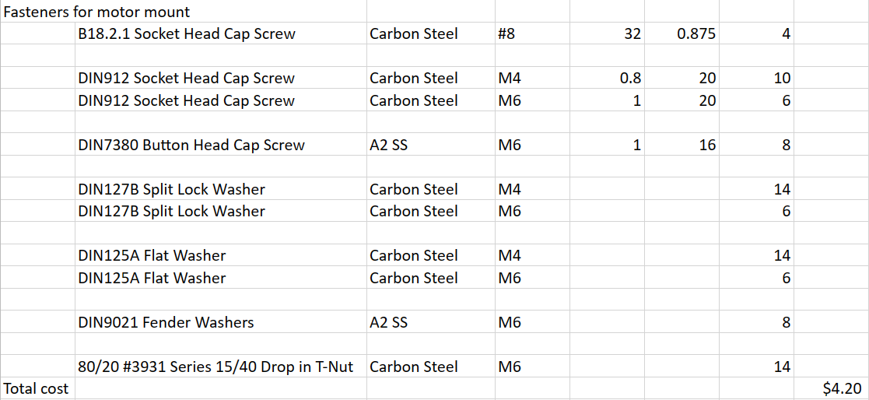
From Boreal Power System

Note: Boreal Power system has all the materials needed in surplus/scrap, will get an invoice from them for the prices listed above.

Total: 95$

