Project Deliverable F: Prototype I and Customer Feedback

University of Ottawa

GNG1103: Engineering Design

November 5th 2023

Group 6

Name: Student Number

Oreofe Oluwatayo (300240663)
Betselot Delnessahou Tadesse (300320450)
Tharshaon Thirukumaran (300297258)
Sohan Udayashankar (300323950)

Abstract

The adaptive necessities of living alongside killer robots is reflected in the environment in which people live. Therefore, the immersive VR environment of Mines Action Canada will be the most important feature to create correctly. Prototype I established a generic city environment that will be used as the basis for the VR experience. Prototype testing was performed and the environment was successful in being realistic and rendered successfully. Furthermore, the environment is traversable by users and successfully implemented colliders to prevent going through objects. The design criteria, bill of materials and target specifications were updated to reflect the progress made by prototype I. Prototype II will focus on implementing VR capabilities since it is integral to an immersive VR experience. It will be tested according to the Prototype II test plan in the upcoming deliverable. Overall, the project is on schedule and is expected to meet target deadlines.

1. Introduction 4
2. Client Meeting Results and Feedback 4
3. Analysis of Critical Elements 4
4. Prototype I 5
4.1. Results 5
4.1.1. Overview 5
4.1.2. Prototype Plan Results 6
4.2. Illustrations and Initial Renders 7
4.3. Storyline Elements 8
4.4. User Controls 9
4.5. Dynamic Elements 9
4.6. Visual 9
4.7. Audio 9
5. Prototype II Test Plan 9
6. Bill of Materials 11
7. Target Specifications 12
8. Conclusion 14

Introduction
Mines Action Canada has tasked Rust in Peace to develop an immersive VR experience that highlights the threat of autonomous killer robots on non-combatants. Important design criteria for this project include realism, human adaptations, generating an emotional response in users and ultimately inspiring preemptive banning of this technology. In a client meeting, our team received feedback on concepts and prototypes and we used this to generate our first prototype. The goal of the first prototype was to develop an immersive VR environment that resembled a realistic city. This included developing buildings, ambient sound effects and objects. Overall, the first prototype successfully passed initial testing and further testing in a second prototype will be used to develop VR capabilities. Further prototypes will also be used to create specific objects highlighting adaptations to autonomous killer robots.

Client Meeting Results and Feedback
During our presentation, our client “Mines Action Canada” gave us their opinions and feedback. We took their constructive feedback and amended our project accordingly. Although they agreed on our general concepts, they had concerns about the length of our story due to the lack of time. They liked our robot and environment (adaptation) design as well as our inventive ideas that reflected human adaptation (ex. nets). Consequently, they felt that our original storyline had too many complicated elements and therefore needed more time and skills to be completed. To accommodate their request to simplify our storyline by using only Storyboard III, we removed the first scene where the main character was shown in his bedroom. We will now be focusing on the main character walking to work in an alley where we can add different details such as human adaptations to the killer robots.
The second feedback they gave us was a new aspect of sound design that we can use to show how people react to living with killer robots. They suggested that we add a regular heartbeat sound effect to our main character and a fast heartbeat to our main character when he is in the presence of killer robots. We took this idea into consideration and downloaded these sounds along with the rest of our ambient sounds as shown in our bill of material.

Analysis of Critical Elements
Two critical elements of the design project are custom environmental assets and sound effects. Firstly, environmental assets will be developed by finding generic 3D assets online and importing them into Blender to edit and create a final asset. The asset will then be imported into Unity and a comparison to the desired asset will be made. The object will then be modified and the process will repeat until it meets design standards. This process is highlighted in Figure 1. Furthermore, sound effects will be implemented by creating scripts that will execute upon user interactions with environmental objects. A feedback loop is used to iterate over this process until the desired sound effect is achieved through user interaction. The ideal result is evaluated by the developers and test users. This process is demonstrated in Figure 2.

Find default asset on VR asset databases
Import asset into Blender and edit
Idea for background item
Asset ready for import into VR setting
Programmer compare custom asset to desired item

Figure 1: Block diagram process of how generic 3D assets will be transformed into custom game assets for use in the final unity project.

User Interaction
Code Block execute
Add audio into code block
Output Sound
Desired sound compared to actual

Figure 2: Block diagram process of how sound effects will be implemented in the game environment through user interactions. Scripts will be executed upon user interactions and a feedback loop is used to iterate until the desired sound effect is achieved.

Prototype I
The first prototype focused on creating a relatively high-fidelity prototype that focused on building an environment. This is one of the most important aspects of the design project since the VR experience takes place in a scene which is the focal point of the project. Therefore, careful consideration was given to testing the prototype and measuring the results. A summary of the prototype tests is highlighted in Table 1. Overall, the first prototype passes most tests and appears to be a realistic city environment. However, it was somewhat generic and needs to highlight adaptations that are representative of living alongside autonomous killer robots.

Results

Overview
Our first design is an environment-based prototype where we set the layout for the user bounded by non-interactive apartment buildings. The scene takes place in a cityscape with tight paths flanked by tall apartment buildings and shops, providing a sense of familiarity in a world dominated by artificial intelligence (AI) robots. This sense of normalcy will make the adaptations stand out more, strongly depicting a dystopian future if we allow decision-makers to deploy AI technology in civilian sectors. The nighttime environment is portrayed through the light cascading from apartment windows and closed businesses, as well as dim ambient street lighting creating an ominous feeling of being watched. The buildings and shops were taken from a prebuilt asset and modified so that they fit the lighting of the scene. Boundaries were already pre-built into the buildings which was a huge time saver. The experience is not yet immersive as the camera is keyboard-controlled. One adaptation has been added yet we are working towards adding more adaptations and conflict-specific environment designs.

Prototype Plan Results
Table 1: Results of the prototype testing plan for prototype I which focused on building an immersive city environment
Test ID | Test | Testing Method | Results | Pass/Fail
1 | City environment is Realistic | User Feedback | - “Environment looks very good - it looks very real”  - “The environment is scary - I wouldn’t want to be there” | Pass
2 | Environment renders on basic hardware | Measurement | - Environment renders and runs at 30 fps on 2020 M2 Macbook air without dedicated graphics (low-end specs) | Pass
3 | User can move in the environment and look around | Observation | - Game users can move from point to point in the city and look around | Pass
4 | Environmental objects hinder movement | Observation | - Users cannot go through walls and cannot move through objects | Pass
5 | City environment has realistic sounds | User Feedback | - “Wow the city sounds alive - what are those sounds?”  - “Oh cool, you can hear people moving around” | Pass
6 | City shows adaptations to killer Robots | User Feedback | - “The city looks generic, what robots are you talking about?” | Fail

Illustrations and Initial Renders
The prototype was generated in Unity and an overall perspective view of the city environment was screenshotted in Figure 3. Different first-person perspectives of the real-time game environment were screenshotted that highlight the perspective of a user. These screenshots are highlighted in Figures 4, 5 and 6.

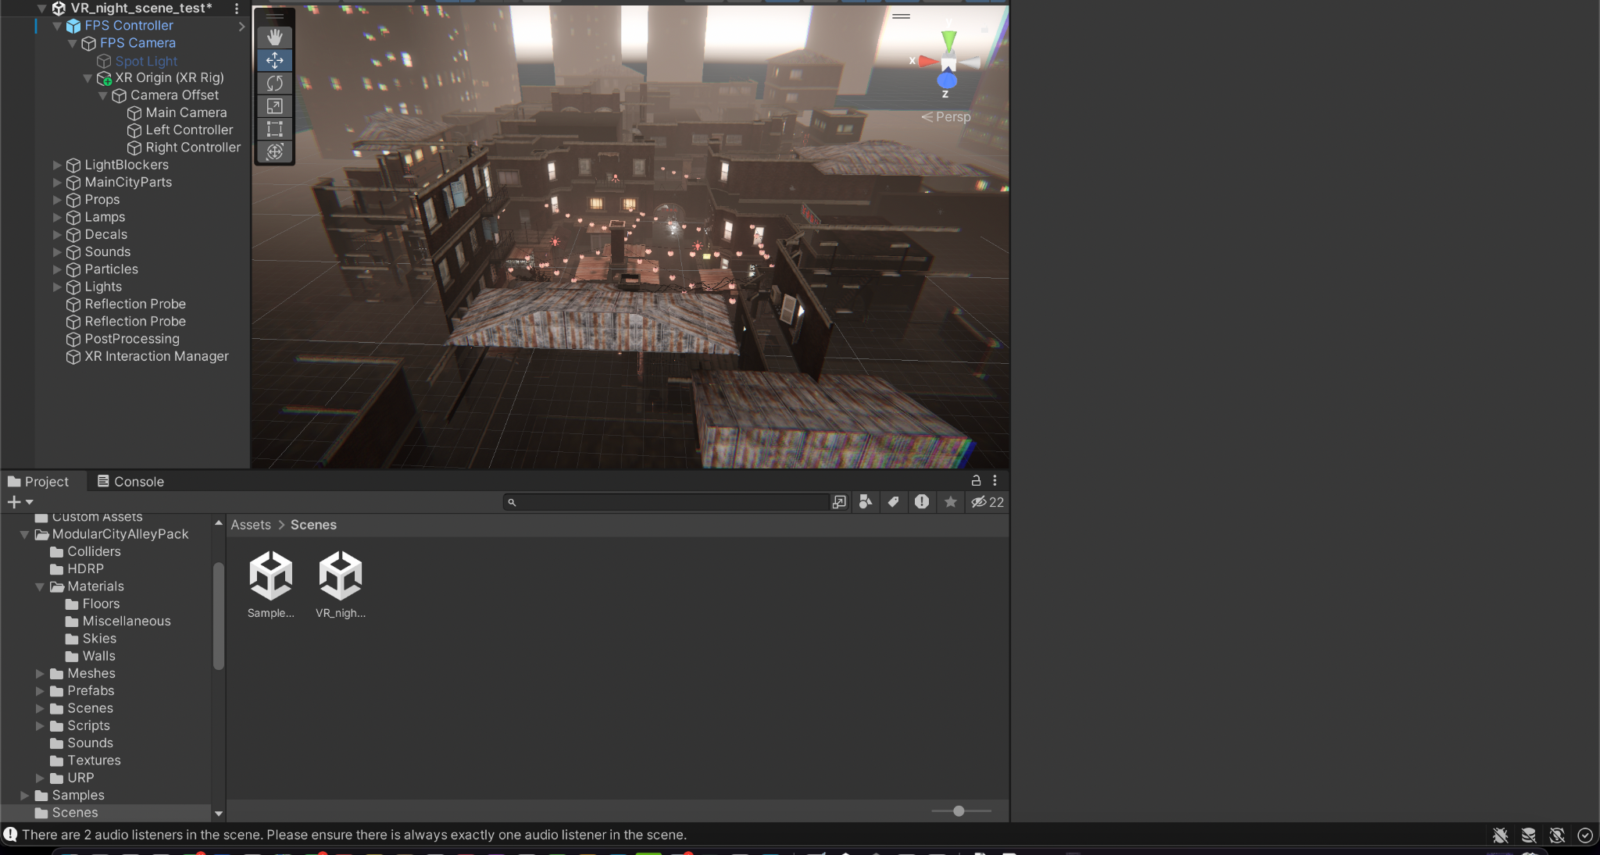
Fig. 3: Overview of the city environment captured in Unity.

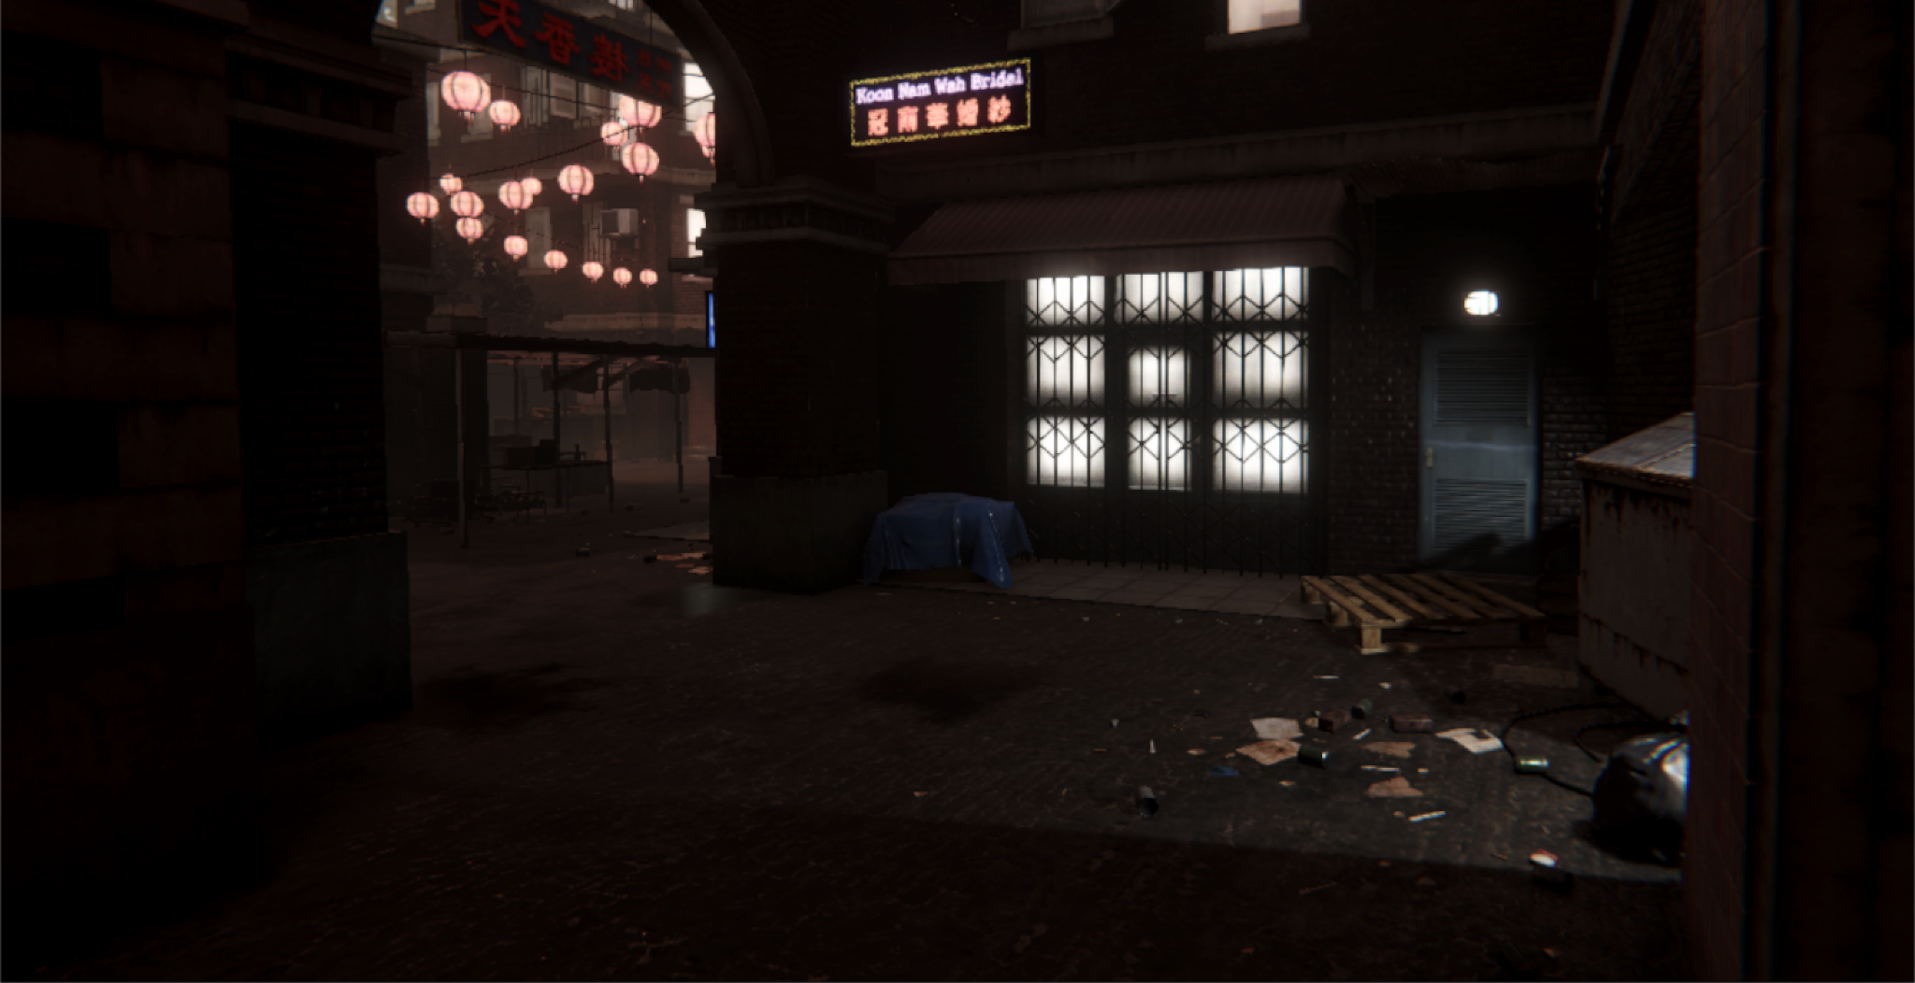
Fig. 4: Alleyway scene in the game environment

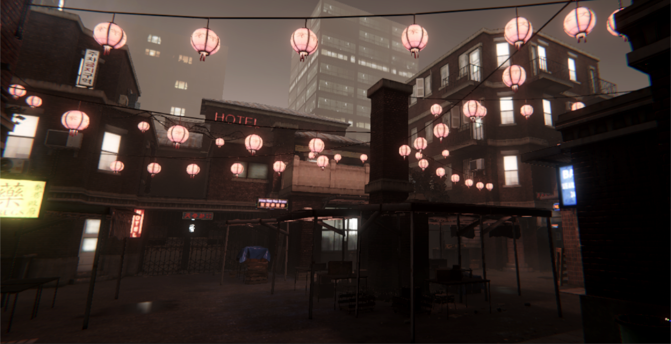
Fig. 5: Main city-center scene in the game environment

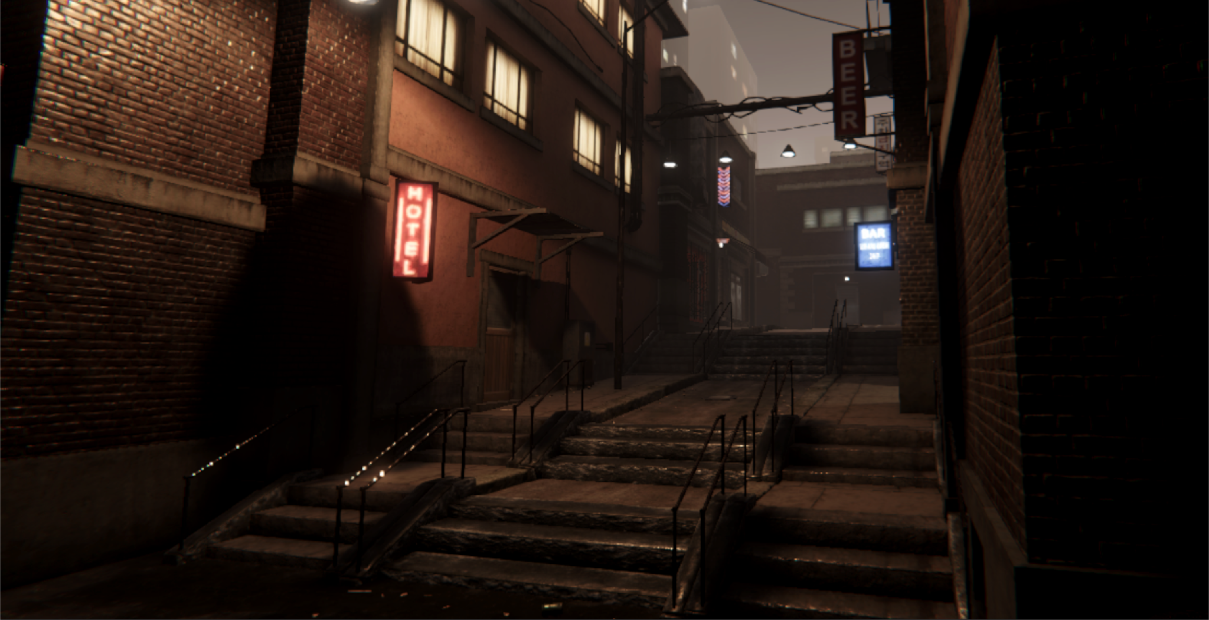
Fig. 6: Staircase leading to an alleyway in the game environment

Storyline Elements
So far, we completed the general city atmosphere that the user will walk through, and the nighttime, desolate environment creates a sense of urgency as the character leaves their workplace late at night, prone to being targeted. Nets have been added overhead as well but we need to add more of these throughout the city. Besides this, there are multiple storyline elements we need to add. The cityscape currently is modeled after a generic city so we need to add elements indicating a conflict. We need to add storefronts and store signs indicating that businesses have shifted to a “civilian protection needs” model, selling items such as masks, reflective/anti-thermal clothing, and anti-drone nets. We also need to add environmental elements meant to alert and keep citizens aware of possible drone threats. This includes adding a curfew time (time of sunset) to the billboards and loudspeakers positioned outside to alert of drone threats (more details in the “Audio” subsection).

User Controls
The current user controls use arrow buttons to move and the mouse to move the camera perspective. These controls are based on a prebuilt script used in the GNG1103 Unity lab where it is being used for design testing and how the city looks from a first-person perspective. In the next deliverable, we plan to implement a virtual reality (VR) camera view which would allow us to start testing our design using the VR headset.

Dynamic Elements
We plan to use no dynamic visual elements as it would be too complicated to implement moving objects, especially objects that dynamically change based on the user. The only dynamic element will be a warning announcement playing when the user crosses a certain threshold.

Visual
The visuals for this prototype were imported from a city pack sourced from Unity Asset Store. The graphics included are a high-fidelity model that includes many details, from light reflections to loose papers and other garbage scattered across city streets. Despite being high-definition, there were no problems rendering and should run on most desktops and laptops considering that we were able to render this on a mid-end Macbook Air. We will continue to monitor render and run speeds as we add more elements to the environment.

Audio
Audio currently includes ambient city noise and distant flowing water to capture a natural living environment. We have yet to add ambient noises specific to the night setting, including crickets chirping, faint conversations from inside buildings, hums of air conditioning units and the ambient whir of drones in the distance. There are several active sounds we need to add: footsteps of the user as they move their character through the city and a warning announcement once the character reaches a certain point on their path home. The speaker will announce a warning that drones have been spotted nearby and to take shelter as soon as possible to avoid confrontation. This will be followed by the sound of rapid heartbeats and heavy breathing for about 10 seconds to capture the panic of the character.

Prototype II Test Plan
In prototype I, the general environment has been established. In prototype II, a VR user interface will be created. The VR interface will be tested to be intuitive, comfortable and responsive. The test plan, as shown in table 2, will be used to measure the quality of the VR capabilities.

Table 2: Prototype II test plan used to measure the quality of the VR interface implemented into the environment.
Test ID | Test Objective  (Why) | What is being figured out  (What) | Testing Method (How) | Attributes to Observe / Record | Duration (When/How Long)
1 | Test if environment is VR compatible | Can a user interact with the world with a VR headset | Connect VR headset to the Unity environment and test movement and hand operations. | Observe if movement is in sync with controller movements and hand positions. | Test in early prototype. Testing should take no more than 5 minutes to conduct.
2 | Test that the VR experience is easy to set up | Is the VR experience user friendly | Observe if users can set up the VR experience on their own and in under 30 seconds | Observe how the user sets up the system and how long it takes | Test in every prototype and continue until satisfied that most users can set up the experience in under 30 seconds
3 | Test that the VR controls are intuitive and comfortable | Is the VR experience ergonomical | Observe how users feel when using the VR experience | Observe if users need to remove the headset, make adjustments or if they become sick. Record any comments about how users felt in the game world | Test in every prototype and stop when users don’t feel the need to comment on comfort and the experience feels seamless.
4 | The VR experience is relatively simple and not too complicated | Is the VR experience not resource intensive and loads efficiently | Measure software parameters and attributes | Measure time to load, size of the program, and time to render graphics in-game | Test in comprehensive prototype and stop when load time is under 15 seconds, size of the program is less than 1 GB and graphics render in-game in under 1 second
5 | Test that the VR experience is accessible | Is the VR experience compatible and accommodating to a broad audience | Survey and observe users | Ask users if they felt if there were any barriers to usability | Test in comprehensive prototype and stop when most users (90%) do not feel their experience was hindered due to a lack of accommodation.

Bill of Materials
The bill of materials remains the same for the first prototype. In Table 3, the items highlighted in green have been implemented/utilized in this prototype while the rest have yet to be implemented.

Table 3: Bill of Materials update with green rows highlighting assets that have been implemented thus far.
Item no. | Description | Quantity | Store | Price (CAD)
#1 | Sound effects | 6 | Freesounds.org | FREE
#2 | Modular city Alley pack | 1 | Unity asset store | $19.80
#3 | 25 Realistic textures | 1 | Unity asset store | FREE
#4 | Street light Pack | 1 | Unity asset store | FREE
#5 | City Alley | 1 | TurboSquid | FREE
#6 | Spray Paint | 1 | TurboSquid | FREE
#7 | Cars | 4 | TurboSquid | FREE
#8 | Billboard_01 | 1 | TurboSquid | FREE
#9 | Fishing Net - Intact and Damaged Low-poly 3D model | 1 | CGTrader | $4.90
#10 | Fishing net | 1 | Sketchfab | FREE
#11 | Masks | 4 | TurboSquid | FREE
#12 | Security Set CCTV Low Poly | 1 | Sketchfab | FREE
#13 | Shop front with male mannequin 3D model | 1 | CGTrader | $13.30
#14 | Old Loudspeakers on the Pole | 1 | Sketchfab | FREE
#15 | Neon Alphabet 3D | 1 | TurboSquid | $5
#16 | 3D Glow - Neon Sign Asset Pack | 1 | TurboSquid | FREE
#17 | Unity | - | - | FREE
#18 | Computer | - | - | -
#19 | VR controllers | - | - | -
Total | - | - | - | $43

Target Specifications
With the completion of prototype I, target specifications were updated to reflect progress. In Table 4, design criteria that have been met, are in progress and need to still be addressed are shown. This update will be used to track progress and highlight what still needs to be worked on.

Table 4: Target specifications updated values. Neon green indicates completed target specifications. Light green indicates specs that are expected to be met. Red indicates specs that are not on track. White indicates specs that have not been addressed in the prototype.
Design specification | Relation  (<, >, =) | Value | Units | Verification
Functional
Environmental Adaptations | = | Yes | N/A | Testing/Review
Emotion evoking | = | Yes | N/A | Testing/Review
Realism | = | Yes | N/A | Testing/Review
Engaging | = | Yes | N/A | Testing/Review
Story Driven | = | Yes | N/A | Testing/Review
Call to Action | = | Yes | N/A | Testing/Review
Informative | = | Yes | N/A | Testing/Review
Dissuade use of autonomous robots | = | Yes | N/A | Testing/Review
Non-Functional
Reliability | = | Yes | N/A | Testing/Review
Storage Space | <= | 2 | Gigabytes | Measure
Safety | = | Yes
Ease of Use | = | Yes | N/A | Testing/Review
Loading Time | <= | 30 | seconds | Measure
Response Time | < | 200 | milliseconds | Measure
Frame Rate | >= | 30 | Frames per second | Measure
Set-up Time | <= | 1 | minute | Measure
Constraints
Cost | <= | 50 | $ (CDN) | Measure
Hardware Requirements | <= | Mid-Range Smartphone | N/A | Test/Review
Disturbing Content | = | No | N/A | Test/Review
No Deadnaming | = | Yes | N/A | Inspection
Duration | <= | 30 | seconds | Measure
Deadline | <= | 2 | months | Measure

Conclusion
The effects of autonomous killer robots are best reflected in the adaptations that civilians will implement in their environment. Therefore, the general environment is one of the most important features to establish. In prototype I, we developed a general city environment which is the home of people living alongside killer robot drone attacks. This environment was built using feedback from the client and design criteria. We then tested the prototype according to the prototype test plan and found the environment was realistic and functional. Therefore the first prototype was successful. We updated the design criteria and will move forward on the next prototype which will focus on developing VR capabilities. This is an important feature since it is integral to the immersive user experience. The VR will be tested according to the prototype II test plan and will be presented in the upcoming deliverable.

