TEAM CONTRACT

GNG5410

Team Members:

1) Jonathan Horton

2) Sachin Kasbekar

3) Gaurang Lele

4) Kristina Prasad

5) Raghav Kaushik Vagata Umesh

Team Procedures

- Day, time, and place for regular team meetings:

Mondays. The time and place of the meeting will be decided by team members in advance. We can arrange more meetings if such a need arises by discussing with team members in advance.

- Preferred method of communication (e.g., e-mail, cell phone, Facebook, Blackboard Discussion Board, face-to-face, in a certain class) to discuss the project and to inform each other of team meetings, announcement, updates, reminders, problems:

Microsoft Teams
E-mail

- Decision-making policy (by consensus? by majority vote?):

By consensus
If the decision cannot be achieved as the result of consensus, then by majority vote

- Method for setting and following meeting agendas (Who will set each agenda? When? How will team members be notified/reminded? Who will be responsible for the team following the agenda during a team meeting? What will be done to keep the team on track during a meeting?):

- The team leader will set up online recurring Microsoft team meeting and invite team.
- The agenda for the following week will be decided in advance of the weekly team meeting depending on group assignments and tasks that need to be completed
- The lab and preferred method of meeting will be discussed in advance
- The meeting agenda during the weekly team meeting will be maintained by a team leader and stored in teams channel (Meetings (Agenda, minutes and action items))
- The team leader will also be responsible for the team to follow the agenda during the team meetings and keep the team on track during a meeting

- Method of record keeping (Who will be responsible for recording & disseminating minutes? How & when will the minutes be disseminated? Where will all agendas & minutes be kept?):

- The team leader will take note of a meeting and share it after the meeting by e-mail.
- Notes will be stored in teams channel (Meetings (Agenda, minutes and action items))

Team Expectations

Work Quality

  - Project standards (What is a realistic level of quality for team presentations, collaborative writing, individual research, preparation of drafts, peer reviews, etc.?):

All individual tasks, presentations, drafts, individual research, peer reviews, etc. should:
- Consistently follow grammar, punctuation, and spelling rules correctly
- Have well-organized and coherent ideas
- Have solid and satisfactory level of reasonable content
- Represent satisfactory and accurate understanding of the topic
- Have required/reasonable length of content

If someone feels overwhelmed by the task or has questions, notify the team as soon as possible.

  - Strategies to fulfill these standards:

- During our weekly meetings, the team will review and discuss any work in progress or completed that is supposed to be submitted during that week. If any of the team members has corrections, they will be addressed by the team and the course of actions will be decided.
- Each team member should attend the meeting prepared and by possibility review/provide comments on the work of other team members.

Team Participation

- Strategies to ensure cooperation and equal distribution of tasks:

- The team will work together as one unit. However, sometimes we will need to distribute the tasks to different members/sub-groups to achieve our set goals in a timely manner.
- Clear and open communication of all issues/problems that have arisen will help the team to stay on track.
- The team will review all task assignments of the week and ensure that all work is distributed evenly.

- Strategies for encouraging/including ideas from all team members (team maintenance):

- We will be open to hearing all suggested ideas without judgment. Everyone is encouraged to bring their suggestions.
- We should be quick on taking the decision as a team on proceeding or not with new suggestions

- Strategies for keeping on task (task maintenance):

- Every deliverable team leader will help the team to stay on task and inform the team of any difficulties with carrying out the task as soon as possible. We will decide together as a team what alternatives are possible if such issues arise.
- Every team member will communicate as soon as possible if the task cannot be completed on time.

- Preferences for leadership (informal, formal, individual, shared):

- Informal collective leadership.
- Everyone contributes to the decision.

Personal Accountability

- Expected individual attendance, punctuality, and participation at all team meetings:

- We will meet on time with a five-minute grace period.
- If someone cannot attend the meeting, please notify the team
- If someone is going to be late, please notify the team

- Expected level of responsibility for fulfilling team assignments, timelines, and deadlines:

- We will set deadlines for the tasks mentioned. If a team member feels he/she cannot achieve the goal on time, then he/she should communicate their difficulties as soon as possible.
- Each team member will do the assignment to his/her best ability.

- Expected level of communication with other team members:

- We will communicate about all the needs, deadlines, mistakes, difficulties openly and on time.
- We will support each other in all communication to the best of our ability.

- Expected level of commitment to team decisions and tasks:

- Each member is expected to commit equally towards the final project goal.
- Be aware of your schedule and do not commit to the task that you may not have the time for.
- It is fair to spread the workload evenly so that no other team members would feel overloaded or overwhelmed.
- We are all open to helping other team members in need.

Consequences for Failing to Follow Procedures and Fulfill Expectations

- Describe, as a group, how you would handle infractions of any of the obligations of this team contract:

- If any infractions happen, we will discuss them during the weekly meeting or in the lab.

- Describe what your team will do if the infractions continue:

- We will discuss the issue together as a team and decide on a further plan of action such as contacting the TA or professor.

***************************************************************************

- I participated in formulating the standards, roles, and procedures as stated in this contract.
- I understand that I am obligated to abide by these terms and conditions.
- I understand that if I do not abide by these terms and conditions, I will suffer the consequences as stated in this contract.

1) Kristina Prasad date Jan 16, 2024

2) Gaurang Lele date Jan 16, 2024

3) Raghav Kaushik Vagata Umesh date Jan 16, 2024
4) Sachin Kasbekar date Jan 16, 2024

5) Jonathan Horton 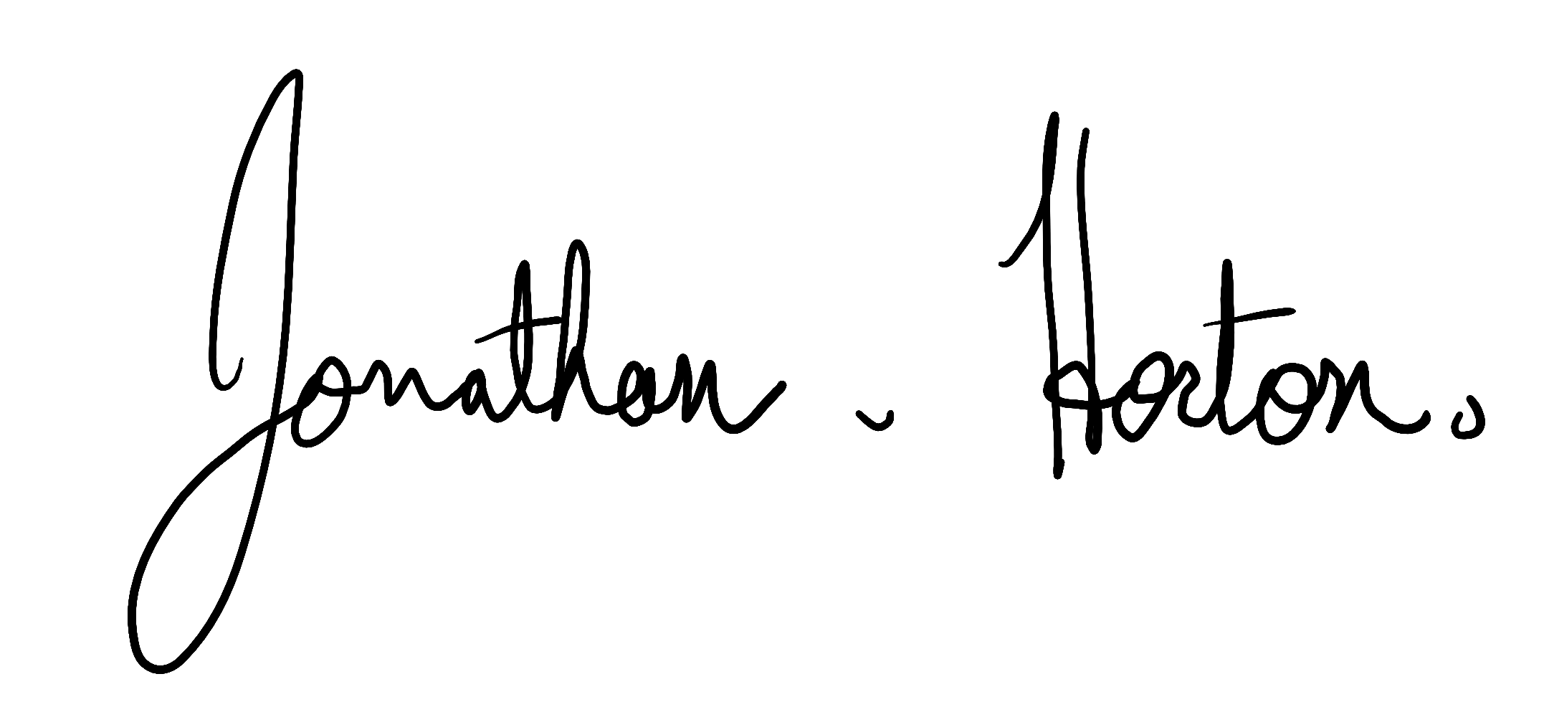 date Jan 16, 2024

* This template was adapted from https://cns.utexas.edu/images/CNS/TIDES/teaching-portal/Team_Contract.doc

