GNG5140

Inclusive Bike – Design Requirements and Project Plan
Deliverable C

Submitted by
Group A - Inclusive Bike
Jonathan Horton
Sachin Kasbekar
Gaurang Lele
Kristina Prasad
Raghav Kaushik Vagata Umesh

2024-02-15
University of Ottawa

Abstract
The design requirement and project plan consist of a list of metrics which are used to define the quality of the existing prototype. The existing prototype is rated in the metrics and compared with the final prototype later. The design features and flaws of the current prototype are explained in detail along with their supported data. Furthermore, the testing results from multiple users are captured and analyzed. The problem statement is updated with added knowledge gained from product research and client feedback. The revised problem statement is used to revise the design requirements. A set of new prototypes are conceived which tackle the design requirements in different ways. These prototypes are documented with their pros and cons detailed.

Table of Content

Abstract i
Table of Content ii
List of Figures ii
List of Tables iv
1 Introduction 5
2 Existing prototype test results and analysis 6
2.1 List the metrics you will use to define the “quality” of the existing prototype or product you will test. 6
2.2 Design features and flaws 7
2.3 Capture user-testing results 9
3 Provide revised prototype requirements, problem statement and prototype definition 10
3.1 Intended design fixes and improvements based on your testing results and analysis. 10
3.2 Provide a list of revised design requirements. 10
3.3 Provide an updated problem statement. 10
3.4 Define new prototypes. 11
4 Conclusion 14

List of Figures
Figure 1: Attachment at the front 11
Figure 2: Attachment at the side 12
Figure 3: Attachment at the rear 13

List of Tables
Table 1: Metrics 6

Introduction

This report explains the stages before the creation of the initial prototype in detail. We have discussed with the client, tested the initial prototype, created different conceptual designs and are on the verge of selecting the final design which will be created into the initial prototype. The client requirements have been discussed thoroughly. The main focus of this project will to increase the safety of the existing prototype and make it usable.

Existing prototype test results and analysis

List the metrics you will use to define the “quality” of the existing prototype or product you will test.
The given table represents the metrics we are planning to use to evaluate the performance of the existing prototype.

Metric # | Need # | Metric | Importance  (1-5) | Value | Units
1 | 1, 2, 3, 6, 7, 11 | Overall mass | 4 | 15-68 | kg
2 | 3, 7, 11 | Maximum weight capacity | 5 | 150 | kg
3 | 6 | Max/min wheelchair wheel size | 4 | 91 cm tall, 81 cm long. | cm
4 | 5, 6, 11 | Max/min wheelchair width | 4 | 64 cm wide | cm
5 | 2, 5, 12 | Time to “mount” wheelchair | 3 | <120 | s
6 | 2, 3 | Pedaling force | 4 | 200 | N
7 | 1, 3, 7, 13, 14 | Speed ratios | 4 | 2-26 | km/h
8 | 3, 7, 12 | Track width | 3 | 84-96 | cm
11 | 3, 7, 14, 16 | Braking distance at speed | 5 | <8-10 | m
14 | 9 | Appearance | 4 | #/10 | subj.
16 | 10 | Reflector size | 2 | 4 | cm²
17 |  | Additional cargo space | 1 | 0-50 | cm³
18 | 2, 3 | Steering force | 2 | >10 | N
19 |  | Steering angle | 4 | >45 | º
20 |  | Operating temperature | 2 | 0-40 | ºC
21 |  | Attachability | 3 | Yes/No
Table 1: Metrics

Design features and flaws
After analyzing the available documentation for the existing attachment, examining the prototype itself visually and evaluating the requirements and comments of the client on it, we can outline some of the existing features and flaws we noticed. The previous team who developed the Inclusive Bike prototype described the process of working on it, materials and methods they used to assemble the prototype, what features they managed to accomplish before the Design Day and what they would like to see improved in the prototype.
Features of the existing prototype are mostly summarized from the visual analysis of the attachment and from available documentation from the previous team.

Features:
- The existing prototype is made of steel tubes of 1” diameter that were welded together using half-mooning method to overlap the tube with the other tube. It is described as the strongest and safest method to connect pipes. These particular pipes were chosen because it was cheaper than aluminum and for its ability to be kept outside year-round.
- The wheels are attached to the carriage using the wheel mount forks from a bike, that were cut and then welded onto the carriage. That way, the width can be measured on each side for both wheels. The tires used are 26” bicycle tires, large and strong enough to carry weight up to 150 kg (the weight capacity as stated in documentation).
- The attachment is painted with red spray paint to conform the previous client request.
- The mounting onto the bike is carried out by removing the front wheel from the fork at the front of the bike and securing the pole of the prototype using U-shaped bolt and a wrench to fix it in front of the bike.
The flaws of the existing prototype are outlined from the review of conclusions and recommendations for the future work from the previous team, visual observations of the existing prototype and requirements that the client stated on the first meeting.

Flaws:
- The system needs to have steering angle improved
The previous team stated in their documentation that the steering angle of the attachment needs to be improved.

- The turn indicators and break lights are lacking
The client stated that she would like to have turn indicators and break lights added to the bike attachment for the improved visibility on the trail and communication with other users of the trail. The same recommendation is mentioned by previous team and our team came to this conclusion after observing the prototype.

- The existing attachment is lacking a ramp
The addition of a locking ramp for convenience so that the client's helper can quickly put the wheelchair on the carriage’s platform, is one of the requirements of the client, as well as it is mentioned in the previous team’s documentation and also was observed by our team.

- The safety straps absent
One of the main client’s concerns was the safety of the wheelchair user during a ride. We all came to a conclusion that the wheelchair needs to be safely secured on the platform of the attachment to the bike. The previous team documentation mentions strapping the wheelchair to the prototype for safety but we haven’t observed any solution for that purpose.

- The material of the prototype floor is wood and requires attaching to the prototype frame
In documentation of the previous team is mentioned that the floor of the prototype is meant to serve as a ramp and then it is supposed to be attached with the bolts to the frame before the ride. From our observation, the material of the floor is not very reliable as it will not withstand wet and muddy conditions. Its durability and weight capacity are under a question too as well as the convenience of screwing it down every time before the ride. We plan to replace the floor material for the metal, have it permanently fixed on the frame and add a ramp or a structure serving that purpose.

- The mounting onto the bike
When observing the carriage, we came to a conclusion that the mounting of the prototype onto the front fork of the bike is inconvenient, troublesome and brings a lot of difficulties to steering the bicycle with the carriage attached to it. We are planning to look into that aspect during our work on the improvement of the prototype.

- The carriage lacks braking system
The previous team mentions in their documentation that they would like to wire a braking system to the wheels of the prototype. If the carriage stays attached in the front of the bike, braking system controlled by the biking person makes sense. If the mounting of the prototype will be moved to the back, then only parking brake makes sense due to safety reasons.

Capture user-testing results
  - The existing prototype is not in a testable condition.
  - As per the client, the user-testing can only be conducted after the initial prototype is ready.

Testing and Results:

- Weight of the attachment: 17.7 kg (attachment) + 0.95 kg (mounting) + 2.26 kg (wooden flooring)
- Weight of the wheelchair: 15 kg
- Time taken for the wheelchair to be put onto the attachment: 12 secs
- Maximum deflection of the wooden base using a force of 80 kgs (80*9.8 = 784N): 2.0-2.4 cm – 200% of wooden ply thickness

Planned Testing that was scrapped:

- Testing the connection of attachment with the bike.
Not possible because of the lack of a bike and a lack of a proper attachment system on the existing prototype.

- Testing the time, it takes to hoist the person on the wheelchair into the attachment and strap them in.
Not possible because of the broken wooden base and a lack of safety straps on the existing prototype.

- Testing the stopping ability and braking distance of the bike with the prototype attached.
Not possible due to a flimsy attachment mechanism which makes it unable to turn in-turn making it impossible to ride a bike with the module attached.

Provide revised prototype requirements, problem statement and prototype definition

List of intended design fixes and improvements based on your testing results and analysis.
    - Replacing the wooden flooring panel on the existing prototype with thicker sheet metal that can carry more load and looks aesthetically pleasing.
    - Adding safety straps which can strap in the wheelchair into the attachment.
    - Reinforcing of the steel tubes used in the previous prototype.
    - Changing the position of the attachment to decrease the mounting time onto the bike.
    - Adding a ramp, to decrease the time and effort it takes for the rider to put the wheelchair in place on the attachment.
    - Adding a GPS system to increase the functionality of the attachment.
    - Adding a SOS button in case of emergencies to increase functionality.
    - Adding rear brake and turning signals to increase safety.

Provide a list of revised design requirements.
- The attachment must have a maximum capacity if 150 kg.
- The attachment must have increased safety features.
- The attachment must have safety straps.
- The attachment must have a stronger base as compared to the existing prototype.

Provide an updated problem statement.
An attachment that can be mounted to a conventional bike which can enable wheelchair users to ride on bike paths during normal weather at slow to medium speed. The bike rider will load the wheelchair user onto the attachment and secure them in place. The attachment will also be equipped with safety features such as a GPS system and braking and turning lights

Define new prototypes.

- Attachment at the front.
The attachment will consist of a platform surrounded by metal pipes which act as a cage. There will be a small ramp attached to the platform for the easy movement of the wheelchair. This attachment will be connected to the front of the bike. The process for attaching will include removing the front wheel and placing the rear of the attachment onto the bike fork and locking it.

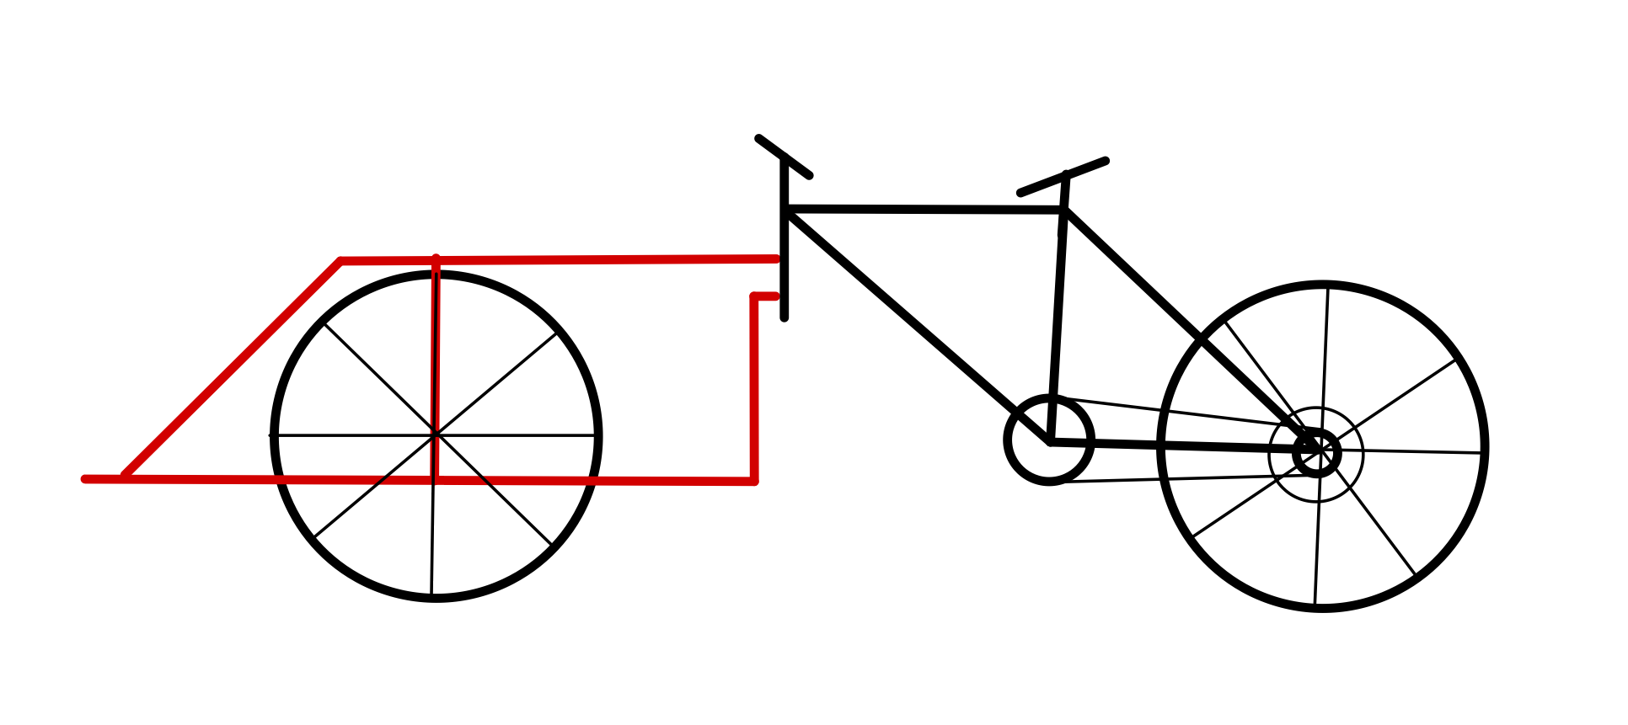
Figure 1: Attachment at the front

Pros:
- Total length of the bike and the attachment is lesser than when the attachment is mounted to the back.
  - Easy to integrate with the bike.
  - The wheelchair user has a good frontal view.

Cons:
- The front wheel has to be removed for the attachment to be mounted to the bike.
- Turning of the bike will be quite difficult for the rider of the bike as they will have to turn the front wheel accounting for the weight of the attachment, the wheelchair and the person sitting in the wheelchair.

- Attachment at the side.
The attachment at the side of the bike will take inspiration from the sidecars that were attached to motorcycles in the past. The attachment will be a platform with either a front or a back sided entry. It will be attached to the centre span of the bike at two points with clamps.

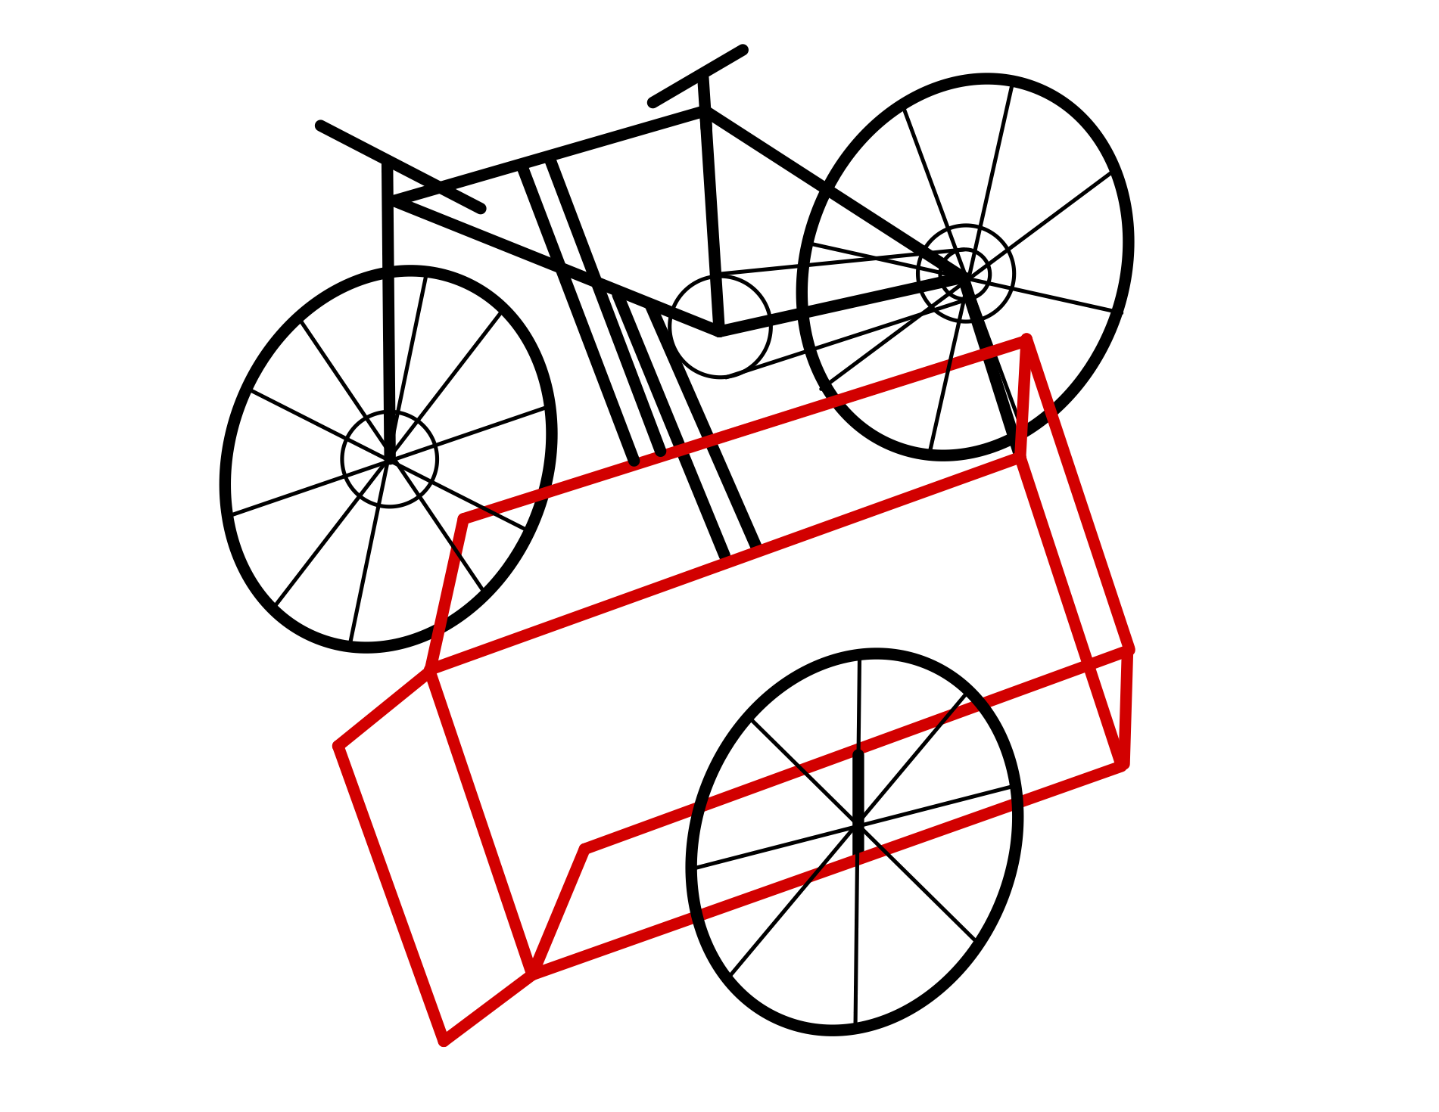
Figure 2: Attachment at the side

Pros:
- The length of the system is the shortest when compared to all the other designs.
- The wheelchair user will have good frontal view of the road.

Cons:
- The width of the bike and the attachment is much more than the width of a standard bike path in Canada.
- High-Speed turning capability is compromised.

- Attachment at the rear
The attachment will be behind the rider. It will be the easiest to mount and dismount compared to all the other options. The design of the attachment will be the same as the other two designs. The mount will consist of two bent pipes which will be welded together and connect the attachment and the bike around its rear wheel.
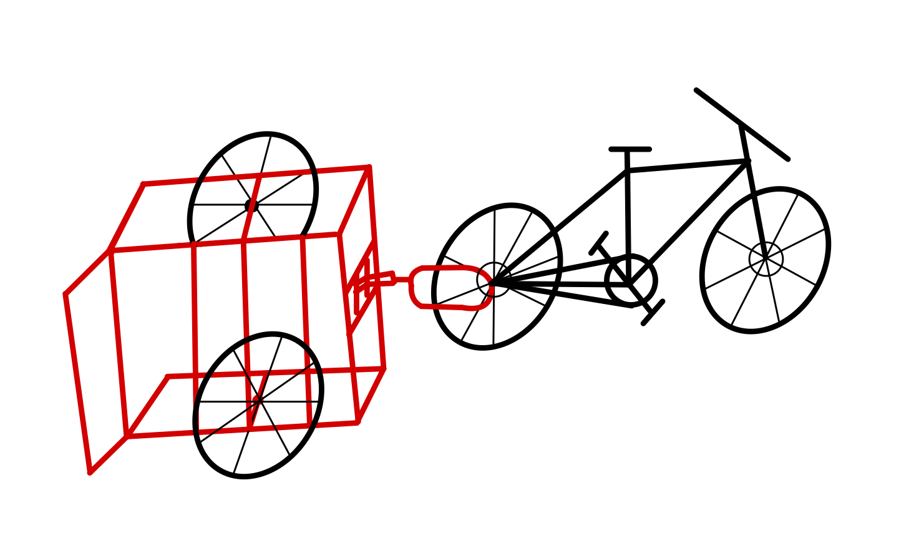
Figure 3: Attachment at the rear
Pros:
- Easiest to mount and dismount.
- Easiest for the rider to control in-case of an accident.

Cons:
- Difficulty in communication as the wheelchair user is behind the rider.

Conclusion

This deliverable involved all of our group members’ inputs for the three initial prototypes. Many different ideas were congregated and analyzed. The three prototypes listed above are a result of that analysis. Some of the testing that we hoped to do on the existing prototype can’t be done because of the condition of the existing prototype. We have a plan to incorporate all of the needs and details that we have learnt from the client. We will be in touch with the end-user through our client after our initial prototype is ready. To conclude, the purpose of this deliverable was to finalize the three initial concepts from which we will choose to develop the one which suits the needs of the client and the user the bes

