Conceptual Design

George Lau, Jake Beattie, Jorge Preciado, Luka Braculi, Steven Lin

February 11th, 2024

Abstract
This is a document which explains the choice of our conceptual design, based on the previous design criterion, in respect to the importance of different factors.

Introduction
The client has requested the students of the University of Ottawa to make an erosion testing system. As of this deliverable, our team has created possible solutions to produce consistent results with what is desired and those that produce fewer setbacks (of which we are aware from research and benchmarking), the most competent subsystems are presented.

Related Work
(implement deliverable C)

Design Concepts (40)
Figure 1. Design Concept with Horizontal Dual Motor System.
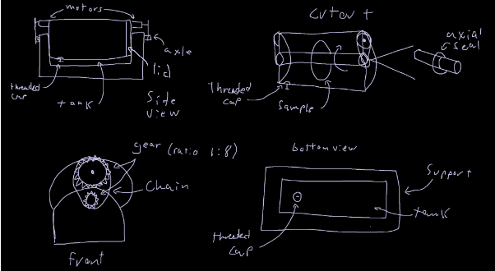
Figure 2. Design Concept with Vertical Single Motor System.
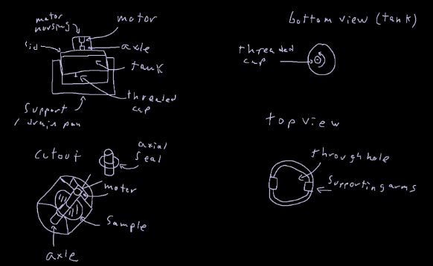
Figure 3. Design Concept with Horizontal Propeller.
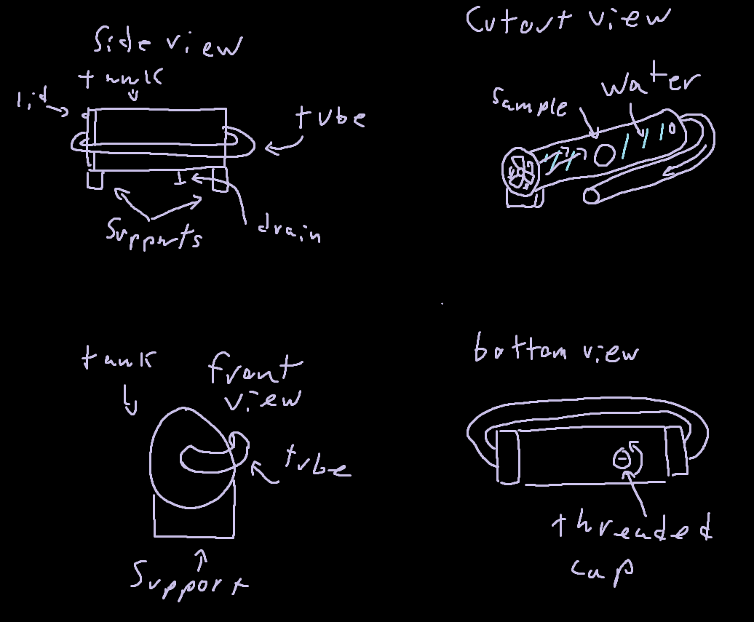
(Put the design concepts here and explain the benefits and drawbacks of subsystems)
(Then add 3 finalized ideas and explain advantages and drawbacks)

While creating ideas for possible solutions we came up with four different subsystems that will help create our final solution. These subsystems are the tank, the eroding system, the drain and a seal. The tank is simply the shell of our testing system, it will hold all of the water and needs to be strong enough to withstand the force inside the tank. The eroding system includes the motor and gears that will spin the component inside the tank. By using a high gear ratio we can increase the rpm’s for the component without using a high rpm motor, instead we can use a higher torque motor so that the gears turn smoothly. The drain will ensure we can empty the water from the tank in a controlled manner. This is important for when the experiment is finished and in case the inside of the tank needs to be accessed. The seal needs to prevent any leaks near the axle that’s attached to the component. The motor will be outside the tank meaning there will be a hole in the tank for the axle to go through, this seal will ensure that there is no leakage at that spot.

Drain: Threaded Cap
In the machine that is designed, we have the idea of making a tank where erosion can be tested and that includes its respective drainage system in which it was decided to make primarily a threaded cap which can be removable to allow the cleaning of the abrasive sands and product of erosion within the fluid. A method to clean the fluid within the system to allow more consistent testing. However, some drawbacks that might present are that as the system is around 20 cm diameter, the threaded cap will have to be small to fit in the system and the eroded particles might not be able to get out the system quickly.
Figure 4. Drain Design Concept of a Threaded Plug
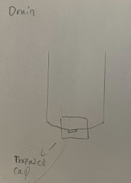
Erosion testing system: Single Motor
The designed system will use a single motor that allows the material to be eroded to rotate or spin indefinitely. The motor is planned to be durable and we choose a brushed motor since it prioritizes the rpm over torque. The advantages of brushed motors are inexpensive, compact and energy efficient. This allows it to be used for long periods of time without issues. Drawbacks to brushed motors are since they don’t have a lot of torque, it could have issues rotating the sample through the fluid, depending on the viscosity.
Figure 5. Single Motor Design Concept
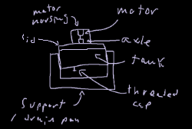
Tank: Cylindrical Vertical Tank
A cylindrical tank is ideal for fluids since it allows for the sample disc to rotate within a minimal area. As well, it allows the fluid to flow around the disc without creating countering current. This is helpful as it allows the fluid to flow around the sample while the sample is also rotating, reducing the amount of friction slowing down the rotations allowing the motor to reach its maximum potential for speed. The vertical tank allows quick access to the sample when the procedure is over, allowing for the lid of the machine to be removed and accessing the interior of the tank.
Axial Seal:
The axial seal is a very important subsystem to avoid any leaks while the system is running. It is important to ensure that the erosion fluid remains inside of the system to not damage electrical components which are located on the exterior, and keep the fluid on the inside to maintain the constant erosion of the sample disc.
Figure 6. Axial Seal Bearing Design Concept
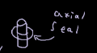
Analysis (40)
(Select an ideal concept choice and analyze and evaluate the decision with a design criteria matrix)

Specifications  (Weight: 1-4) | Plan 1 | Plan 2 | Plan 3
Cost (4) | 2 motors: ~$50  gears: ~$15  housing: ~$25  axle: ~$18  2 seals: ~$20  2 chains: ~$30  plug: ~$9  total: ~$167  (1) | Housing: ~$25  motor: ~$25  axle: ~$18  2 seals: $20  plug: ~$9  total: ~$97  (3) | housing: ~$25  propeller: ~$30  plug: ~$9  tube: ~$10  total: ~$74  (4)
Safety (4) | Mostly safe, as long as fingers don’t get caught in the gears  (3) | No concerns about safety as long as the system is closed while operating.  (4) | No concerns as long as the system is closed while operating.  (4)
Erosion (3) | The system uses two motors supported by gears to spin the material part on an axle in a sand-water solution.  (3) | The system uses a motor to spin the part on an axle in a sand-water solution.  (2) | The system uses a propeller to spin the part in water.  (1)
Reproducibility (3) | The system uses a pair of synced motors to control the speed and direction of the axle.  (3) | The system uses a single motor to control the speed and direction of the axle.  (2) | The part is attached to the propeller as it spins.  (1)
Measurability (3) | The system controls the speed and force applied through by controlling the voltage input. The system allows a set amount of water and sand. The mass of the sample can be measured outside the tank.  (2) | The system controls the speed and force applied through by controlling the voltage input. The system allows a set amount of water and sand. The mass of the sample can be measured outside the tank.  (2) | The system controls the speed and force applied through by controlling the voltage input. The system allows a set amount of water and sand. The mass of the sample can be measured outside the tank.  (2)
Flexibility (2) | The use of two motors and gears grants an increased range to accommodate a higher range of torques and speeds.  (3) | The system is dependent on the operation parameters of the motor.  (2) | The system is dependent on the operation parameters of the propeller.  (2)
Total | 46 | 50 | 48

Cost: How much the system is expected to cost. The budget for our product is rather tight at $100 - $120.
Safety: How safe the system is to operate.
Erosion: How much wear the system can apply to a given part.
Reproducibility: How precisely the system can reproduce an experiment.
Measurability: How much data can be collected.
Flexibility: How many variables can the system accommodate. How large the operating range for the variables is.

The specification weightings place cost and safety as the most important features of our systems followed by erosion, repeatability, and measurability, then finally flexibility. While a team really only needs one setup, the production budget for the resulting system was specified to be a tight $100-120, limiting the complexity of the system. In a similar tier, safety is held highly due to the need for the system to not be a health hazard when operated. In the next rank, erosion, reproducibility, and measurability define the core functions of the system; without these, the system will not operate. Finally, the flexibility of the system will be an added benefit as it allows more data to be collected, but does not define a core function of the system.

Conclusion
In conclusion, based on the 3 conceptual designs our team came up with. The solution we determined to be the most effective based on our design criteria was the 2nd solution, due to the reduction in cost as well as ease of use and repeatability.

