Deliverable D - Conceptual Design

Introduction
The main goal of this document is conceptual design. To break down this Loyalty Rewards Project with Zafin into smaller subsystems which are intended to be the main components of the final product. Each subsystem has concepts that are just ideas for how we can solve the subsystem. After presenting our ideas to Zafin, they gave us some feedback on our ideas so we modified the concepts of the subsystems and also performed an analysis of our ideas using our most target specifications.

Concepts For Subsystems

Partner Integration
This subsystem is essentially how the program allows the banks to integrate and add new businesses into their loyalty program ecosystem. This system should handle both the addition and the removal of businesses. It should also be able to store a database of retailers and their associated values or contribution of points to the program.

Concepts:
The integration of business partners should be easily configurable. The program itself should serve as a framework that allows the financial institution to design a system that works for them. It should give them the tools necessary to allow for different methods of adding their partners to their system and to determine the points that would be associated with a partner. For example, if a bank decides that it wants a tiered system with preferred businesses, the program should be flexible enough to do this. The program should give the financial institution free control over how the loyalty system would work, through the use of templates or configurable settings within certain parameters. The program should allow banks to design an easily configurable multi-tiered retailer partnership, whereby users are rewarded a varying number of points based on the fees paid by the retailer.

We understand that retailers each have their own unique point system. Because of this, we want our point democratization system to be as effortless to implement as possible. To facilitate this, we could implement an open-source approach. All of the steps to implement our service into existing reward systems would be freely accessible. This approach incentivizes retailers to implement our system by lowering the bar of entry.

Another approach to make the addition and removal of businesses effortless is to implement some kind of mailing system. It would be able to identify which retailers are already partnered with the financial institution and which ones are not. For the retailers that are not partnered, the software could generate invitations to send out to them on approval by the bank. This would make it more straightforward to add new partners so the bank wouldn’t have to search for them.

Data Analysis/User Feedback

By its nature, our software will have to interact with, collect and store data from a diverse set of sources. This data will be volatile and a high level of security must be maintained due to its personal and financial nature. It is because of this that it is one of our team’s top priorities in the prototyping phase.

Concepts:
Reward systems manage vast amounts of user data and can be a valuable asset for the merchants that take advantage of it. Our final product will focus on utilizing this network of valuable information to provide real-time metrics to retailers that participate in our point program. Not only would this system benefit the merchants and retailers that make use of it, but it also incentivizes them to make use of the point system, promoting activity and full utilization.

No matter what data the software collects, it needs to be analyzed efficiently even if there is a lot of it. An idea for this is that the software would be able to create charts, graphs and show trends based on what the analyzer wants to see. This way they can create targeted offers, or special sales or use any other business technique more strategically.

The program should be able to handle and summarize the data surrounding the points. It should look at where the points are being obtained, the types of businesses where they are being obtained, the specific business that they are being acquired, how many at each business, and any other significant source of data that would generate a thorough understanding of where points are coming from. The program would also look at how points are being spent by looking into where they are being used, how many points are used at once, the types of business they are being spent on, and so on. The data would then need to be summarized through the use of programs such as Microsoft’s Power BI. Once the data is analyzed, it would send targeted offers to the cardholder based on the results. It would also help the bank figure out what businesses would be beneficial to add to the loyalty ecosystem, so they can focus on trying to add them to their system.

User Interface
This subsystem deals with the point where the users (ie. the banks, businesses, and customers) interact with the software. The point is to make the software simple and intuitive and it covers the following criteria and more: How straightforward is the software to use? Can I trust this software? Is it safe to use? etc.

Concepts:
An approach we are considering is a fully virtual web interface. Our service will need to be accessed around the clock by a wide range of stakeholders from financial institutions to retail partners. That is why we believe that a web app would be the best approach in making our services as accessible as possible. The web app would have all data, and action items relating to rewards and point systems.

Another idea is in the final software, the main screen can be a navigation page so no matter who the user is they will quickly be able to find the information they are looking for or get the services that they need. This way the user will not have to waste time searching around for it.

Modified Concepts For Each Subsystem

Partner Integration
During the client meeting, Zafin seemed to like the Partner Integration subsystem, but they did give us some advice on how to make it better. They told us that they wanted the team to refine it even further, and to think of specifically how we would integrate these business partners.

The refinement of the tiered system takes into consideration that some businesses will not want to join due to the fee mentioned in the initial conceptualization of this idea. This leads to the creation of a tiered system with two additional tiers that handle this problem. The first tier is essentially the baseline tier, where the business does not participate in the loyalty program, so the bank only gives the points it would normally give out. The second tier allows smaller businesses or businesses that don’t want to pay an opportunity to join the loyalty program. This tier would allow cardholders to gain more points at these retailers, but no additional benefits, such as offers or bonuses, would be provided for these businesses.
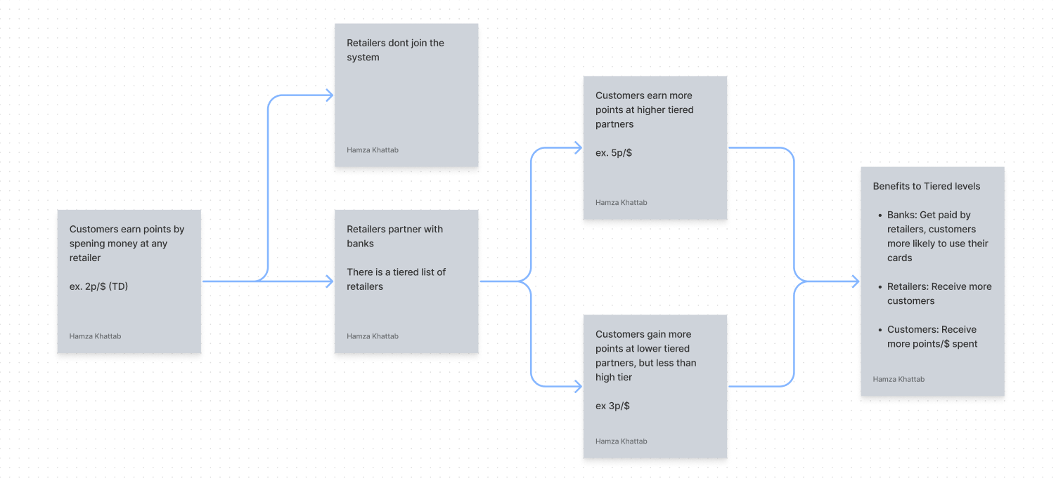
Figure 1. Tiered System Flowchart

Data Analysis / User Feedback
For data analysis, Zafin mentioned is it the internet or just my pcthat we need to narrow down the most important and useful piece(s) of data since if we collect all the data then we will have way too much to analyze which won’t be useful. So we decided to narrow down our data collection to the kinds of items the user likes to spend their points on, which business partners they like to spend them on, and how they found out about our loyalty program. We believe this is the most useful data to collect because, the software will be able to offer them items of their interest from the place they trust, and by knowing where the user found out about our loyalty program, the financial institutions will be able to know what methods of advertising are working and what methods need to be changed. With the tools available in this project our group has decided that an Azure SQL database would be the most suitable. It provides a framework that is well-suited to our needs and is readily available with our current resources. Data management and analysis would be managed with proprietary software that connects to our web app.

User Interface
During our discussion with Zafin, they mentioned that the user interface is very much a key aspect of our design and that we should focus on its ease of access. Outside of this, they did not have very much specific feedback as we reached the end of our time with them. We plan to continue on the course of using a web app-based system that allows both retailers and financial institutions to gain quick access to their point system/offers.

Final Concept
Below are the lists of the target specifications that relate most to our concepts.

Design Criteria - Functional Requirements | Relation | Value | Units | Verification
Some form of data analysis of user behavior | = | Yes | N/A | Test
Can have targeted offers | = | Yes | N/A | Test
Addition of new businesses | = | Yes | N/A | Test
Includes as many types of businesses as possible | = | Yes | N/A | Test
Rewards aligned with the bank’s strategies/goals | = | Yes | N/A | Test
Scalability | > | 0 | Number | Test

Design Criteria - Non Functional Requirements | Relation | Value | Units | Verification
Seamless addition of new businesses | = | Yes | N/A | Test
Ease of Use software | = | Yes | N/A | Test
Fast Response Time | < | 1 | second | Test
Explains how the points can be used  (ex. User Guides, tooltips, etc.) | = | Yes | N/A | Test
Some kind of security measure(s) | = | Safe | N/A | Test

The concepts we chose from each of our subsystems are the tiered partner system for partner integration, analysis through MS Power BI/Azure SQL database, and a web app service with a navigation page as the home screen for the user interface. We chose these concepts over the other ones because they are the concepts that are explained in the most depth and are the ones that we can expand on. They also have the least risks associated with them.

The program needs to be flexible enough to allow financial institutions to integrate new businesses in whichever way they see fit. The tiered system allows them to do just that, it allows banks to create different tiers when adding unique businesses. This gives full control over how many point cardholders would receive at these businesses, it also allows banks to set priority levels for the “best” business partners. The tiered system also allows for the implementation of several different kinds of programs, such as one where cardholders gain equal amounts of “bonus” points at participating partners, or another where there is an alternating set of preferred business partners. This system also takes into consideration the scaling of both the bank and its loyalty program ecosystem. As the loyalty program grows, more businesses will join the program, but some will also leave. This allows the program to be adaptable.

The program should also be able to collect and store data. Our idea is to make a power app where customers will make their transactions and the data of what was purchased, the business it was purchased at, how many points were spent, and how the user found out about this loyalty service (if applicable) would all be stored in an excel file and connected to Power BI through Power Automate. This will allow the data to be easily updated and accessed by the banks that will perform their own marketing/business analysis.

Finally, concerning the user interface, we chose a web application for the convenience of the users. It will be easily accessible anytime as Zafin provides platforms to financial institutions in many places around the world. It would also be useful to have a navigation page as the opening screen to orient every kind of user.

Conclusion
Moving forward, we have decided to create a tiered loyalty program that can collect and analyze data surrounding the acquisition and the usage of points by cardholders. This would leverage the tools provided by the MS and Azure stacks to create the reports on the data collected. This would all be accessible on an intuitive web app. This solution meets the most important of the requirements that were stated in previous deliverables and is also a realistic solution considering the time frame.

