Deliverable E - Project Plan &

Cost Estimate
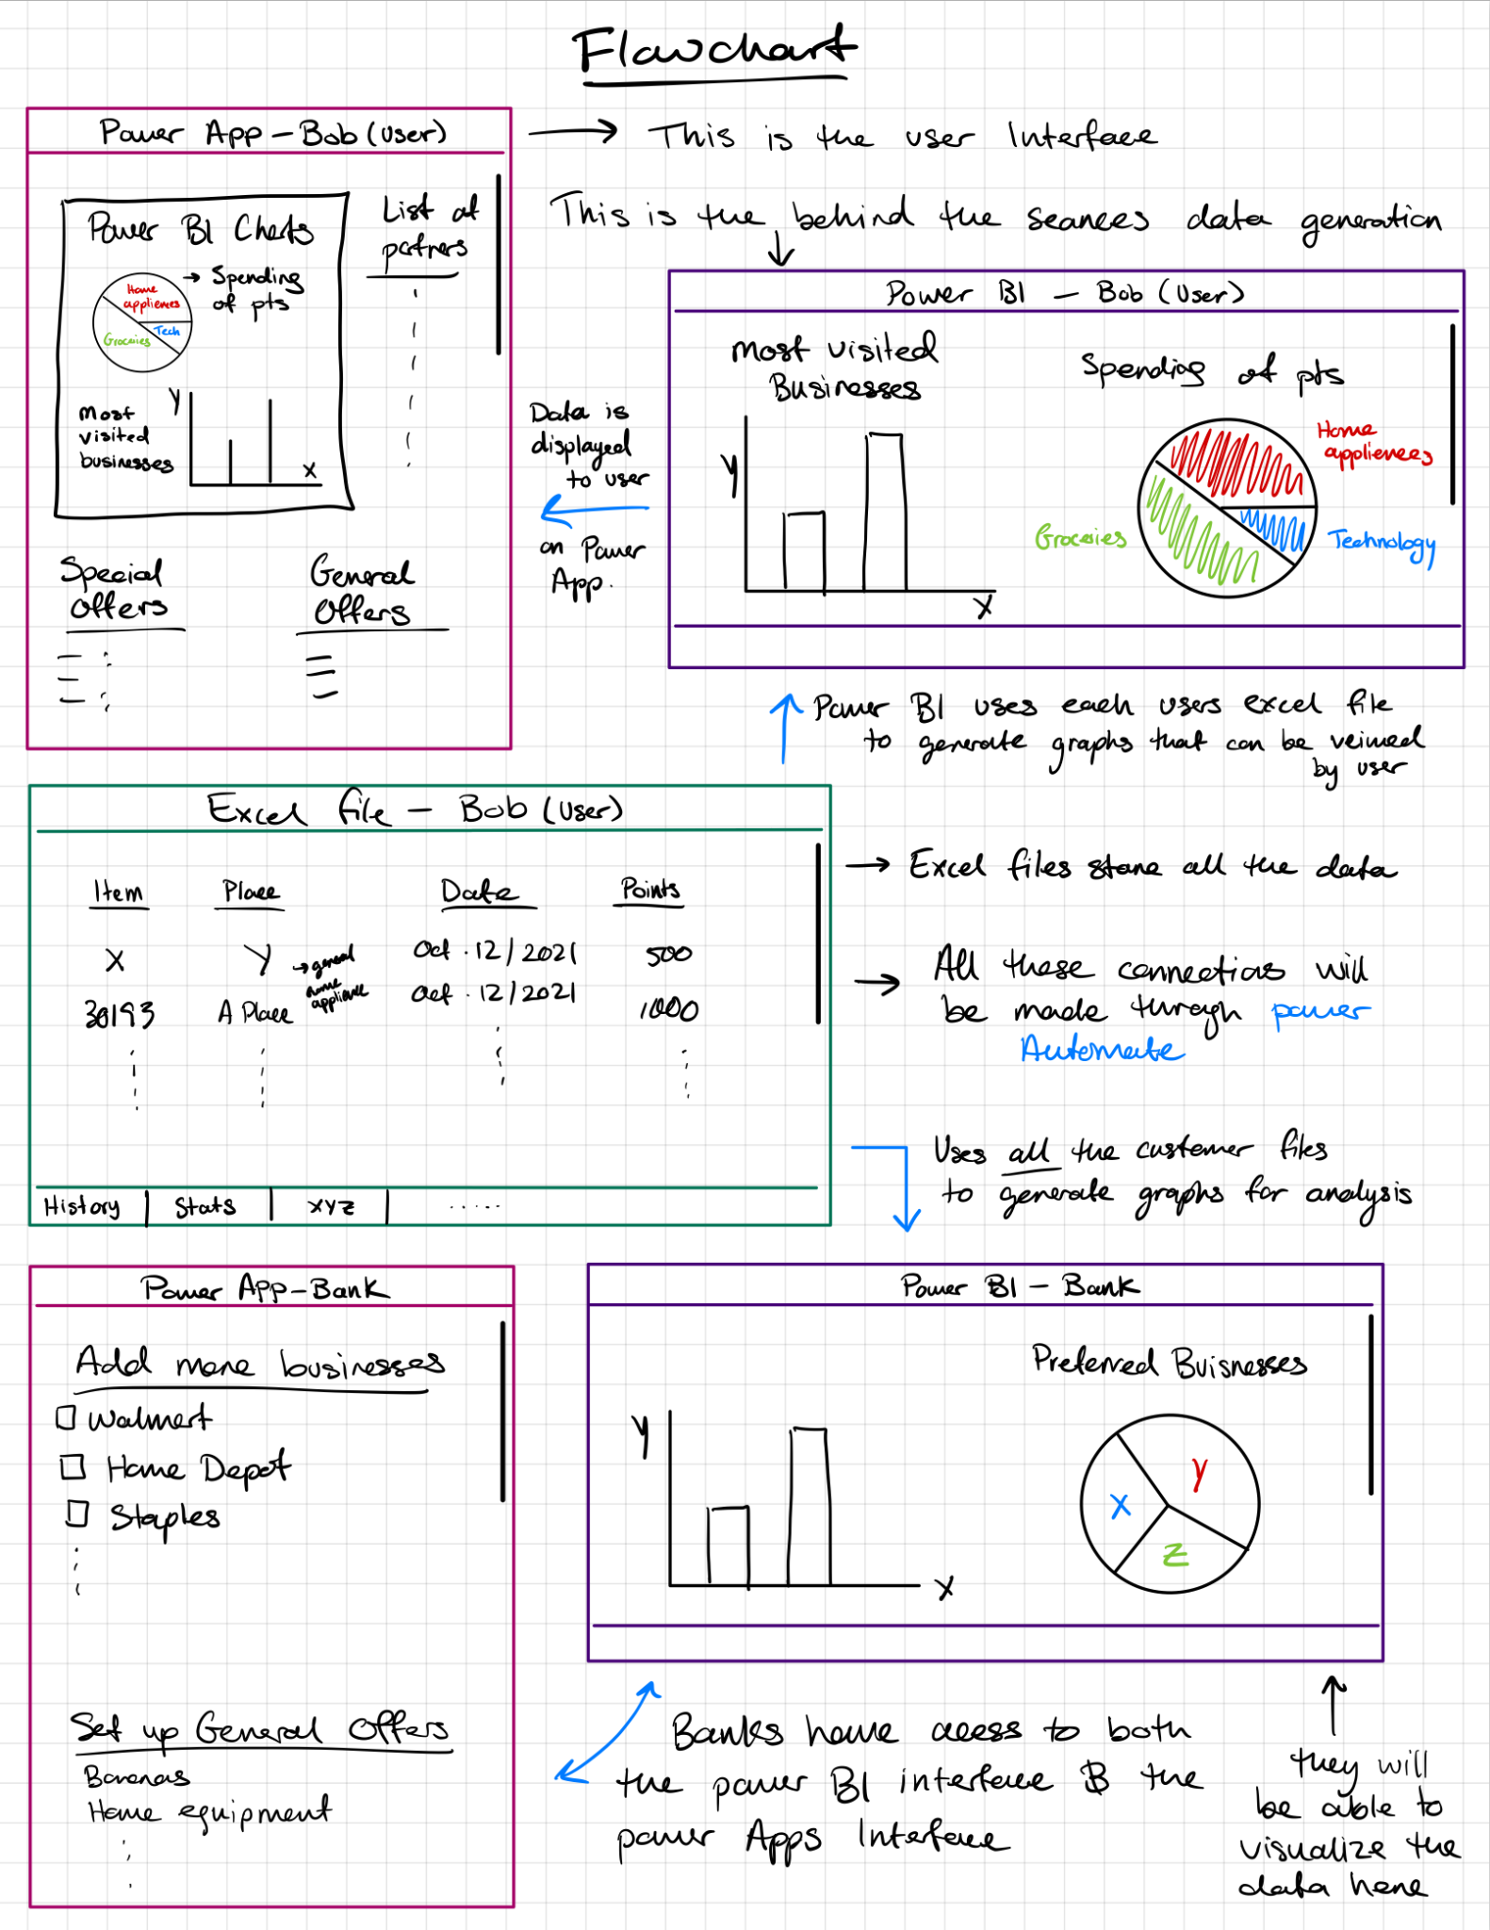

Prototyping test plan
Below is a table of the prototyping test plan

Test ID | Test Objective  (why) | Description of Prototype used and of Basic Test Method  (what) | Description of results to be recorded and how these results will be used  (how) | Estimated Test duration and planned start date (when)
1 | Get feedback | Figma Flowcharts with simple explanation shown to people for feedback of Tiered System | - General thoughts  - Likes/Dislikes  - How they felt about the idea  Results will be used to focus the idea further. If overall feedback was negative, then a different/revised idea may be implemented instead. | Oct 27 - Nov 4
2 | Testing/ Analysing of Data Analysis Subsystem | By using the MS and Azure stacks, create a simple prototype of the data analysis system and test it using random test cases. | - Checking the functionality of subsystem  - Gaining a better understanding of Power BI  - Looking at the handling of different test cases  - Asking for feedback if needed | Oct 27 - Nov 4

Risks & Contingencies
The most significant risk of this project is that our project idea isn’t feasible due to some limitations of the Power System that we are currently unaware of. To minimize this risk, we can talk to the TA/PM and see if they think we can do the project, and we can also do some research and learn more about the power system to gain a better understanding of what is (and isn’t) possible or way too advanced for our current capabilities. And if it turns out that this risk is the case, then we will have to resort to manually coding the software using Visual Studio Code, which we can also gain some knowledge on just in case.

Another significant risk is the constraint of time that we have to complete the prototypes and learn any new skills needed to build the prototypes. To minimize this risk, additional wiggle room is considered when planning and allocating the time required for each prototype. This allows the plan to remain flexible, as it gives us enough time to replan and reschedule the prototype if some issues arise.

Bill Of Materials
Please see the attached Excel file.

Wrike Task Plan
Here is the link to the updated task plan https://www.wrike.com/workspace.htm?acc=4961174#path=folder&id=760158710&c=timeline3&vid=47651413&a=4961174&so=10&bso=10&sd=0&f=&st=space-760158710

Please contact us if the link doesn’t work for some reason. Here is a screenshot of the plan.

